Nha Trang, Khánh Hòa, Vietnam
Vietnam's Riviera curves around a turquoise bay sheltered by forested islands — Cham temples, volcanic mud baths, and some of the country's best urban beaches all within reach of a single shore day.
⚓ Pier (Cam Ranh, 60 km) or Tender (Cau Da, 6 km) · 🕒 Typical call: 8–10 hrs · 💵 Vietnamese Dong (VND) — cash essential · 🗣️ Vietnamese · 🏖️ Beach day possible
✍️ MY DAY IN PORT (FILL IN)
Ship / Date
In port | arrive ______ · all aboard ______
Booked excursion
Notes / meeting point
GETTING ASHORE
- Docking: Large ships dock at Cam Ranh Port (~60 km south); mid-size ships tender to Cau Da Pier (~6 km south of city center)
- Walk to center: Not walkable from either port — taxi or Grab app required
- Best For: Mud baths, Cham temple history, beach clubs, island snorkeling
- Don't Miss: Po Nagar Cham Towers and a mud bath at Thap Ba Hot Springs
GETTING AROUND
- 🚕 Taxi: 65,000–130,000 VND (~$3–5) — Cau Da Port is ~6 km from the city center; metered taxis (Mai Linh, Vinasun) take about 15 minutes. Confirm the meter is
- 📱 Rideshare: ✅ Grab
- 🚌 Hop-on hop-off: ✅ Nha Trang Bus City Tour
TOP THINGS TO DO
- Po Nagar Cham Towers — A remarkably preserved Hindu temple complex built by the Champa Kingdom between the 8th and 13th centuries, still an active place…
- Mud Bath at Thap Ba Hot Springs — Nha Trang's signature experience: soak in a private tub of warm mineral-rich mud, dry in the sun, then rinse and relax in…
- Long Son Pagoda & White Buddha — A working Buddhist temple crowned by a giant 24-metre white Buddha seated atop a hill.
- Island Snorkeling — Hon Mun Marine Reserve — Hon Mun is Vietnam's first marine protected area, with colorful coral reefs and calm clear water.
- VinWonders & Vinpearl Cable Car — Ride the record-breaking 3.3 km cross-sea cable car to Hon Tre Island for a massive water park, amusement park rides, and an…
BEST WALKS
- Beachfront & Landmarks Stroll: 2–3 km · 1.5 hrs · Easy — Walk Tran Phu Beach from the Tram Huong (Pink Lotus) tower southward past the sailing clubs, dip at…
- Cultural North: Po Nagar & Long Son: ~5 km taxi hop · 2–3 hrs · Easy — Taxi or Grab to Po Nagar Cham Towers, explore the complex, then continue to Long Son Pagoda for the…
WEATHER · DAYLIGHT · MONEY
Month | High °F | Low °F | Rainy days
May | 90 | 79 | 17
Jul | 90 | 79 | 17
Sep | 88 | 78 | 22
Daylight: May 5:19AM–6:00PM · Jul 5:26AM–6:12PM · Sep 5:32AM–5:44PM
cruiseports.org/nha-trang · Confirm terminal & all-aboard time with your ship

Nha Trang, Khánh Hòa, Vietnam — Port Map
Red = walkable sights · Amber = excursions farther out · P = cruise terminal
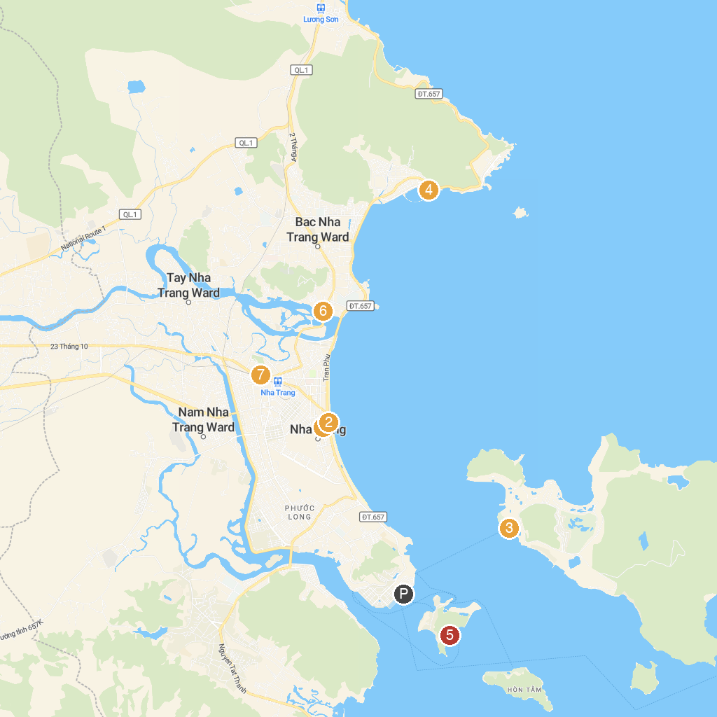
MAP KEY
1. Galina Hotel & Spa | 5. Bai Tranh Beach
2. Tri Nguyen Aquarium | 6. Po Nagar Temple
3. Con Sẻ Tre Tourist Village | 7. Monkey Island tourist resort
4. Flyboard Nha Trang | 8. Long Son Pagoda
P. Cruise port / terminal
Map © MapTiler © OpenStreetMap contributors · cruiseports.org

