Newport, Wales, United Kingdom
Newport sits at the edge of the River Usk, a working port that punches above its weight as a cruise gateway — with Roman legionary ruins twenty minutes away and Cardiff's capital buzz just down the M4.
⚓ Docked (South Dock, River Usk) · 🕒 Typical call: 8-10 hrs · 💷 Currency: British Pound (GBP) · 🗣️ Language: English (Welsh spoken)
✍️ MY DAY IN PORT (FILL IN)
Ship / Date
In port | arrive ______ · all aboard ______
Booked excursion
Notes / meeting point
GETTING ASHORE
- Docking: Alongside berth at South Dock, ABP Newport — 244 m berth, no tendering
- Walk to centre: ~2 miles (3.2 km) — shuttle bus provided; not walkable for most
- Best For: Roman history, Welsh culture, day trips to Cardiff or Wye Valley
- Don't Miss: Caerleon Roman Amphitheatre & Baths — 20 min from port, world-class ruins
GETTING AROUND
- 🚕 Taxi: £10–£18 — The city centre is approximately 2 miles from the port. Licensed taxis use metered fares; expect £10–£18 each way depend
- 📱 Rideshare: ✅ Uber, Bolt
- 🚌 Hop-on hop-off: ✅ City Sightseeing Newport
TOP THINGS TO DO
- Caerleon Roman Fortress & Baths — One of Britain's most intact Roman legionary sites: a 2,000-year-old amphitheatre, exposed barracks, and the National Roman…
- Cardiff City & Cardiff Castle — Wales's capital is just 10 miles away — stroll the Victorian arcades, visit Cardiff Castle's ornate State Apartments, or explore…
- Wye Valley & Tintern Abbey — Drive the Wye Valley AONB to reach Tintern Abbey, the romantic 12th-century ruin on the riverbank that inspired Turner and…
- Tredegar House — A magnificent late 17th-century mansion on the outskirts of Newport, seat of the Morgan family for 500 years.
- St Fagans National Museum of History — Wales's most popular heritage attraction near Cardiff — over 40 historic buildings relocated to a 100-acre parkland, from Iron…
BEST WALKS
- Newport City Heritage Walk: 2.5 km | Mostly flat | 45–60 min — From the city centre, walk along the River Usk to Newport Transporter Bridge (a 1906 Edwardian…
- Caerleon Roman Trail: 1.5 km loop | Flat | 45 min on-site — A self-guided walk around the Caerleon fortress site taking in the amphitheatre, legionary baths…
WEATHER · DAYLIGHT · MONEY
Month | High °F | Low °F | Rainy days
May | 61 | 48 | 13
Jul | 70 | 57 | 12
Sep | 65 | 54 | 11
Daylight: May 5:19AM–8:57PM · Jul 5:12AM–9:22PM · Sep 6:47AM–7:25PM
cruiseports.org/newport-uk · Confirm terminal & all-aboard time with your ship

Newport, Wales, United Kingdom — Port Map
Red = walkable sights · Amber = excursions farther out · P = cruise terminal
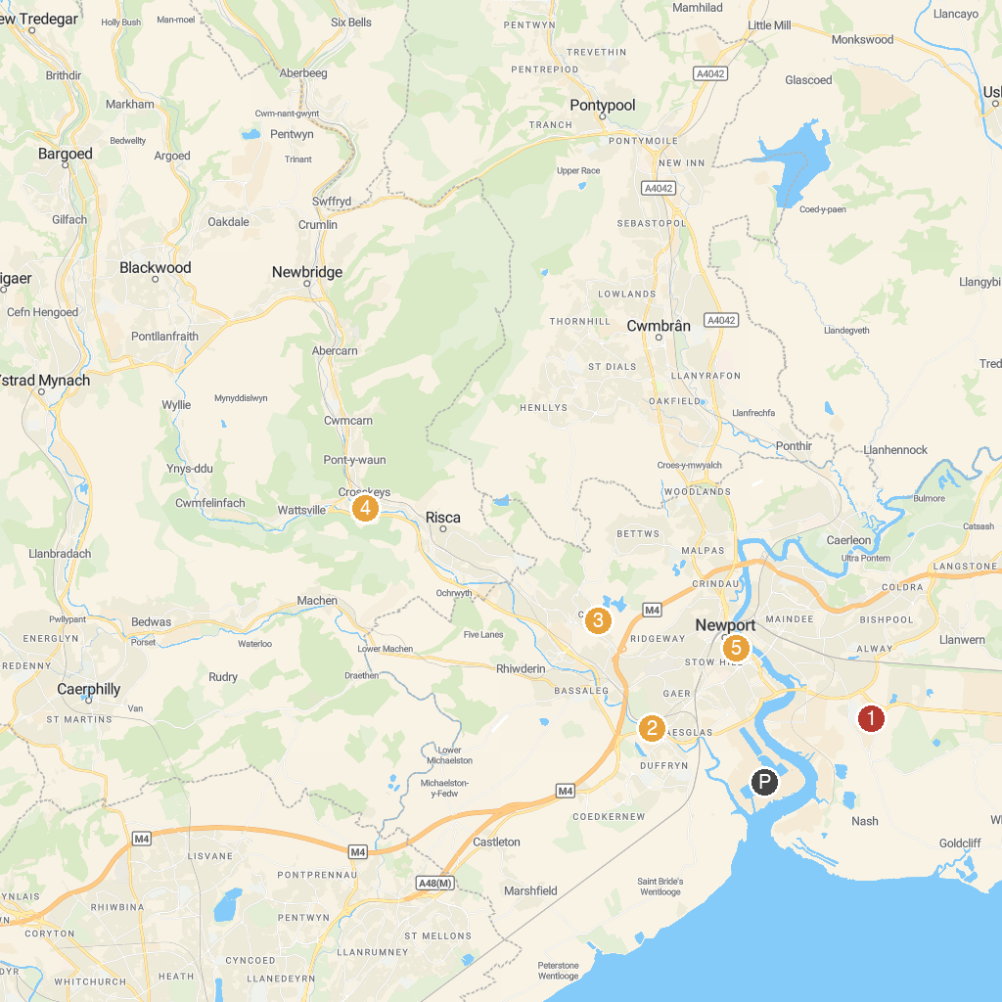
MAP KEY
1. Newport Medieval Ship | 5. Sirhowy Valley Country Park
2. Tredegar Park | 6. Llandegfedd Lake Visitor & Activity Centre
3. Fourteen Locks Canal Centre | 7. Panteg Park
4. Waunfawr Park | 8. Newport Museum and Art Gallery
P. Cruise port / terminal
Map © MapTiler © OpenStreetMap contributors · cruiseports.org

