Newport, Rhode Island, USA
America's first resort city delivers Gilded Age grandeur on a walkable shoreline — Vanderbilt mansions, a dramatic cliff-top trail, and one of the finest natural harbors on the East Coast.
⚓ Mostly tender (large ships anchor in harbor) · 🕒 Typical call: 7-9 hrs · 💵 USD · 🗣️ English · 🍂 Peak season: Sept–Oct
✍️ MY DAY IN PORT (FILL IN)
Ship / Date
In port | arrive ______ · all aboard ______
Booked excursion
Notes / meeting point
GETTING ASHORE
- Docking: Most large ships tender to Perrotti Park or Ann Street Pier; smaller vessels may dock at South Alofsin Pier (Fort Adams)
- Walk to center: 5 min from Ann Street Pier tender landing to Thames St & Bowen's Wharf
- Best For: Gilded Age mansion tours, Cliff Walk, maritime history, New England seafood
- Don't Miss: The Breakers (Vanderbilt mansion) and the 3.5-mile Cliff Walk along the Atlantic
GETTING AROUND
- 🚕 Taxi: $8–12 — Taxis available near the tender dock. Short rides to The Breakers or Cliff Walk entry points run roughly $8–12; fares in
- 📱 Rideshare: ✅ Uber, Lyft
- 🚌 Hop-on hop-off: ✅
TOP THINGS TO DO
- The Breakers & Gilded Age Mansions — Tour The Breakers, Cornelius Vanderbilt II's 70-room Italian Renaissance palazzo on Bellevue Avenue — the grandest of Newport's…
- Cliff Walk — New England's first National Recreation Trail: a 3.5-mile path hugging the Atlantic shoreline with jaw-dropping ocean views on…
- Newport Harbor & Narragansett Bay Boat Tour — Narrated sailing or motor tours of Newport Harbor take you past Rose Island Lighthouse, Fort Adams, and the constellation of…
- Fort Adams State Park — The largest coastal fortification in the United States, Fort Adams guards the entrance to Narragansett Bay.
- International Tennis Hall of Fame — Housed in the historic Newport Casino (a National Historic Landmark on Bellevue Avenue), this museum holds over 1,900 artifacts…
BEST WALKS
- Downtown Waterfront Stroll: 1 mile • 30 min • Easy — From Ann Street Pier, wander along America's Cup Avenue to Bowen's Wharf, Bannister's Wharf, and…
- Cliff Walk (Northern Section): 2 miles round-trip • 1 hr • Moderate — Start at the Cliff Walk at Easton's Beach entrance (Memorial Blvd) for the most dramatic…
- Bellevue Avenue Mansion Mile: 1.5 miles one-way • 45 min • Easy — Stroll or take a rideshare to the top of Bellevue Avenue and walk south past The Elms, Rosecliff…
WEATHER · DAYLIGHT · MONEY
Month | High °F | Low °F | Rainy days
May | 61 | 48 | 13
Jul | 70 | 57 | 12
Sep | 65 | 54 | 11
Daylight: May 5:19AM–8:57PM · Jul 5:12AM–9:22PM · Sep 6:47AM–7:25PM
cruiseports.org/newport-ri · Confirm terminal & all-aboard time with your ship

Newport, Rhode Island, USA — Port Map
Red = walkable sights · Amber = excursions farther out · P = cruise terminal
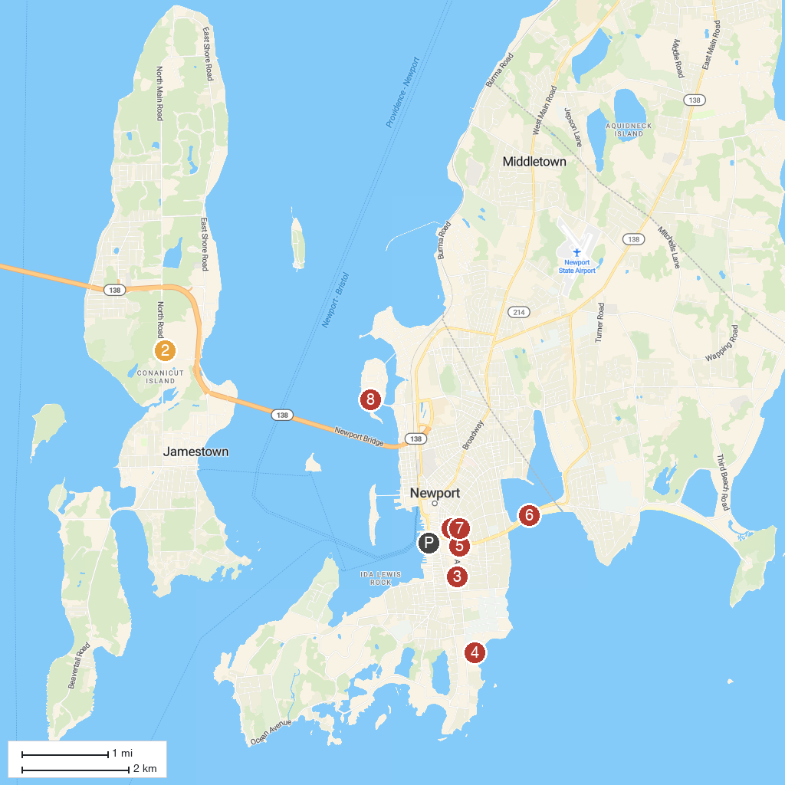
MAP KEY
1. Newport Windmill Tower | 5. International Tennis Hall of Fame
2. Windmill Hill Historic District | 6. Easton's Beach
3. The Elms | 7. Newport Art Museum
4. Rosecliff | 8. Naval War College Museum
P. Cruise port / terminal
Map © MapTiler © OpenStreetMap contributors · cruiseports.org

