Newhaven, Edinburgh, Scotland
Newhaven is Edinburgh's cruise gateway — a charming former fishing harbour with a tram stop steps from the tender pier, whisking you straight into one of Europe's most spectacular capital cities.
⚓ Tender port (ships anchor offshore) · 🕒 Typical call: 8–10 hrs · 💷 Currency: British Pound (GBP) · 🗣️ Language: English · 🚋 Tram to city centre: 25 min
✍️ MY DAY IN PORT (FILL IN)
Ship / Date
In port | arrive ______ · all aboard ______
Booked excursion
Notes / meeting point
GETTING ASHORE
- Docking: Tender — ships anchor in the Firth of Forth; ~15 min tender ride to Newhaven Harbour pontoon
- Walk to tram: 5 min (flat, ~500 m) to Newhaven tram terminus; 25 min by tram to Princes Street
- Best For: Edinburgh Castle, Royal Mile, Royal Yacht Britannia, scenic coastal walks
- Don't Miss: Book Edinburgh Castle tickets online weeks ahead — they rarely sell walk-ups
GETTING AROUND
- 🚕 Taxi: £11–£17 — Licensed taxis queue near the quayside. The ride to Edinburgh city centre takes 8–11 minutes depending on traffic.
- 📱 Rideshare: ✅ Uber, Bolt
- 🚌 Hop-on hop-off: ✅
TOP THINGS TO DO
- Edinburgh Castle & the Royal Mile — Scotland's most visited attraction crowns the volcanic rock above the city.
- Royal Yacht Britannia — Queen Elizabeth II's former royal yacht is permanently berthed at Ocean Terminal, a 15-minute walk from the tender pier.
- National Museum of Scotland — Free and outstanding — covers Scottish history, science, fashion, and natural history across grand Victorian galleries.
- Palace of Holyroodhouse — The King's official Scottish residence anchors the bottom of the Royal Mile.
- Arthur's Seat Hike — An extinct volcano rising 251 m above Edinburgh — the summit offers panoramic views over the city, the Firth of Forth, and on…
BEST WALKS
- Newhaven Harbour & Lighthouse Loop: 1 km · 20 min · Flat · Free — From the tender pontoon, walk around the picturesque 19th-century stone harbour, past the octagonal…
- Newhaven to Leith Waterfront: 2.5 km · 35 min · Flat · Free — Head east along the Shore path from Newhaven through the trendy Leith waterfront.
WEATHER · DAYLIGHT · MONEY
Month | High °F | Low °F | Rainy days
May | 57 | 45 | 13
Jul | 65 | 54 | 16
Sep | 61 | 51 | 12
Daylight: May 5:01AM–9:18PM · Jul 4:47AM–9:48PM · Sep 6:44AM–7:30PM
cruiseports.org/newhaven · Confirm terminal & all-aboard time with your ship

Newhaven, Edinburgh, Scotland — Port Map
Red = walkable sights · Amber = excursions farther out · P = cruise terminal
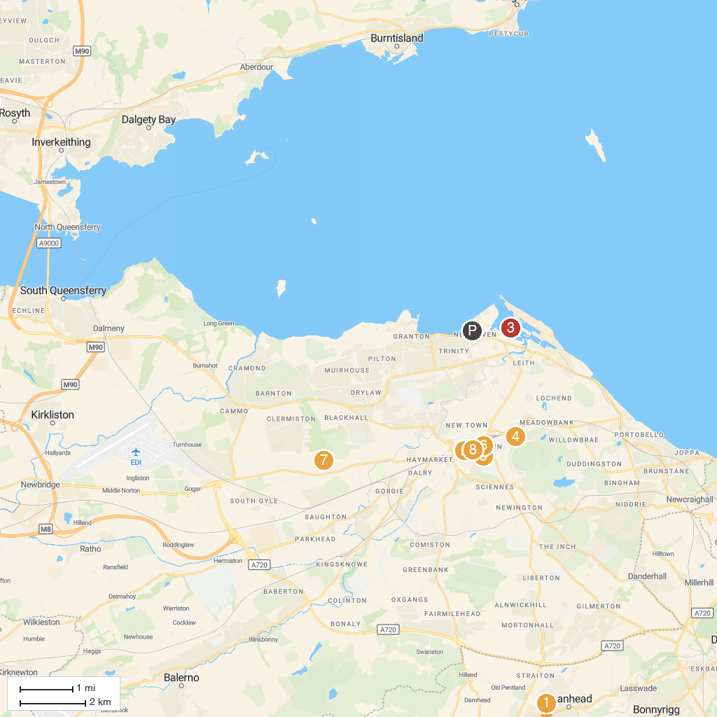
MAP KEY
1. Rosslyn Castle | 5. National Museum of Scotland
2. Edinburgh Castle | 6. The Real Mary King's Close
3. The Royal Yacht Britannia | 7. Edinburgh Zoo
4. Scottish Parliament Building | 8. The Scotch Whisky Experience
P. Cruise port / terminal
Map © MapTiler © OpenStreetMap contributors · cruiseports.org

