Newcastle upon Tyne, England, United Kingdom
One of England's most transformed cities, Newcastle pairs dramatic River Tyne bridges and medieval heritage with vibrant arts, surf beaches, and one of Britain's best seafood quays — all backed by the warmest welcome you'll find anywhere.
⚓ Pier (docked) · 🕒 Typical call: 8–10 hrs · 💷 British Pound (GBP) · 🗣️ English (Geordie dialect) · 🌊 Coastal & city combo
✍️ MY DAY IN PORT (FILL IN)
Ship / Date
In port | arrive ______ · all aboard ______
Booked excursion
Notes / meeting point
GETTING ASHORE
- Docking: Pier — Northumbrian Quay / International Passenger Terminal, North Shields
- Walk to centre: Not walkable — 8 miles to Newcastle city centre; Metro or shuttle recommended
- Best For: History, bridges, contemporary art, North Sea beaches, seafood
- Don't Miss: Tynemouth Priory on the cliffs, BALTIC art gallery, North Shields Fish Quay
GETTING AROUND
- 🚕 Taxi: ~£25–£40 one way — Several companies (e.g. Newcastle Airport Transfers, Jewels Transfers) offer fixed-fare pre-booked transfers from the Po
- 📱 Rideshare: ✅ Uber, Bolt
- 🚌 Hop-on hop-off: ✅ Go North East Toon Tour
TOP THINGS TO DO
- The Tyne Bridges Walk — Stroll the Quayside and count the seven bridges spanning the gorge, crossing the elegant Gateshead Millennium Bridge (the world's…
- Newcastle Castle & Grey Street — Climb the 12th-century Norman keep that gave the city its name for panoramic views, then walk up to Grey Street — one of…
- BALTIC Centre for Contemporary Art — A converted flour mill on the Gateshead riverbank housing cutting-edge contemporary art across five floors.
- Tynemouth Priory & Castle — Perched dramatically on a headland above the North Sea, this English Heritage site spans a 7th-century priory, a medieval castle…
- Tynemouth Longsands & Fish Quay — A mile of golden North Sea beach just south of the priory, popular with surfers — then head to North Shields Fish Quay for the…
BEST WALKS
- Quayside & Bridges Loop: 2.5 km · ~45 min · Easy · Free — Walk the Newcastle Quayside east toward the Millennium Bridge, cross into Gateshead, visit BALTIC…
- Tynemouth Coastal Walk: 2 km · ~40 min · Easy · Free — From Tynemouth Metro station, walk down to Front Street, descend to King Edward's Bay (a sheltered…
WEATHER · DAYLIGHT · MONEY
Month | High °F | Low °F | Rainy days
May | 58 | 45 | 13
Jul | 67 | 54 | 15
Sep | 63 | 50 | 12
Daylight: May 4:59AM–9:07PM · Jul 4:48AM–9:35PM · Sep 6:39AM–7:22PM
cruiseports.org/newcastle-upon-tyne · Confirm terminal & all-aboard time with your ship

Newcastle upon Tyne, England, United Kingdom — Port Map
Red = walkable sights · Amber = excursions farther out · P = cruise terminal
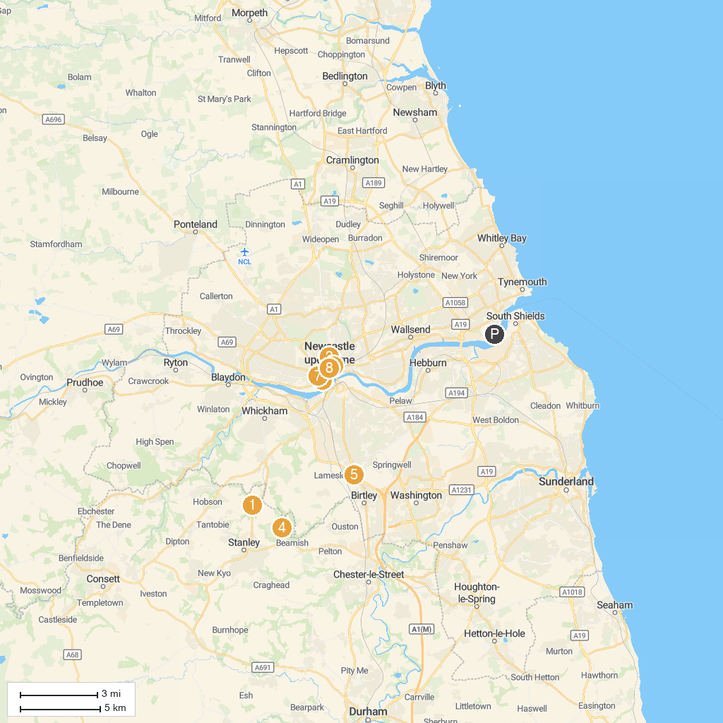
MAP KEY
1. Causey Arch | 5. Angel of the North
2. Life Science Centre | 6. Laing Art Gallery
3. Great North Museum: Hancock | 7. Discovery Museum
4. Beamish - The Living Museum of the North | 8. Grey's Monument
P. Cruise port / terminal
Map © MapTiler © OpenStreetMap contributors · cruiseports.org

