Newcastle, New South Wales, Australia
Where coal tankers and surfers share the same harbor channel — Newcastle blends gritty industrial heritage with world-class beaches and a booming food scene that surprises every first-time visitor.
⚓ Pier (Channel Berth, Carrington) · 🚌 Shuttle to CBD required · 🕒 Typical call: 8-10 hrs · 💵 Australian Dollar (AUD) · 🗣️ English
✍️ MY DAY IN PORT (FILL IN)
Ship / Date
In port | arrive ______ · all aboard ______
Booked excursion
Notes / meeting point
GETTING ASHORE
- Docking: Pier at Channel Berth, Carrington — shuttle to city (10–15 min)
- Walk to center: Not walkable from berth; free/low-cost shuttle to Honeysuckle/Queens Wharf
- Best For: Beaches, coastal walks, Fort Scratchley, Hunter Valley wine day trips
- Don't Miss: The Bogey Hole convict ocean pool & Newcastle Memorial Walk clifftop views
GETTING AROUND
- 🚕 Taxi: AUD $12–20 — Metered taxis available outside the terminal at Dyke Point. Short ride to city center, roughly 3–5 km.
- 📱 Rideshare: ✅ Uber, DiDi, Bolt
TOP THINGS TO DO
- Hunter Valley Wine Tour — Australia's oldest wine region produces world-class Semillon and Shiraz.
- Fort Scratchley Historic Site — A 19th-century harbor fort that fired on a Japanese submarine in WWII — the only Australian fort to engage an enemy vessel.
- Bathers Way Coastal Walk — A 6 km clifftop coastal pathway from Nobby's Headland south to Merewether Beach.
- Blackbutt Reserve — A free-entry nature reserve 15 minutes from the CBD where you can see koalas, kangaroos, emus, and wombats in a natural bushland…
- Harbour & Ocean Boat Tour — High-speed ocean rafting tours depart near the shuttle drop-off, heading out of the harbor to see sea caves, rugged cliffs…
BEST WALKS
- Honeysuckle to Nobby's Beach & Fort Scratchley: 4 km return | 1.5–2 hrs | Flat then uphill — Walk the harbor foreshore east from Honeysuckle past Queens Wharf, along the beach path to Nobby's…
- Newcastle Memorial Walk & Bogey Hole: 3 km | 1 hr | Coastal clifftop — From Strzelecki Lookout, follow the spectacular 450-metre clifftop Memorial Walk — including its…
WEATHER · DAYLIGHT · MONEY
Month | High °F | Low °F | Rainy days
May | 68 | 55 | 9
Jul | 63 | 50 | 7
Sep | 69 | 55 | 8
Daylight: May 6:36AM–5:01PM · Jul 6:53AM–5:04PM · Sep 5:52AM–5:44PM
cruiseports.org/newcastle-nsw · Confirm terminal & all-aboard time with your ship

Newcastle, New South Wales, Australia — Port Map
Red = walkable sights · Amber = excursions farther out · P = cruise terminal
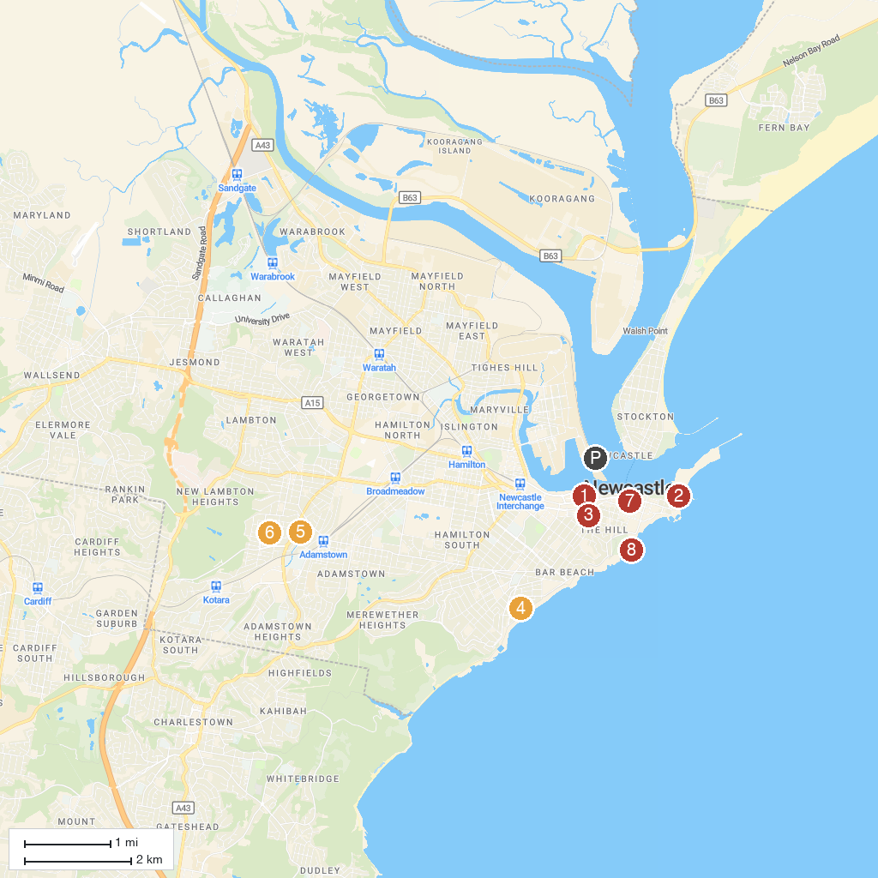
MAP KEY
1. Newcastle Museum | 5. Alder Park
2. Fort Scratchley | 6. Novocastrian Park
3. Newcastle Art Gallery | 7. Newcastle Afoot
4. Dixon Park | 8. Bogey Hole
P. Cruise port / terminal
Map © MapTiler © OpenStreetMap contributors · cruiseports.org

