New York, New York, USA
The ultimate port call: cruise into Manhattan with the Statue of Liberty on your left and the skyline straight ahead. New York rewards every style of shore day, from world-class art to legendary pizza.
⚓ Docked · 🕒 Typical call: 8-12 hrs · 💵 USD · 🗣️ English · 🗽 Iconic skyline arrival
✍️ MY DAY IN PORT (FILL IN)
Ship / Date
In port | arrive ______ · all aboard ______
Booked excursion
Notes / meeting point
GETTING ASHORE
- Docking: Manhattan Cruise Terminal (Piers 88–92) or Brooklyn Cruise Terminal (Red Hook)
- Walk to center: 15-min walk or quick subway from Midtown pier; Red Hook requires taxi/rideshare (~20 min)
- Best For: First-timers, culture lovers, foodies, shoppers
- Don't Miss: Statue of Liberty ferry, Central Park, the High Line
GETTING AROUND
- 🚕 Taxi: $15–18 (Manhattan terminal), $40–50 (Brooklyn terminal), $60–75 (Cape Liberty to Manhattan) — Yellow cabs available at all terminals. Prices vary greatly by terminal — Manhattan terminal passengers are a short ride
- 📱 Rideshare: ✅ Uber, Lyft
- 🚌 Hop-on hop-off: ✅
TOP THINGS TO DO
- Statue of Liberty & Ellis Island — The quintessential New York experience.
- Metropolitan Museum of Art — One of the world's greatest art collections, spanning 5,000 years of human creativity.
- Central Park Walking Tour — 843 acres of urban parkland with Bethesda Fountain, the Bow Bridge, Belvedere Castle, and Strawberry Fields.
- 9/11 Memorial & Museum — A moving tribute at the site of the World Trade Center.
- The High Line & Chelsea Market — A 1.45-mile elevated park built on a disused rail line above the streets of West Chelsea.
BEST WALKS
- Midtown Highlights Walk: 3–4 km · 1.5–2 hrs · Easy — From the cruise terminal, walk east to Times Square, south on 7th Ave to Bryant Park and the New…
- Lower Manhattan & Brooklyn Bridge: 4–5 km · 2–2.5 hrs · Easy — Take the subway from the pier down to Fulton Street.
WEATHER · DAYLIGHT · MONEY
Month | High °F | Low °F | Rainy days
May | 70 | 53 | 11
Jul | 84 | 69 | 13
Sep | 76 | 62 | 10
Daylight: May 5:38AM–8:06PM · Jul 5:38AM–8:25PM · Sep 6:37AM–7:04PM
cruiseports.org/new-york · Confirm terminal & all-aboard time with your ship

New York, New York, USA — Port Map
Red = walkable sights · Amber = excursions farther out · P = cruise terminal
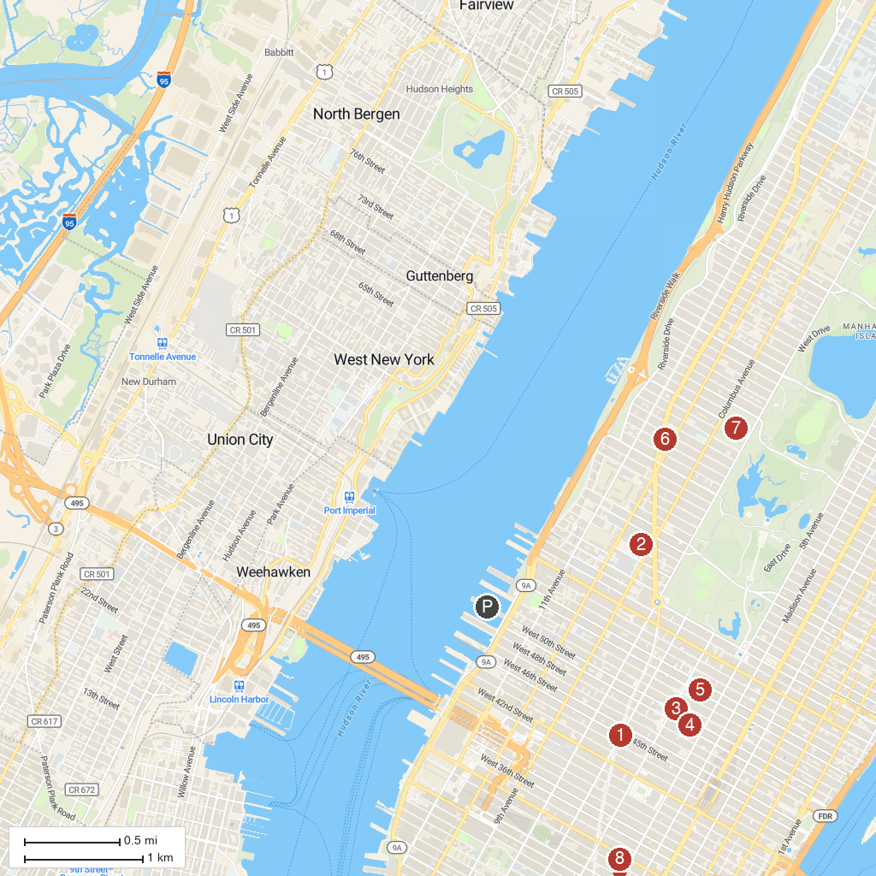
MAP KEY
1. Times Square | 5. The Museum of Modern Art
2. Lincoln Center for the Performing Arts | 6. Beacon Theatre
3. Radio City Music Hall | 7. American Museum of Natural History
4. Rockefeller Center | 8. Empire State Building
P. Cruise port / terminal
Map © MapTiler © OpenStreetMap contributors · cruiseports.org

