New Plymouth, Taranaki, New Zealand
A volcanic cone rising behind a surf coast, world-class kinetic art in the CBD, and Māori legends woven into every hillside — New Plymouth punches well above its size for a cruise day ashore.
⚓ Docked (Port Taranaki) · 🚌 Shuttle required to CBD · 🕒 Typical call: 8-10 hrs · 💵 NZD — cards accepted everywhere · 🗣️ English / Te Reo Māori
✍️ MY DAY IN PORT (FILL IN)
Ship / Date
In port | arrive ______ · all aboard ______
Booked excursion
Notes / meeting point
GETTING ASHORE
- Docking: Docked at Port Taranaki; mandatory shuttle to port gate or CBD (~10 min)
- Walk to center: Not walkable through active port; shuttle drops at Puke Ariki on the waterfront
- Best For: Art lovers, volcano trekkers, coastal walkers, and foodie café culture
- Don't Miss: Govett-Brewster / Len Lye Centre and the Coastal Walkway Wind Wand
GETTING AROUND
- 🚕 Taxi: NZD 15–20 — Taxis wait at the port gate for the approximately 2.5 km ride to the New Plymouth city center. Pre-booked services like
- 📱 Rideshare: ✅ Uber
TOP THINGS TO DO
- Mount Taranaki & Egmont National Park — A near-perfect dormant stratovolcano — and the reason The Last Samurai was filmed here (it doubles for Mt Fuji).
- Govett-Brewster Art Gallery / Len Lye Centre — New Zealand's leading contemporary art museum, housed in a striking stainless-steel building in the CBD.
- Coastal Walkway & Wind Wand — A flat, paved 13 km coastal path hugging the Tasman Sea.
- Puke Ariki Museum — The city's excellent free museum on the seafront covers Taranaki Māori history, the geology of Mt Taranaki, and the region's…
- Pukeiti Rhododendron Garden — A world-renowned rhododendron garden set in lush native rainforest on the lower slopes of Mt Taranaki, about 30 min from port.
BEST WALKS
- Coastal Walkway: CBD to the Wave-Arch Bridge: 12 km return | Easy, flat | Allow 3-4 hrs or rent a bike — From the Puke Ariki drop-off, walk west along the paved Coastal Walkway past the Wind Wand, Ngāmotu…
- CBD Art & Park Loop: 2-3 km | Easy | Allow 2-3 hrs — From the shuttle drop, walk to the Govett-Brewster Art Gallery / Len Lye Centre on Queen Street…
WEATHER · DAYLIGHT · MONEY
Month | High °F | Low °F | Rainy days
May | 60 | 52 | 15
Jul | 55 | 46 | 17
Sep | 57 | 48 | 18
Daylight: May 7:19AM–5:19PM · Jul 7:39AM–5:19PM · Sep 6:25AM–6:13PM
cruiseports.org/new-plymouth · Confirm terminal & all-aboard time with your ship

New Plymouth, Taranaki, New Zealand — Port Map
Red = walkable sights · Amber = excursions farther out · P = cruise terminal
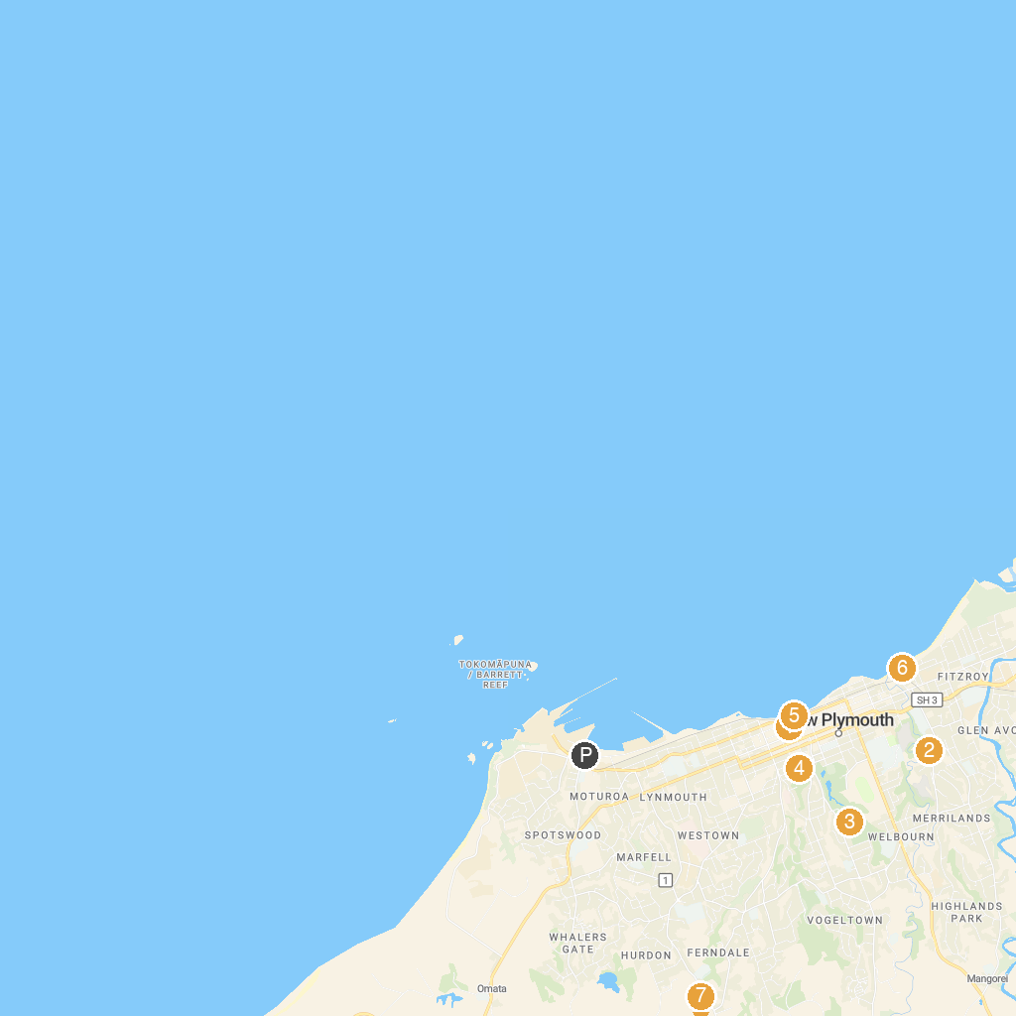
MAP KEY
1. Puke Ariki | 5. Coastal Walkway Foreshore
2. Te Kainga Marire | 6. Fitzroy Park
3. Brooklands Zoo | 7. Pouakai Zoo
4. New Plymouth Observatory
P. Cruise port / terminal
Map © MapTiler © OpenStreetMap contributors · cruiseports.org

