New London, Connecticut, USA
Where whaling history meets nuclear submarines — New London delivers an authentically gritty New England port call with free military museums, Revolutionary War stories, and lobster rolls around the corner from your gangway.
⚓ Pier (City Pier) · 🕒 Typical call: 6–9 hrs · 💵 USD · 🗣️ English · 🦞 New England seafood
✍️ MY DAY IN PORT (FILL IN)
Ship / Date
In port | arrive ______ · all aboard ______
Booked excursion
Notes / meeting point
GETTING ASHORE
- Docking: City Pier — walk straight ashore into downtown
- Walk to center: 3–5 min up State Street
- Best For: Maritime history, military museums, seafood
- Don't Miss: USS Nautilus — world's first nuclear submarine (free)
GETTING AROUND
- 🚕 Taxi: $8–$12 — Metered taxis serve the port; the drop rate is $3.75 plus mileage. The roughly 1-mile ride to the city center typically
- 📱 Rideshare: ✅ Uber, Lyft
TOP THINGS TO DO
- USS Nautilus & Submarine Force Museum — Tour the world's first nuclear-powered submarine docked in Groton across the river.
- Fort Trumbull State Park — Walk the ramparts of this dramatic Egyptian Revival-style 19th-century fort with sweeping views of the Thames River and your ship.
- US Coast Guard Academy — Visit the free USCG Museum on campus.
- Monte Cristo Cottage — Eugene O'Neill's childhood summer home — the setting for Long Day's Journey Into Night.
- Ocean Beach Park — New London's best beach — half a mile of white sand on Long Island Sound with a boardwalk, pool, and beachside cafe.
BEST WALKS
- Downtown Historic District Walk: 45–60 min | Easy | 0.75 miles — Walk from City Pier up State Street past murals and 19th-century architecture, then along Bank…
- Waterfront to Fort Trumbull: 30 min ride-share + walk | Easy–Moderate | Fort grounds — Take an Uber or walk 25 minutes along the riverfront to Fort Trumbull State Park.
WEATHER · DAYLIGHT · MONEY
Month | High °F | Low °F | Rainy days
May | 71 | 53 | 13
Jul | 82 | 66 | 13
Sep | 77 | 59 | 7
Daylight: May 6:18AM–8:42PM · Jul 6:18AM–9:00PM · Sep 7:15AM–7:41PM
cruiseports.org/new-london-ct · Confirm terminal & all-aboard time with your ship

New London, Connecticut, USA — Port Map
Red = walkable sights · Amber = excursions farther out · P = cruise terminal
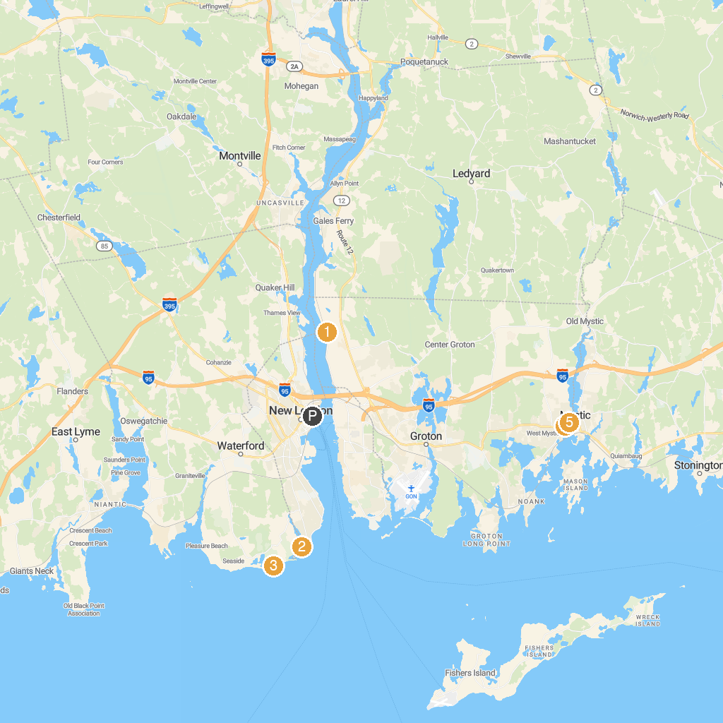
MAP KEY
1. Fort Shantok Archeological District | 5. Ocean Beach Park
2. Mystic Aquarium | 6. Harkness Memorial State Park
3. Race Rock Lighthouse | 7. Mystic Museum of Art
4. Submarine Force Library & Museum | 8. Argia Mystic Cruises
P. Cruise port / terminal
Map © MapTiler © OpenStreetMap contributors · cruiseports.org

