New Bedford, Massachusetts, USA
The Whaling City that made America rich — 19th-century cobblestones, a world-class museum, the nation's top fishing port, and scallops so fresh they barely need seasoning.
⚓ Pier (Pier 3 in 2026) · 🕒 Typical call: 6-8 hrs · 💵 US Dollars · 🗣️ English / Portuguese
✍️ MY DAY IN PORT (FILL IN)
Ship / Date
In port | arrive ______ · all aboard ______
Booked excursion
Notes / meeting point
GETTING ASHORE
- Docking: Pier 3 (temporary 2026 season while State Pier is rebuilt)
- Walk to center: ~0.3 mi / 5-10 min to Whaling National Historical Park
- Best For: American history, Moby-Dick fans, seafood, Portuguese culture
- Don't Miss: New Bedford Whaling Museum — one of the finest maritime museums anywhere
GETTING AROUND
- 🚕 Taxi: $7–$12 — Taxis are available at State Pier for the short ride to downtown. The historic Whaling Museum and waterfront district ar
- 📱 Rideshare: ✅ Uber, Lyft
TOP THINGS TO DO
- New Bedford Whaling Museum — World-class museum with five whale skeletons (including a blue whale), the half-scale Lagoda ship model you can board (the…
- Whaling National Historical Park & Seamen's Bethel — Free ranger-led walking tours of the park cover the architecture, cobblestone streets, and commerce that made New Bedford the…
- Frederick Douglass & the Underground Railroad — New Bedford was known as the 'Fugitive's Gibraltar.' Frederick Douglass fled here in 1838 and found his first paid work on these…
- Portuguese Food & Scallop Trail — New Bedford is the US scallop capital and home to a large Azorean-American community.
- Fort Taber / Fort Rodman Park & Beaches — The southern tip of the city offers panoramic views of Buzzards Bay, Civil War-era fortifications, the dramatic hurricane…
BEST WALKS
- Whaling Heritage Walk: ~1 mile loop | 45-60 min | Easy (but cobblestones) — From the pier, cross Whale's Tooth Bridge into the Whaling National Historical Park.
- Downtown & Rotch-Jones-Duff House: ~0.8 mile | 30-45 min | Easy — From the museum, walk a few blocks to the Rotch-Jones-Duff House & Garden Museum — an 1834 Greek…
WEATHER · DAYLIGHT · MONEY
Month | High °F | Low °F | Rainy days
May | 64 | 51 | 12
Jul | 79 | 67 | 10
Sep | 72 | 61 | 10
Daylight: May 5:24AM–7:56PM · Jul 5:23AM–8:15PM · Sep 6:24AM–6:52PM
cruiseports.org/new-bedford-ma · Confirm terminal & all-aboard time with your ship

New Bedford, Massachusetts, USA — Port Map
Red = walkable sights · Amber = excursions farther out · P = cruise terminal
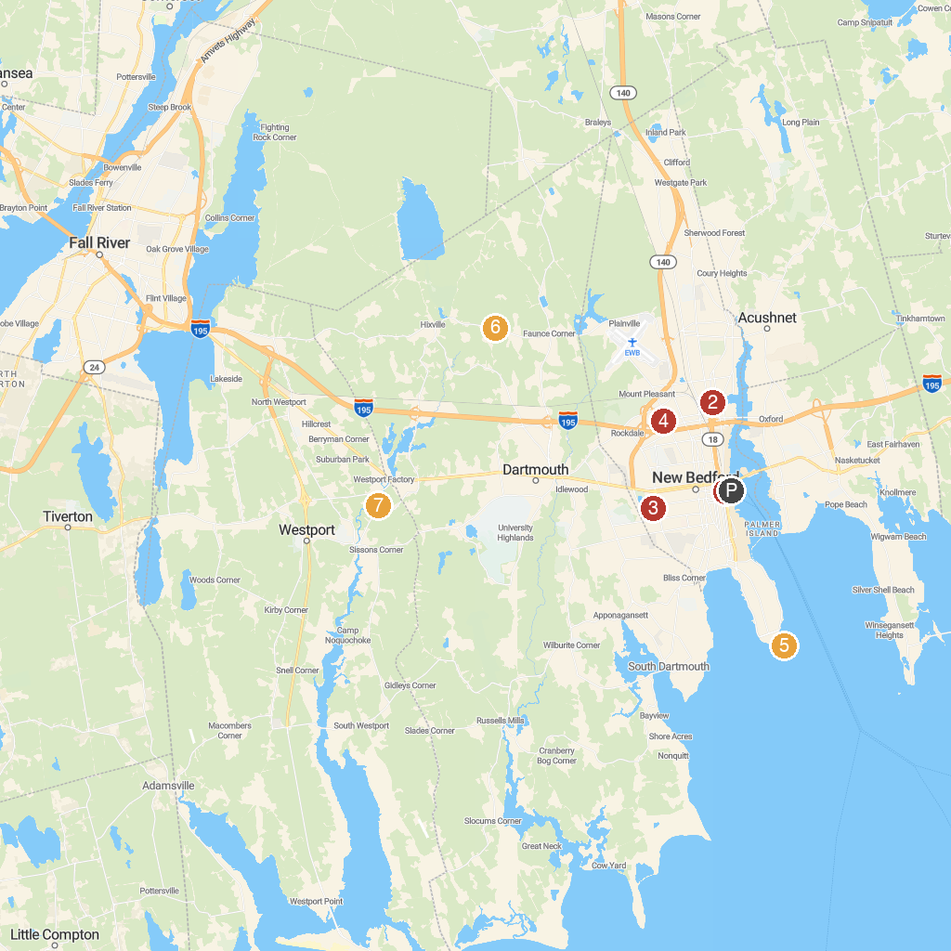
MAP KEY
1. New Bedford Whaling Museum | 5. Fort Rodman
2. St Anthony of Padua Parish | 6. Dartmouth Regional Park & Trails
3. Buttonwood Park | 7. Forge Pond Conservation Area
4. Allen C. Haskell Public Gardens
P. Cruise port / terminal
Map © MapTiler © OpenStreetMap contributors · cruiseports.org

