Nevers, Burgundy, France
A city of potters and pilgrims where the Loire bends through Burgundy — follow the blue line to a Renaissance palace, an incorrupt saint, and some of France's finest ceramics.
⚓ Pier (canal quay) · 🕒 Typical call: 6–8 hrs · 💶 Euro (€) · 🗣️ French
✍️ MY DAY IN PORT (FILL IN)
Ship / Date
In port | arrive ______ · all aboard ______
Booked excursion
Notes / meeting point
GETTING ASHORE
- Docking: Canal quay alongside (hotel barges & small river ships)
- Walk to center: ~1.5 km / 20 min from port; gentle incline into old town
- Best For: History, art, pilgrimage, pottery, local food & wine
- Don't Miss: Saint Bernadette's incorrupt body & Négus de Nevers chocolates
GETTING AROUND
- 🚕 Taxi: €6–€10 — Local taxis serve the port to city center run. Street hailing is unreliable; book in advance through a local taxi compan
- 📱 Rideshare: ✅ Uber
TOP THINGS TO DO
- The Fil Bleu Walking Trail — Follow the blue line painted on Nevers' pavements for a self-guided tour of the Palais Ducal, Porte du Croux, Cathédrale…
- Faïence Pottery Workshop & Museum — Watch master painters hand-decorate cobalt-blue earthenware at Faïencerie Georges, then explore the world-class Musée de la…
- Espace Bernadette Soubirous — Saint-Gildard convent is where Bernadette of Lourdes lived, died, and rests today — her remarkably preserved body in a gilded…
- Cathédrale Saint-Cyr-et-Sainte-Julitte — One of France's most striking cathedrals — Romanesque on one end, Gothic on the other after WWII bombing, filled with vivid…
- Sancerre & Pouilly-Fumé Wine Country — Nevers sits just south of two of the world's most acclaimed Sauvignon Blanc appellations.
BEST WALKS
- Fil Bleu Heritage Loop: 2–3 hrs · 3 km · Easy–moderate — Start at the Porte du Croux medieval tower, follow the blue line past the Palais Ducal, through the…
WEATHER · DAYLIGHT · MONEY
Month | High °F | Low °F | Rainy days
May | 66 | 50 | 12
Jul | 79 | 61 | 9
Sep | 73 | 56 | 10
Daylight: May 6:12AM–9:16PM · Jul 6:08AM–9:38PM · Sep 7:25AM–7:58PM
cruiseports.org/nevers · Confirm terminal & all-aboard time with your ship

Nevers, Burgundy, France — Port Map
Red = walkable sights · Amber = excursions farther out · P = cruise terminal
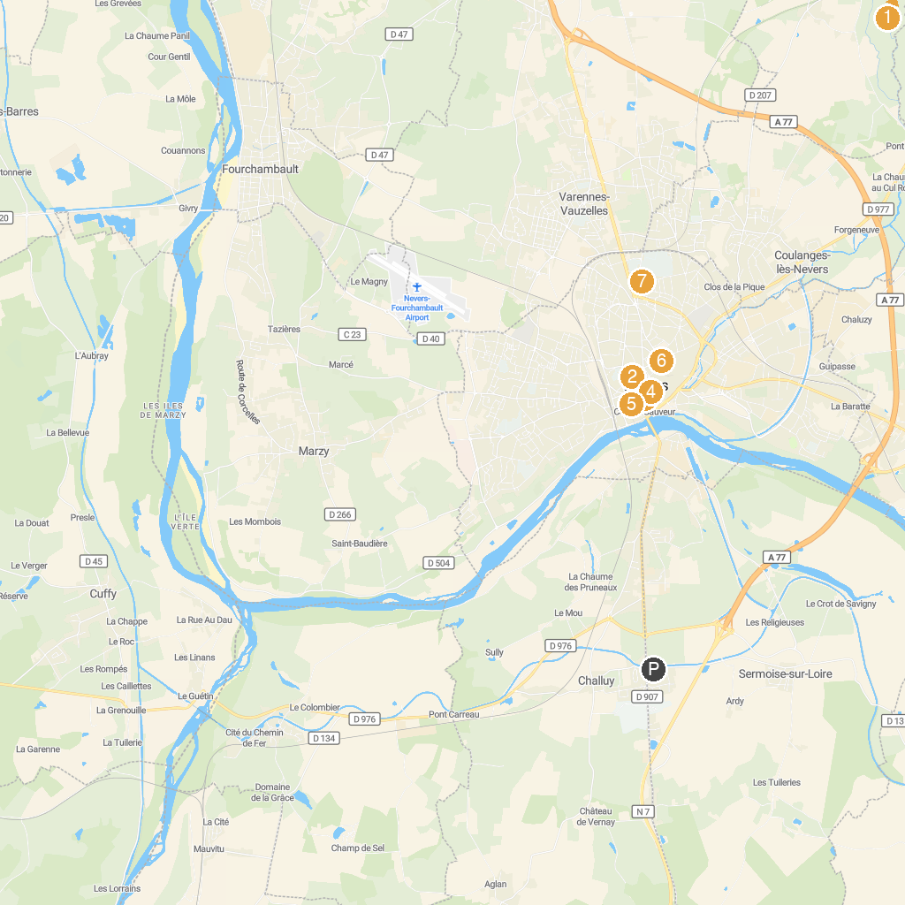
MAP KEY
1. Château des Bordes | 5. Palais ducal de Nevers
2. Parc Roger Salengro | 6. Musée municipal Frédéric Blandin
3. Château d'Apremont-sur-Allier | 7. Porte de Paris
4. Nevers Cathedral | 8. Eglise Sainte Bernadette du Banlay
P. Cruise port / terminal
Map © MapTiler © OpenStreetMap contributors · cruiseports.org

