Neum, Herzegovina-Neretva, Bosnia and Herzegovina
Bosnia's only slice of the Adriatic — a budget-friendly bay town where Balkan flavors meet Mediterranean calm, with Mostar just an hour inland.
⚓ Tender port · 🕒 Typical call: 6-8 hrs · 💵 Bosnian Mark (BAM); euros accepted · 🗣️ Bosnian / Croatian · 🏖️ Pebble beaches
✍️ MY DAY IN PORT (FILL IN)
Ship / Date
In port | arrive ______ · all aboard ______
Booked excursion
Notes / meeting point
GETTING ASHORE
- Docking: Tender — ships anchor in Klek-Neum Bay; 5-10 min boat ride to pier
- Walk to center: Immediate — promenade begins at the tender dock
- Best For: Day trips to Mostar, budget seafood, curious history
- Don't Miss: Ćevapi lunch on the promenade; Mostar's Old Bridge
GETTING AROUND
- 🚕 Taxi: 10–20 KM (~$5–11 USD) — Local taxis are available near the port for short trips within Neum. Fares are metered with a base charge of ~3.50 KM; a
- 📱 Rideshare: ❌ not available
TOP THINGS TO DO
- Mostar & Stari Most — The UNESCO-listed Old Bridge of Mostar is one of the Balkans' most stunning sights.
- Kravice Waterfalls — A stunning natural amphitheater of cascading falls emptying into an emerald swimming lake.
- Ston & Mali Ston (Croatia) — Cross into Croatia to see Europe's longest medieval walls and the oyster farms of Mali Ston Bay.
- Medugorje Pilgrimage — One of Catholicism's most visited pilgrimage sites, where apparitions of the Virgin Mary were reported in 1981.
- Vjetrenica Cave — Bosnia's most important cave system features large chambers, underground rivers, and nearly 200 subterranean species.
BEST WALKS
- Promenade & Town Stroll: 2 km · Flat · 30-45 min — Walk the full length of the seafront promenade from the municipal pier past restaurants, souvenir…
- Stari Neum & Illyrian Fort: 1.5 km uphill · Moderate · 45 min — Climb the steep streets behind the resort strip to reach old Neum's stone houses, the Church of St.
WEATHER · DAYLIGHT · MONEY
Month | High °F | Low °F | Rainy days
May | 72 | 57 | 11
Jul | 89 | 70 | 4
Sep | 79 | 63 | 8
Daylight: May 5:26AM–8:05PM · Jul 5:24AM–8:26PM · Sep 6:29AM–6:59PM
cruiseports.org/neum · Confirm terminal & all-aboard time with your ship

Neum, Herzegovina-Neretva, Bosnia and Herzegovina — Port Map
Red = walkable sights · Amber = excursions farther out · P = cruise terminal
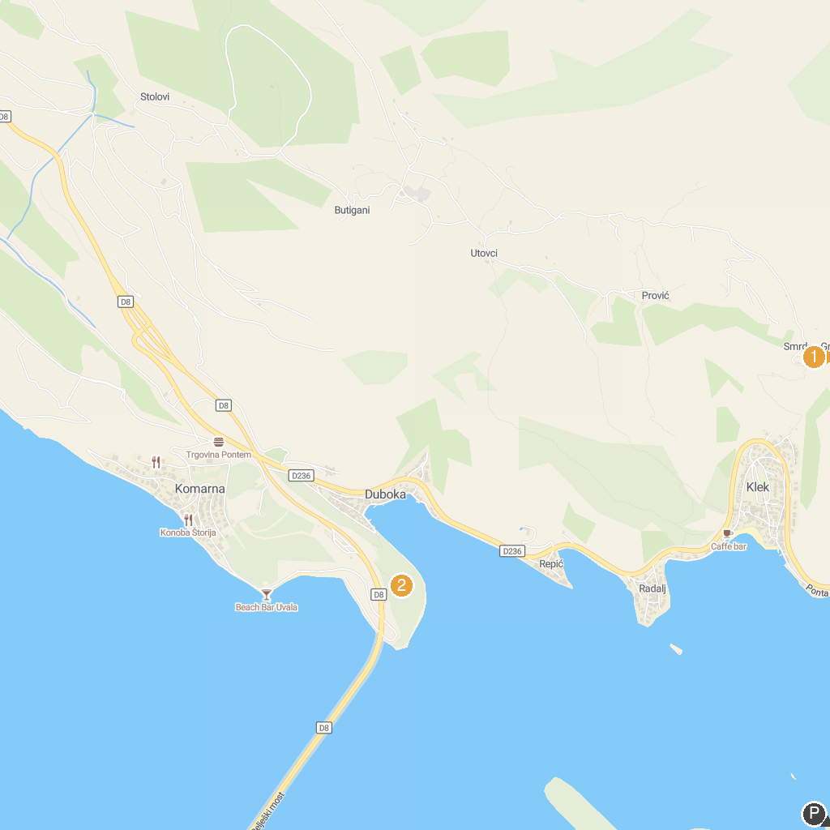
MAP KEY
1. Smrden grad | 2. Anđeo Duje
P. Cruise port / terminal
Map © MapTiler © OpenStreetMap contributors · cruiseports.org

