Nessebar, Black Sea Coast, Bulgaria
Three thousand years of history compressed onto a single peninsula — the UNESCO-listed Old Town of Nessebar delivers medieval Byzantine churches, wooden Revival houses, and clifftop sea views just steps from the pier.
⚓ Mostly docked (tender possible for large ships) · 🕒 Typical call: 6–8 hrs · 💵 Euro (EUR) — adopted Jan 2026 · 🗣️ Bulgarian / English widely spoken
✍️ MY DAY IN PORT (FILL IN)
Ship / Date
In port | arrive ______ · all aboard ______
Booked excursion
Notes / meeting point
GETTING ASHORE
- Docking: Cruise terminal at Old Town entrance; large ships may tender
- Walk to center: 2–5 min to Old Town gate from pier
- Best For: History, Byzantine architecture, cobblestone wandering
- Don't Miss: Church of Saint Stephen's floor-to-ceiling frescoes
GETTING AROUND
- 🚕 Taxi: 7–15 BGN (4–8 EUR) — Local taxis start at 4.50 BGN with 3.00 BGN/km during the day. Apps SB Taxi and Step Taxi allow pre-booking; useful for
- 📱 Rideshare: ❌ not available
TOP THINGS TO DO
- UNESCO Old Town Walking Tour — Thread through 3,000 years of civilisation on a peninsula barely 850 metres long.
- Church of Saint Stephen — Frescoes — The 11th-century New Bishopric's interior is entirely covered in vivid 16th-century frescoes depicting over 1,000 figures.
- Archaeological Museum — At the Old Town entrance, explore Thracian, Greek, and Roman artefacts plus an outstanding collection of Orthodox icons.
- South Beach — Blue Flag Sands — A wide sandy beach on the New Town side with calm, shallow water, sun loungers for rent, and Blue Flag accreditation.
- Sunny Beach Day Trip — Bulgaria's largest resort beach is 5 km north — miles of golden sand, water sports, beach bars, and a lively scene.
BEST WALKS
- Old Town Peninsula Loop: 2–3 hrs · Easy · ~2 km — Start at the ancient fortress walls at the isthmus entrance, pass the iconic windmill, then weave…
- Isthmus to South Beach Stroll: 45 min one way · Easy · ~1.5 km — Cross the narrow isthmus connecting the peninsula to the mainland and continue south along the…
WEATHER · DAYLIGHT · MONEY
Month | High °F | Low °F | Rainy days
May | 69 | 52 | 14
Jul | 82 | 63 | 8
Sep | 75 | 57 | 6
Daylight: May 5:56AM–8:34PM · Jul 5:54AM–8:54PM · Sep 6:59AM–7:28PM
cruiseports.org/nessebar · Confirm terminal & all-aboard time with your ship

Nessebar, Black Sea Coast, Bulgaria — Port Map
Red = walkable sights · Amber = excursions farther out · P = cruise terminal
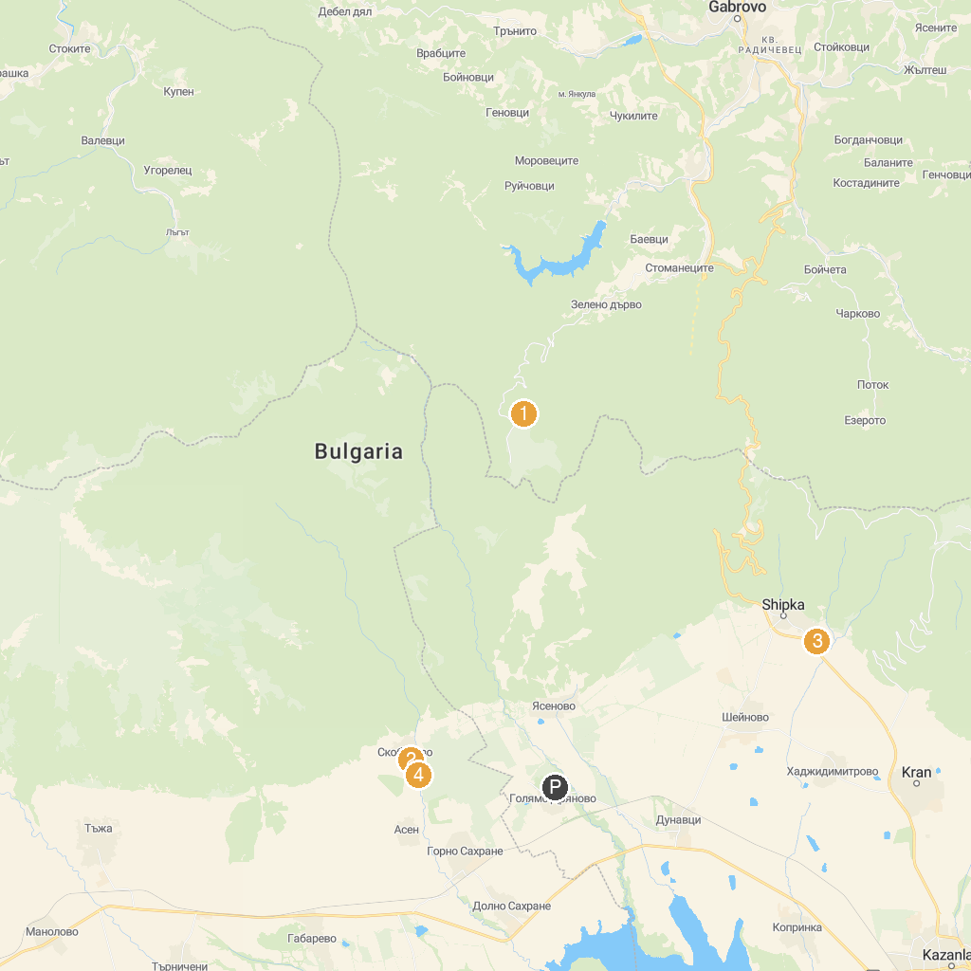
MAP KEY
1. Geographical center of Bulgaria | 5. Museum Chudomir
2. Щраусова ферма "Четири сезона" село Скобелево | 6. Thracian Tomb of Kazanlak
3. Thracian tomb Griffins | 7. Damascena Ethnographic Complex
4. Museum of Roses (Rosarium park)
P. Cruise port / terminal
Map © MapTiler © OpenStreetMap contributors · cruiseports.org

