Nelson, South Island, New Zealand
New Zealand's sunniest city sits at the top of the South Island, ringed by three national parks. It's equal parts art colony, craft brewing hub, and gateway to Abel Tasman's golden beaches.
⚓ Pier (commercial port, shuttle required) · 🕒 Typical call: 8-10 hrs · 💵 NZD — cards accepted everywhere · 🗣️ English · ☀️ Sunshine capital of NZ
✍️ MY DAY IN PORT (FILL IN)
Ship / Date
In port | arrive ______ · all aboard ______
Booked excursion
Notes / meeting point
GETTING ASHORE
- Docking: Pier at Port Nelson (McGlashen Quay); shuttle to city ~10 min
- Walk to centre: Not walkable — active commercial port; free shuttle to i-SITE
- Best For: Abel Tasman day trips, arts & galleries, craft beer, coastal walks
- Don't Miss: Centre of New Zealand hike + Nelson Classic Car Museum + The Free House brewery
GETTING AROUND
- 🚕 Taxi: NZD $13–15 (~USD $8–9) — The city center is about 2.5–3 km from the port. Nelson City Taxis charges a $4.50 NZD flagfall plus $3.40/km, making th
- 📱 Rideshare: ✅ Uber
TOP THINGS TO DO
- Abel Tasman National Park Day Trip — New Zealand's most-visited national park offers golden beaches, turquoise bays, and fur seal colonies.
- Sea Kayaking, Abel Tasman — Paddle sheltered coves past Split Apple Rock and seal colonies at Tonga Island Marine Reserve.
- Centre of New Zealand Walk — A 20–30 min uphill walk through Botanical Reserve leads to the monument marking NZ's trigonometric survey origin point, with 360°…
- Nelson Classic Car Museum — In the suburb of Annesbrook (~5 km from the centre) sits one of Australasia's finest collections — over 150 immaculate vintage…
- Nelson Craft Beer & Hop Farm Trail — Nelson is New Zealand's hop-growing capital.
BEST WALKS
- Trafalgar Street to Christ Church Cathedral: 0.5 km · 10 min · Easy — Walk up Nelson's main street to the landmark Anglican cathedral at the top.
- Queens Gardens & Suter Art Gallery: 0.5 km · 5 min from i-SITE · Easy — Stroll through the Victorian ornamental park with its lily pond and rose garden, then pop into the…
- Botanical Hill — Centre of New Zealand: 3 km return · 1-1.5 hrs · Moderate — Walk or taxi to the base of Botanical Reserve, then climb 20–30 minutes through bush to the survey…
WEATHER · DAYLIGHT · MONEY
Month | High °F | Low °F | Rainy days
May | 59 | 48 | 11
Jul | 54 | 42 | 10
Sep | 58 | 45 | 13
Daylight: May 7:28AM–5:17PM · Jul 7:49AM–5:16PM · Sep 6:28AM–6:16PM
cruiseports.org/nelson-nz · Confirm terminal & all-aboard time with your ship

Nelson, South Island, New Zealand — Port Map
Red = walkable sights · Amber = excursions farther out · P = cruise terminal
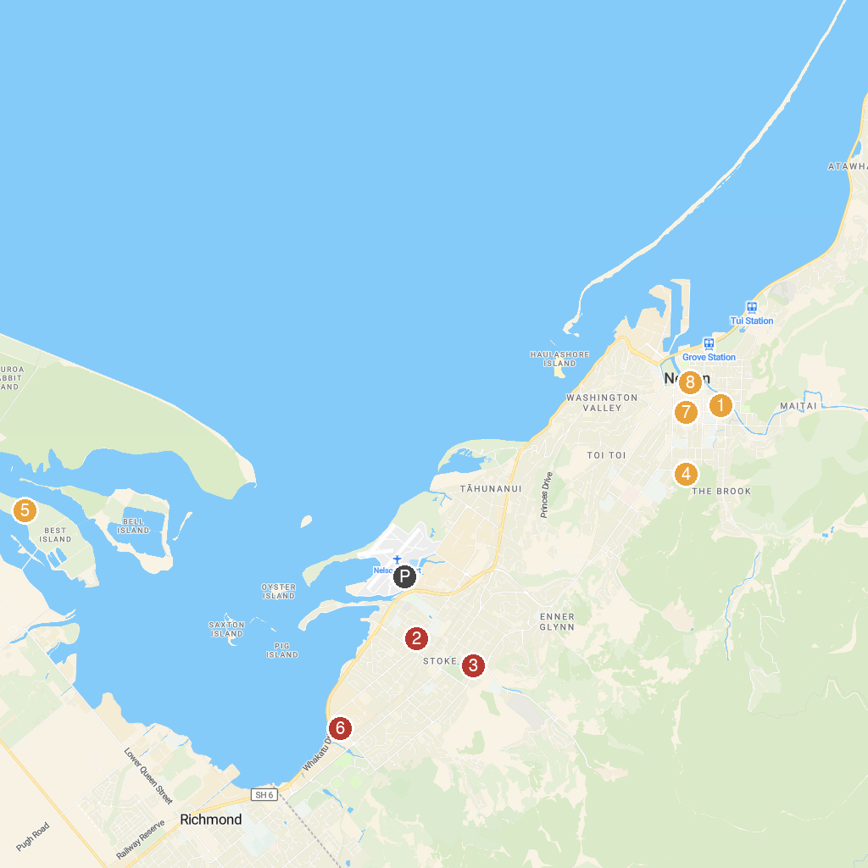
MAP KEY
1. Queen's Gardens | 5. Greenacres Golf Club
2. Broadgreen Historic House | 6. Annesbrook Church
3. Isel House | 7. The Nelson Provincial Museum
4. Fairfield House, Nelson | 8. Maitai Walkway
P. Cruise port / terminal
Map © MapTiler © OpenStreetMap contributors · cruiseports.org

