Nawiliwili, Kauai, Hawaii, USA
Kauai's main cruise harbor opens the door to the Garden Isle — towering Na Pali cliffs, the Grand Canyon of the Pacific, and a beach steps from the pier.
⚓ Docked (pier) · 🕒 Typical call: 8-10 hrs · 💵 USD · 🗣️ English
✍️ MY DAY IN PORT (FILL IN)
Ship / Date
In port | arrive ______ · all aboard ______
Booked excursion
Notes / meeting point
GETTING ASHORE
- Docking: Alongside pier at Nawiliwili Harbor — no tender required
- Walk to center: Kalapaki Beach 10 min; Anchor Cove shops 10 min; Lihue ~2 mi (taxi/rideshare)
- Best For: Helicopter tours, Na Pali Coast sails, Waimea Canyon, beach time
- Don't Miss: Fern Grotto river cruise or a helicopter flight over the Na Pali Coast
GETTING AROUND
- 🚕 Taxi: $15–19 to Lihue town center — Taxis are available at the pier and can reach Lihue town center in about 3 minutes (2 miles). Fares vary by operator.
- 📱 Rideshare: ✅ Uber, Lyft
- 🚌 Hop-on hop-off: ✅ Clark's Hawaii Tours
TOP THINGS TO DO
- Na Pali Coast Snorkel & Sail — Board a catamaran or raft from Port Allen (~35 min drive) and cruise along the dramatic Na Pali cliffs, snorkel pristine reefs…
- Helicopter Tour Over Kauai — See Waialeale Crater, Na Pali Coast, and Waimea Canyon from the air — Kauai's rugged interior is largely inaccessible by road…
- Waimea Canyon Drive — Drive to the 'Grand Canyon of the Pacific' — 3,600 feet deep with vivid red rock walls and lush green ridges.
- Wailua River & Fern Grotto — A peaceful river cruise up the Wailua River to a natural lava-rock fern grotto draped in tropical ferns.
- Poipu Beach Day — Consistently ranked one of America's best beaches, Poipu offers calm swimming, snorkeling, and regular sightings of Hawaiian monk…
BEST WALKS
- Pier to Kalapaki Beach: 0.5 mi · 10 min · Easy — Walk from the pier exit along the harbor road to Kalapaki Beach — a crescent of calm sand with…
- Kalapaki to Anchor Cove & Lihue Center: 0.7 mi · 15 min · Easy — From Kalapaki Beach stroll along Rice Street to Anchor Cove Shopping Center and Harbor Mall for…
WEATHER · DAYLIGHT · MONEY
Month | High °F | Low °F | Rainy days
May | 78 | 71 | 23
Jul | 81 | 74 | 24
Sep | 82 | 75 | 23
Daylight: May 5:58AM–7:09PM · Jul 6:03AM–7:23PM · Sep 6:24AM–6:39PM
cruiseports.org/nawiliwili · Confirm terminal & all-aboard time with your ship

Nawiliwili, Kauai, Hawaii, USA — Port Map
Red = walkable sights · Amber = excursions farther out · P = cruise terminal
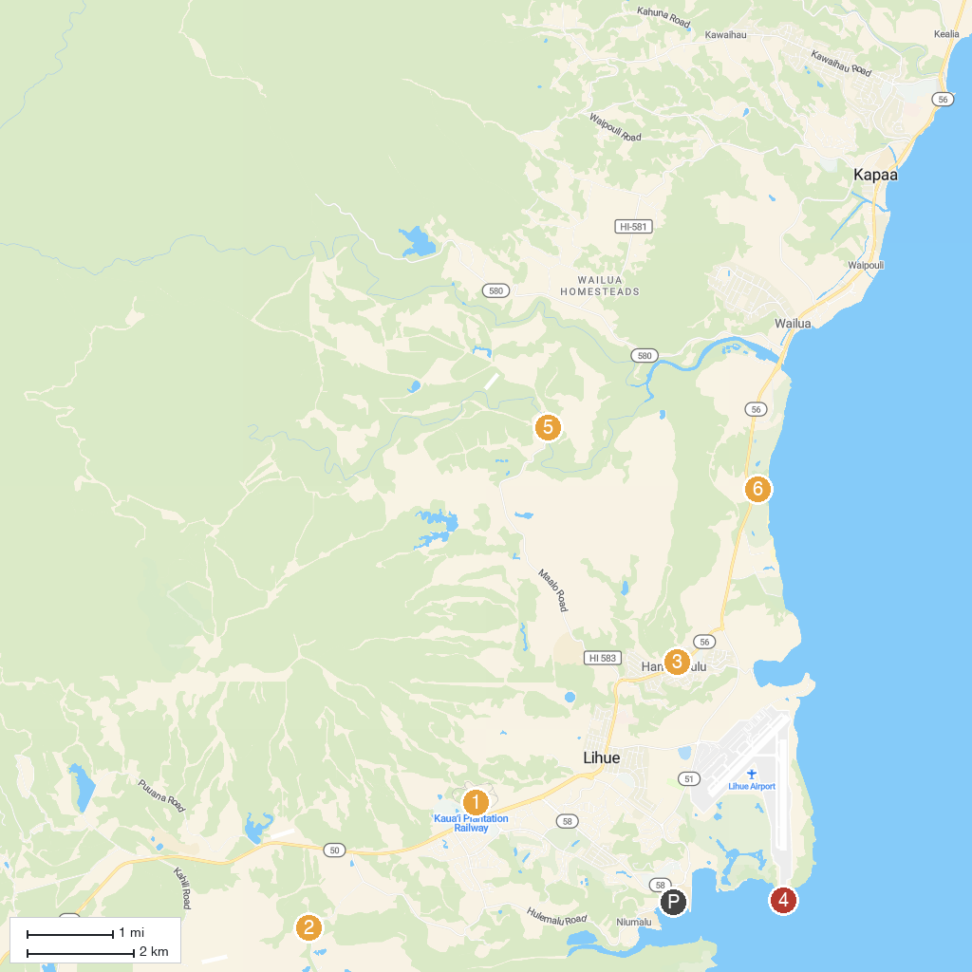
MAP KEY
1. Kilohana | 5. Wailua Falls
2. Kipu Ranch Adventures | 6. Kapa'a Beach Park
3. Kauai Backcountry Adventures | 7. Wailua Golf Course
4. Ninini Point Lighthouse
P. Cruise port / terminal
Map © MapTiler © OpenStreetMap contributors · cruiseports.org

