Natal, Rio Grande do Norte, Brazil
Brazil's sunniest city sits where a star-shaped Portuguese fort guards the mouth of the Potengi River. Beyond the port, enormous white sand dunes, warm Atlantic waters, and one of the world's great seafood restaurants await.
⚓ Pier (docked) · 🕒 Typical call: 8-10 hrs · 💵 Brazilian Real (BRL) · 🗣️ Portuguese
✍️ MY DAY IN PORT (FILL IN)
Ship / Date
In port | arrive ______ · all aboard ______
Booked excursion
Notes / meeting point
GETTING ASHORE
- Docking: Pier at Porto de Natal on the Potengi River — no tendering
- Walk to center: Ribeira historic district is adjacent but not recommended on foot; take Uber to Ponta Negra (~25 min)
- Best For: Dune buggies, beach days, seafood, colonial history
- Don't Miss: Genipabu dunes buggy ride and lunch at Camarões Potiguar
GETTING AROUND
- 🚕 Taxi: R$22–40 (USD $4–8) — The cruise terminal is in central Natal, so taxis are very short trips. Metered fares start at ~R$5.10 base plus R$3.50/
- 📱 Rideshare: ✅ Uber, 99
TOP THINGS TO DO
- Genipabu Dune Buggy — Massive white dunes north of the Potengi River are Natal's signature experience.
- Forte dos Reis Magos — A star-shaped Portuguese fort built in 1598 on a reef where the Potengi River meets the Atlantic.
- World's Largest Cashew Tree — A single cashew tree in Pirangi do Norte covers an area the size of two football fields due to a rare genetic mutation.
- Ponta Negra Beach Day — Natal's best beach for cruise visitors — a lively boardwalk, beach kiosks with chairs and umbrellas, warm clear water, and…
- Northeastern Brazilian Seafood Lunch — Lunch at Camarões Potiguar in Ponta Negra is an essential Natal experience — one of Brazil's top seafood restaurants.
BEST WALKS
- Ponta Negra Boardwalk & Morro do Careca: Easy · ~1.5 km · Flat seafront — Take an Uber to Ponta Negra beach, then stroll the palm-lined Avenida Erivan França boardwalk.
- Forte dos Reis Magos & Ribeira Waterfront: Easy · ~1 km · Historic waterfront — Uber to Forte dos Reis Magos on the reef at the river mouth.
WEATHER · DAYLIGHT · MONEY
Month | High °F | Low °F | Rainy days
May | 83 | 75 | 21
Jul | 81 | 72 | 21
Sep | 83 | 74 | 12
Daylight: May 5:21AM–5:12PM · Jul 5:32AM–5:21PM · Sep 5:14AM–5:17PM
cruiseports.org/natal · Confirm terminal & all-aboard time with your ship

Natal, Rio Grande do Norte, Brazil — Port Map
Red = walkable sights · Amber = excursions farther out · P = cruise terminal
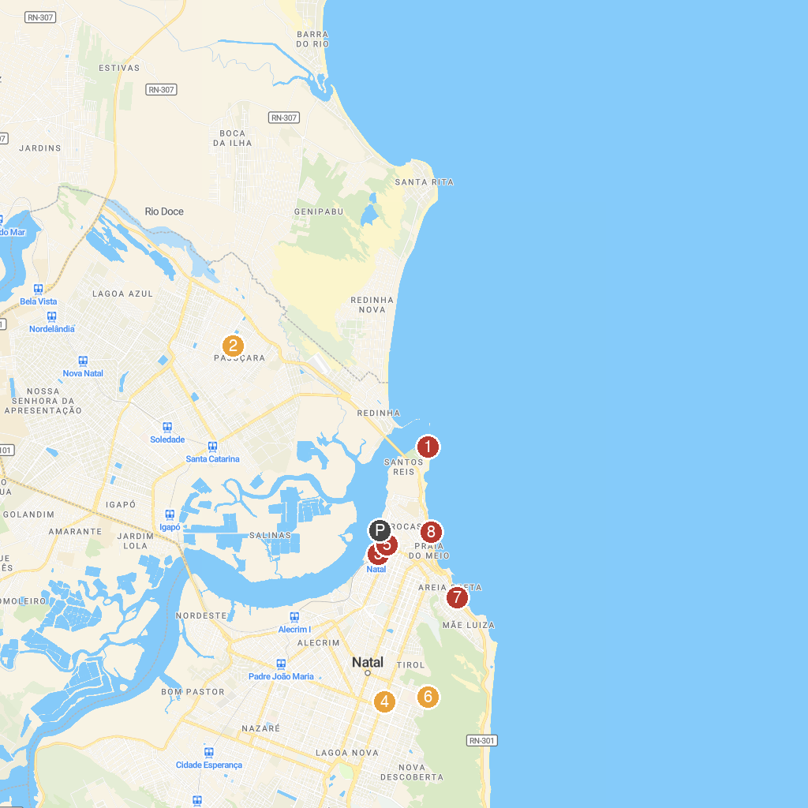
MAP KEY
1. Fortaleza dos Reis Magos | 5. Paróquia do Bom Jesus das Dores
2. Paróquia Santuário Nossa Senhora de Fátima | 6. Bosque dos Namorados do Parque das Dunas
3. Popular Culture Museum Djalma Maranhão | 7. Letreiro da Cidade de Natal
4. Museu de Minérios do RN | 8. Estátua de Iemanjá
P. Cruise port / terminal
Map © MapTiler © OpenStreetMap contributors · cruiseports.org

