Nassau, New Providence, Bahamas
One of the world's busiest cruise ports drops you steps from a pastel colonial capital — Atlantis gleams across the harbor on Paradise Island, pristine Cable Beach stretches west, and the Fish Fry serves the best conch you'll eat anywhere.
⚓ Docked — Prince George Wharf · 🕒 Typical call: 7-10 hrs · 💵 USD accepted everywhere (BSD = USD) · 🗣️ English
✍️ MY DAY IN PORT (FILL IN)
Ship / Date
In port | arrive ______ · all aboard ______
Booked excursion
Notes / meeting point
GETTING ASHORE
- Docking: Prince George Wharf — walk off the ship into downtown Nassau in under 2 minutes
- Walk to center: Straw Market: immediate; Parliament Square: 5-7 min; Queen's Staircase: 15-20 min
- Best For: Atlantis Resort day passes, Blue Lagoon Island, colonial history, duty-free shopping, Bahamian conch cuisine
- Don't Miss: Arawak Cay (the Fish Fry) — cracked conch and conch salad served from colorful shacks a short jitney ride west of the pier
GETTING AROUND
- 🚕 Taxi: $6 for 2 passengers to city center; $3/extra passenger — Government-regulated fixed fares are posted at the port — no meters, rates are by destination. Confirm the fare before g
- 📱 Rideshare: ❌ not available
TOP THINGS TO DO
- Atlantis Aquaventure Day Pass — The mega-resort on Paradise Island opens its 141-acre Aquaventure water park, the Dig marine habitat aquarium, and multiple…
- Blue Lagoon Island Beach Day — A 30-minute catamaran from the pier deposits you on a gorgeous private island with calm turquoise water, white sand, beach…
- Pearl Island Beach Resort Day Pass — A smaller, less-crowded private island alternative with pristine snorkeling just off the beach, a historic lighthouse, and day…
- Snorkeling at the Sea Gardens Reef — Boat trips to Nassau's shallow reef gardens take 20 minutes and put you above healthy coral heads, sergeant majors, parrotfish…
- Colonial Nassau Walking Tour — Parliament Square's pastel Georgian government buildings, the Pirates of Nassau Museum (an interactive deep-dive into Nassau's…
BEST WALKS
- Downtown Nassau Heritage Loop: 2-3 hrs · ~3.5 km · Moderate · Mostly flat with some uphill near the fort — Nassau's best colonial sights in a single loop from the pier.
- Bay Street Waterfront & Junkanoo Beach Stroll: 1.5 hrs · ~2.5 km · Easy · Flat waterfront walk — A relaxed walk west from the pier along Nassau's main commercial strip.
WEATHER · DAYLIGHT · MONEY
Month | High °F | Low °F | Rainy days
May | 82 | 76 | 16
Jul | 87 | 81 | 17
Sep | 86 | 80 | 18
Daylight: May 6:24AM–7:46PM · Jul 6:29AM–8:01PM · Sep 6:55AM–7:12PM
cruiseports.org/nassau · Confirm terminal & all-aboard time with your ship

Nassau, New Providence, Bahamas — Port Map
Red = walkable sights · Amber = excursions farther out · P = cruise terminal
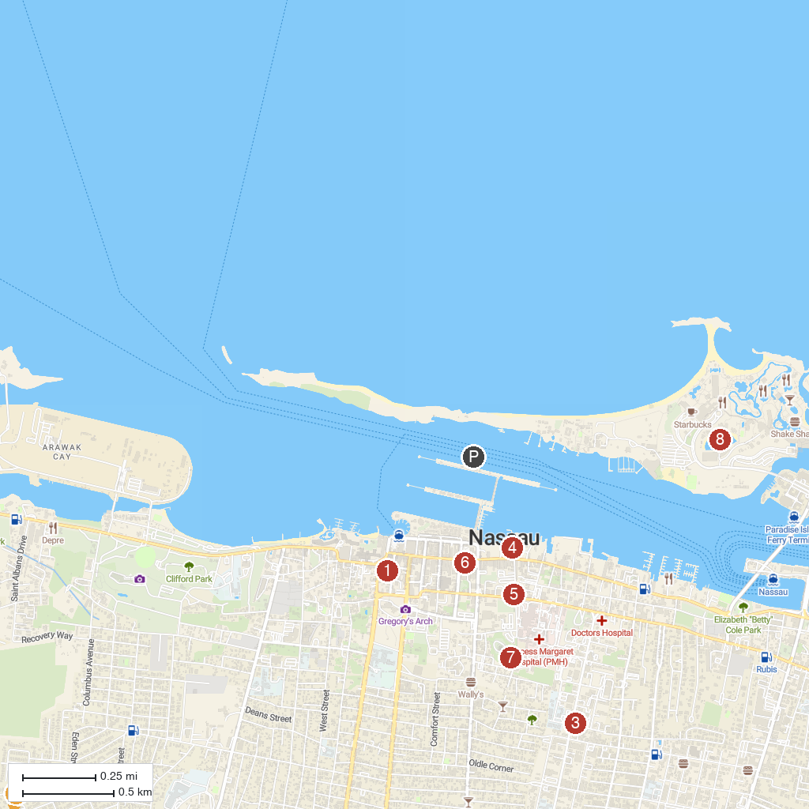
MAP KEY
1. Pirates of Nassau | 5. Bahamas Historical Society
2. Jamaa' Ahlus-Sunnah Bahamas | 6. Parliament Square
3. Evangelistic Temple | 7. Fort Fincastle Water Tower
4. Bahamas Jet Boat | 8. Dolphin Cay Atlantis
P. Cruise port / terminal
Map © MapTiler © OpenStreetMap contributors · cruiseports.org

