Nashville, Tennessee, USA
River cruise ships tie up right at the foot of Broadway — minutes from neon-lit honky tonks, legendary music museums, and Nashville hot chicken. Music City delivers more per block than almost anywhere in America.
⚓ Pier (Riverfront Park floating dock) · 🕒 Typical call: 8–12 hrs or overnight · 💵 USD · 🗣️ English · 🎸 River cruise port (Cumberland River)
✍️ MY DAY IN PORT (FILL IN)
Ship / Date
In port | arrive ______ · all aboard ______
Booked excursion
Notes / meeting point
GETTING ASHORE
- Docking: Floating pier at Nashville Riverfront Park, 1st Ave N & Broadway
- Walk to Broadway: 2 min (1 block) to Lower Broadway honky tonks
- Best For: Country music history, live bands, Southern food, walkable downtown
- Don't Miss: Ryman Auditorium, Country Music Hall of Fame, Nashville hot chicken
GETTING AROUND
- 🚕 Taxi: base + .50/mile — Nashville taxis use metered fares set by Metro Nashville. Useful for reaching areas beyond downtown such as East Nashvil
- 📱 Rideshare: ✅ Uber, Lyft
- 🚌 Hop-on hop-off: ✅ Old Town Trolley Tours / Gray Line Nashville
TOP THINGS TO DO
- Country Music Hall of Fame & Museum — The world's largest popular music museum houses millions of artifacts — stage costumes, instruments, and memorabilia from…
- Ryman Auditorium Tour — The 'Mother Church of Country Music' — former home of the Grand Ole Opry since 1943.
- Johnny Cash & Patsy Cline Museums — Two intimate, well-researched museums share a building on 3rd Ave.
- Nashville Hot Chicken on Broadway — Nashville's signature dish — cayenne-battered fried chicken with heat levels from mild to 'shut the cluck up.' Hattie B's and…
- Lower Broadway Honky Tonks — Live country music starts at 10 AM and runs until 3 AM in the neon-lit bars of Lower Broadway.
BEST WALKS
- Broadway & the Music Corridor: 1.2 miles round-trip | Easy | 45–60 min — Walk from the dock up to Broadway, stroll the honky tonk strip west to the Country Music Hall of…
- Riverfront to Seigenthaler Bridge: 0.8 miles round-trip | Easy | 30 min — Walk south along the riverfront path to the John Seigenthaler Pedestrian Bridge for the best…
WEATHER · DAYLIGHT · MONEY
Month | High °F | Low °F | Rainy days
May | 78 | 59 | 12
Jul | 89 | 71 | 16
Sep | 83 | 65 | 8
Daylight: May 5:40AM–7:46PM · Jul 5:42AM–8:04PM · Sep 6:30AM–6:53PM
cruiseports.org/nashville-tn · Confirm terminal & all-aboard time with your ship

Nashville, Tennessee, USA — Port Map
Red = walkable sights · Amber = excursions farther out · P = cruise terminal
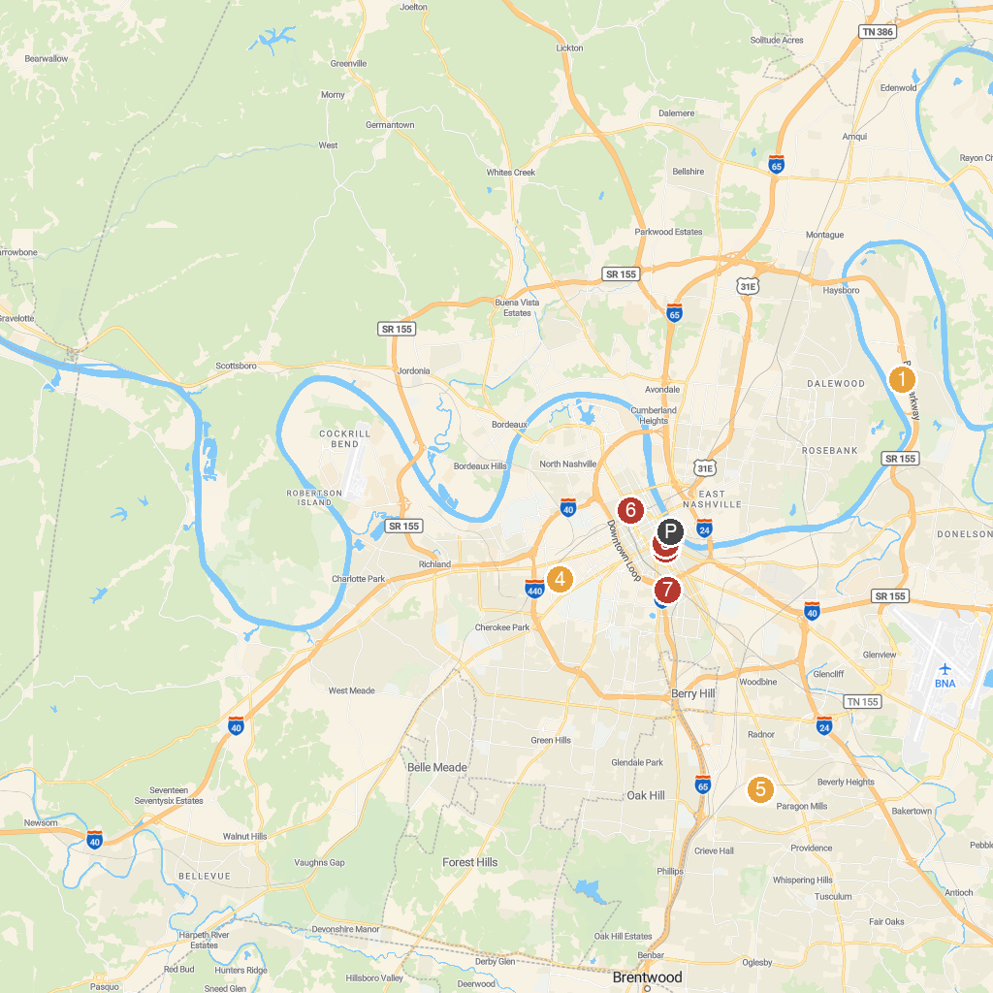
MAP KEY
1. Grand Ole Opry | 5. Nashville Zoo at Grassmere
2. Country Music Hall of Fame and Museum | 6. NashTrash Tours
3. Nashville Symphony Schermerhorn Symphony Center | 7. Adventure Science Center
4. The Parthenon
P. Cruise port / terminal
Map © MapTiler © OpenStreetMap contributors · cruiseports.org

