Narvik, Nordland, Norway
Deep inside the Arctic Circle, Narvik sits where Swedish iron ore meets an ice-free fjord — a town forged by industry and shaped forever by the fierce 1940 Battle of Narvik. Big views, big history, and one of Norway's most dramatic train rides await.
⚓ Pier (docked) · 🕒 Typical call: 6-8 hrs · 💵 Norwegian Krone (NOK) — nearly cashless · 🗣️ Norwegian / English widely spoken · ☀️ Midnight Sun (late May–July)
✍️ MY DAY IN PORT (FILL IN)
Ship / Date
In port | arrive ______ · all aboard ______
Booked excursion
Notes / meeting point
GETTING ASHORE
- Docking: Pier — Fagerneskaia (Fagernes Quay), 150 m berth completed 2019
- Walk to center: ~1.5 km (15–20 min), flat and paved along the waterfront
- Best For: WWII history buffs, scenic rail journeys, Arctic panoramas
- Don't Miss: Narvik War Museum and the Narvikfjellet Gondola summit views
GETTING AROUND
- 🚕 Taxi: 150–190 NOK (~$14–18 USD) — Narvik Taxi serves the port with metered fares. The 2 km ride to city center costs roughly 150–190 NOK. Book via phone (
- 📱 Rideshare: ❌ not available
TOP THINGS TO DO
- Narvik War Museum — One of Norway's best modern museums, dedicated to the 1940 Battle of Narvik — a fierce two-month Arctic campaign (9 April – 8…
- Narvikfjellet Gondola — A modern cable car lifts you 656 m above sea level for sweeping panoramas of the Ofotfjord, surrounding peaks, and the town below.
- Ofoten Railway (Ofotbanen) — Opened in 1902 to haul Swedish iron ore to the sea, the Ofoten Line clings dramatically to mountain cliffs above the fjord.
- Polar Park Day Trip — The world's northernmost wildlife park, about 65 km (40 miles) northeast of Narvik in the Salangsdalen valley (Bardu).
- Fjord & Coastal Scenic Drive — Small-group minivan tours take you along the dramatic Ofotfjord coastline, through Skjomen valley, and to viewpoints inaccessible…
BEST WALKS
- Pier to Town Center Highlights: 2 km | ~30–40 min | Easy, flat — Walk from Fagerneskaia along the main road to Narvik Torg (town square), where the Peace Monument…
- Hike to Narvikfjellet (Free Alternative): 3 km one way | 2–3 hrs | Strenuous, uphill — Skip the gondola fee and hike the marked trail from the cable car base station up to the…
WEATHER · DAYLIGHT · MONEY
Month | High °F | Low °F | Rainy days
May | 45 | 36 | 17
Jul | 63 | 53 | 15
Sep | 53 | 44 | 18
Daylight: Sep 6:06AM–7:21PM
cruiseports.org/narvik · Confirm terminal & all-aboard time with your ship

Narvik, Nordland, Norway — Port Map
Red = walkable sights · Amber = excursions farther out · P = cruise terminal
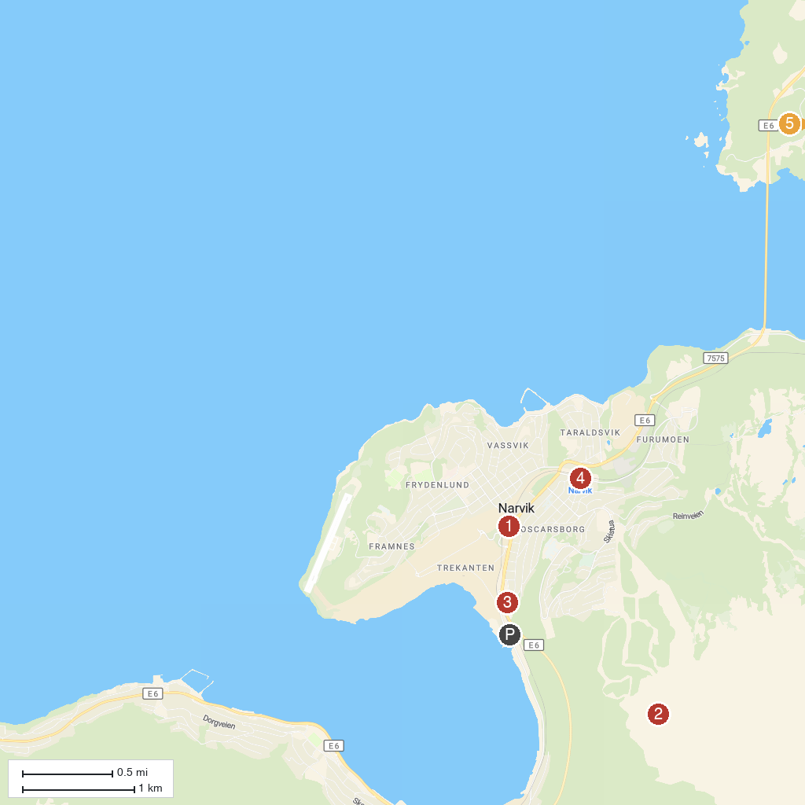
MAP KEY
1. Narvik War Museum | 4. Arctic Train
2. Fjellheisstasjonen Narvik | 5. Narvikin näköalapaikka
3. Narvik Museum
P. Cruise port / terminal
Map © MapTiler © OpenStreetMap contributors · cruiseports.org

