Naples, Campania, Italy
Europe's most chaotic, beautiful, and delicious port city. Naples is the gateway to Pompeii and the Amalfi Coast — but it rewards those who slow down and eat.
⚓ Docked — Stazione Marittima · 🕒 Typical call: 8-12 hrs · 💶 Currency: Euro (€) · 🗣️ Language: Italian · 🍕 Food city
✍️ MY DAY IN PORT (FILL IN)
Ship / Date
In port | arrive ______ · all aboard ______
Booked excursion
Notes / meeting point
GETTING ASHORE
- Docking: Stazione Marittima, central Naples — walkable to the historic centre
- Walk to center: 10-15 min on foot to Piazza del Plebiscito and Via Toledo
- Best For: History buffs (Pompeii), foodies, Amalfi Coast day-trippers
- Don't Miss: Pizza at a historic centre pizzeria — this is where pizza was born
GETTING AROUND
- 🚕 Taxi: €10–€15 — Metered taxis available at the port exit; fixed urban fares apply to major city-center destinations. Confirm the fare be
- 📱 Rideshare: ✅ Uber, Free Now
- 🚌 Hop-on hop-off: ✅ City Sightseeing Naples
TOP THINGS TO DO
- Pompeii & Herculaneum — The ancient Roman cities buried by Vesuvius in 79 AD are UNESCO World Heritage Sites and among the best-preserved archaeological…
- Amalfi Coast Drive — The cliff-hugging road linking Positano, Amalfi, and Ravello is one of Italy's most scenic drives.
- Island of Capri — The legendary island with its Blue Grotto sea cave, designer boutiques, and dramatic clifftop views.
- Naples Historic Centre Walk — The centro storico is a UNESCO World Heritage Site in its own right.
- Mount Vesuvius Hike — Take the Circumvesuviana to Ercolano, then a bus up to the crater rim of Europe's only active mainland volcano.
BEST WALKS
- Spaccanapoli & the Historic Centre: 2.5 km · ~1.5 hrs · Easy-moderate (some hills) — Walk from the waterfront up through Piazza del Plebiscito, past the Royal Palace, then plunge into…
- Lungomare Waterfront Stroll: 3 km · ~45 min · Easy — Head south along the seafront Lungomare Caracciolo to Castel dell'Ovo, the oldest castle in Naples…
WEATHER · DAYLIGHT · MONEY
Month | High °F | Low °F | Rainy days
May | 71 | 56 | 11
Jul | 86 | 70 | 4
Sep | 79 | 65 | 9
Daylight: May 5:45AM–8:13PM · Jul 5:44AM–8:32PM · Sep 6:43AM–7:11PM
cruiseports.org/naples · Confirm terminal & all-aboard time with your ship

Naples, Campania, Italy — Port Map
Red = walkable sights · Amber = excursions farther out · P = cruise terminal
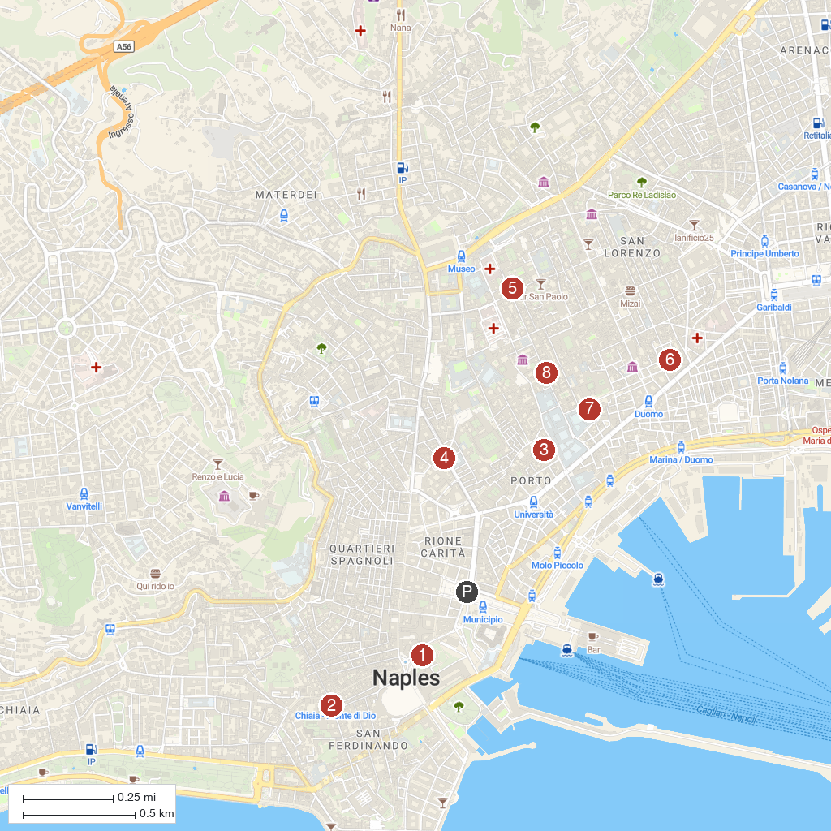
MAP KEY
1. San Carlo Theatre | 5. Chiesa di Santa Maria Regina Coeli
2. Basilica di Santa Maria degli Angeli a Pizzofalcone | 6. Chiesa di Sant'Agostino alla Zecca
3. Basilica San Giovanni Maggiore | 7. Church of Saints Marcellinus and Festus
4. Fontana di Carlo II | 8. Statua del Dio Nilo
P. Cruise port / terminal
Map © MapTiler © OpenStreetMap contributors · cruiseports.org

