Napier, Hawke's Bay, New Zealand
Rebuilt overnight after a 1931 earthquake, Napier emerged as one of the world's most cohesive Art Deco cities — all pastel facades, sunken gardens, and vine-laced hills rolling to the sea.
⚓ Pier (docked, shuttle required) · 🕒 Typical call: 8-10 hrs · 💵 NZD — cards accepted everywhere · 🗣️ English · 🍷 Hawke's Bay wine region
✍️ MY DAY IN PORT (FILL IN)
Ship / Date
In port | arrive ______ · all aboard ______
Booked excursion
Notes / meeting point
GETTING ASHORE
- Docking: Pier at Napier Port; free shuttle ~10 min to city centre (walking the port is prohibited)
- Walk to centre: 0 min from shuttle drop-off at Marine Parade i-SITE; CBD is flat and compact
- Best For: Art Deco architecture, Hawke's Bay wine, Cape Kidnappers gannets, waterfront strolls
- Don't Miss: Self-guided Art Deco walk on Emerson & Tennyson Streets; MTG Hawke's Bay earthquake exhibit (free)
GETTING AROUND
- 🚕 Taxi: NZ–15 — Taxis cannot access the cruise wharf directly; take the free shuttle to the i-SITE first. Local operators include Hawke'
- 📱 Rideshare: ✅ Uber
- 🚌 Hop-on hop-off: ✅
TOP THINGS TO DO
- Guided Art Deco Walking Tour — Expert local guides from the Art Deco Trust lead you through Napier's remarkable 1930s streetscapes, explaining the earthquake…
- Cape Kidnappers Gannet Safari — A 4WD overland safari to the world's largest and most accessible mainland Australasian gannet colony.
- Hawke's Bay Winery Lunch — Hawke's Bay produces some of New Zealand's finest Syrah and Chardonnay.
- Napier Prison Tour — New Zealand's oldest prison, established 1862, sits on the side of Bluff Hill.
- National Aquarium of New Zealand — A 1.5-million-litre oceanarium with a walk-through shark tunnel, little blue penguins, and nocturnal kiwi birds — a great option…
BEST WALKS
- Art Deco Quarter Self-Guided Walk: 1–2 hrs · Flat · Free — Start at the i-SITE on Marine Parade, walk up Emerson Street to the Art Deco Centre on Tennyson…
- Marine Parade Waterfront Stroll: 45 min · Flat · Free — Head south from the i-SITE along Marine Parade to the National Aquarium.
- Bluff Hill Lookout: 1–1.5 hrs return · Steep · Free — A genuine climb up the hill east of the CBD rewards you with panoramic views over Napier Port (you…
WEATHER · DAYLIGHT · MONEY
Month | High °F | Low °F | Rainy days
May | 63 | 50 | 8
Jul | 56 | 45 | 10
Sep | 60 | 47 | 13
Daylight: May 7:09AM–5:07PM · Jul 7:29AM–5:07PM · Sep 6:13AM–6:02PM
cruiseports.org/napier · Confirm terminal & all-aboard time with your ship

Napier, Hawke's Bay, New Zealand — Port Map
Red = walkable sights · Amber = excursions farther out · P = cruise terminal
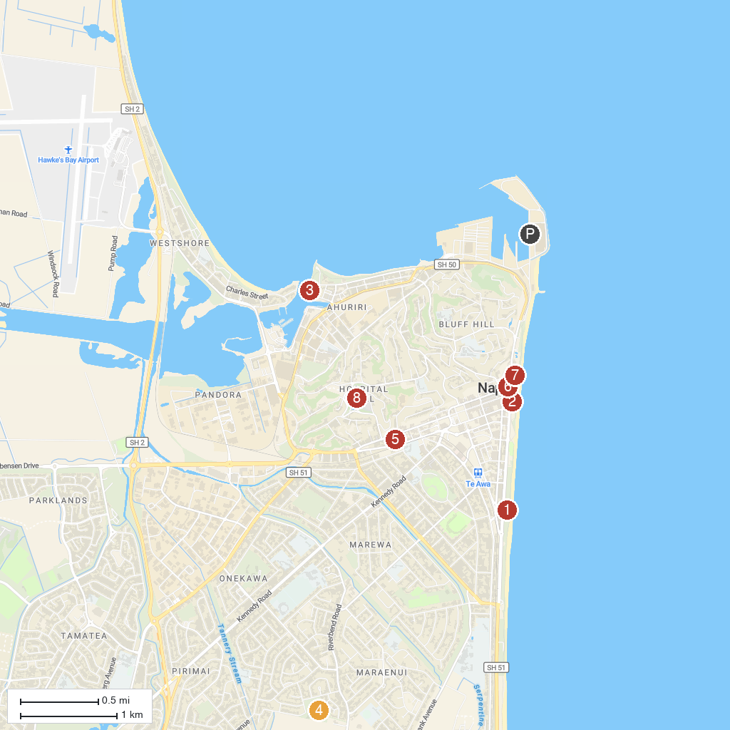
MAP KEY
1. National Aquarium of New Zealand | 5. Faraday Museum of Technology
2. Napier isite Visitor Information Centre | 6. Hawke's Bay Museum
3. Ahuriri Estuary | 7. Tom Parker Fountain
4. Maraenui Park | 8. Botanical gardens
P. Cruise port / terminal
Map © MapTiler © OpenStreetMap contributors · cruiseports.org

