Napa, California, USA
America's wine capital turns cruise day into a world-class food-and-wine walkabout — step off the ship and into the vineyards.
⚓ River dock at Cuttings Wharf (small ships) / via San Francisco · 🕒 Typical call: 8-10 hrs (overnight on some itineraries) · 💵 USD · 🗣️ English · 🍷 Small-ship river cruise destination
✍️ MY DAY IN PORT (FILL IN)
Ship / Date
In port | arrive ______ · all aboard ______
Booked excursion
Notes / meeting point
GETTING ASHORE
- Docking: Pier — small ships tie up on the lower Napa River (Cuttings Wharf area, ~7 mi south of downtown)
- Walk to center: Not walkable from the river dock — shuttle/coach into downtown Napa (~7 mi)
- Best For: Wine tasting, farm-to-table dining, riverfront walks
- Don't Miss: Oxbow Public Market, the Napa Valley Wine Train
GETTING AROUND
- 🚕 Taxi: $10–20 for short local trips — Local taxis are available but less common than rideshare. Short downtown trips are affordable; longer trips to Yountvill
- 📱 Rideshare: ✅ Uber, Lyft
TOP THINGS TO DO
- Downtown Tasting Room Crawl — Over 20 tasting rooms sit within a 10-block radius of the dock.
- Napa Valley Wine Train — A ~3-hour, 36-mile round trip up the valley to St.
- Oxbow Public Market — Napa's beloved indoor market features Hog Island Oyster Co., Gott's Roadside burgers, The Model Bakery, artisan cheese, and local…
- Napa River Gondola Ride — Drift down the Napa River in an authentic Venetian-style gondola, complete with a singing gondolier.
- Castello di Amorosa Winery — A meticulously built replica of a 13th-century Tuscan castle near Calistoga, complete with drawbridge, dungeon, and cave cellars…
BEST WALKS
- Napa Riverfront Promenade: 1.5 miles · Flat · 30–45 min — Walk the paved riverfront path from the Main Street Dock past Angele Restaurant, the Oxbow Public…
- Downtown Tasting Room Loop: 1 mile · Flat · Self-paced — From the dock, head up Main Street and loop through First and Second streets to discover 20+…
WEATHER · DAYLIGHT · MONEY
Month | High °F | Low °F | Rainy days
May | 76 | 52 | 3
Jul | 86 | 57 | 0
Sep | 85 | 57 | 1
Daylight: May 5:57AM–8:13PM · Jul 5:58AM–8:31PM · Sep 6:51AM–7:16PM
cruiseports.org/napa-ca · Confirm terminal & all-aboard time with your ship

Napa, California, USA — Port Map
Red = walkable sights · Amber = excursions farther out · P = cruise terminal
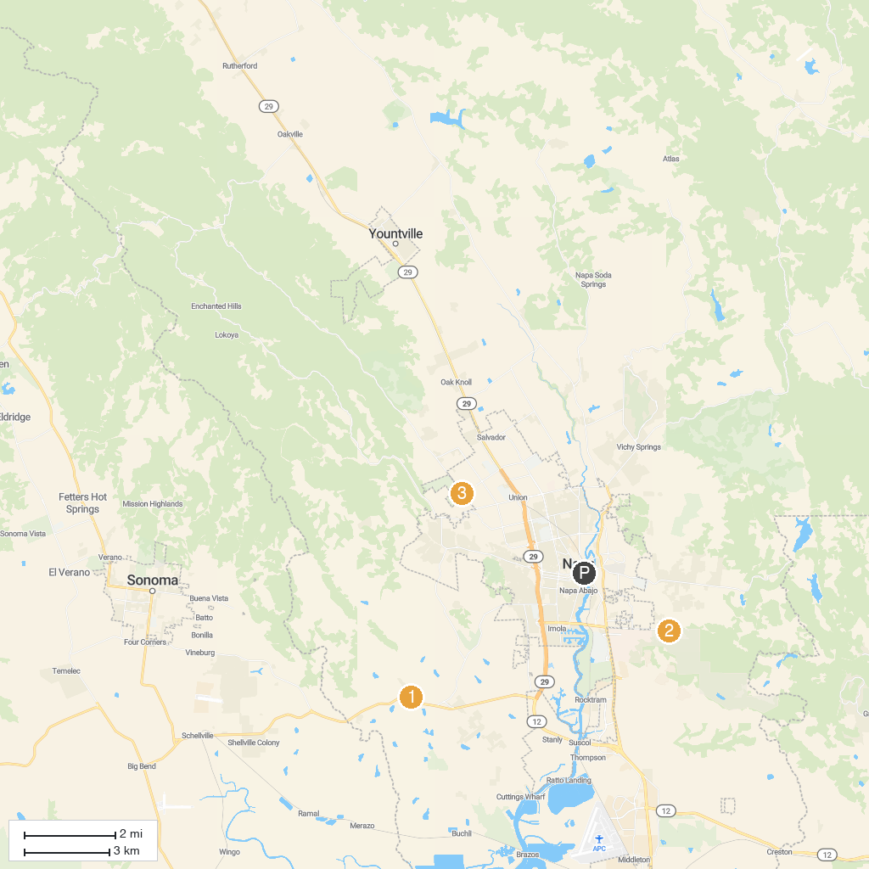
MAP KEY
1. di Rosa Center for Contemporary Art | 4. Alston Park
2. Skyline Wilderness Park | 5. Sonoma State Historic Park
3. Napa Valley Casino
P. Cruise port / terminal
Map © MapTiler © OpenStreetMap contributors · cruiseports.org

