Nantucket, Massachusetts, USA
America's 'Grey Lady' is a living museum of cobblestone streets, weathered-shingle cottages, and one of the world's great whaling collections — all a short tender ride from your ship.
⚓ Tender port (no cruise pier) · 🕒 Typical call: 7–9 hrs · 💵 USD · 🗣️ English · 🚴 30+ miles of bike paths
✍️ MY DAY IN PORT (FILL IN)
Ship / Date
In port | arrive ______ · all aboard ______
Booked excursion
Notes / meeting point
GETTING ASHORE
- Docking: Tender — ships anchor offshore; 15–25 min ride to Straight Wharf
- Walk to center: 2 min from tender landing to Main Street
- Best For: History lovers, walkers, seafood fans, beach seekers
- Don't Miss: Nantucket Whaling Museum + the Brant Point penny tradition
GETTING AROUND
- 🚕 Taxi: (1 pax, in-town); +/additional pax — Licensed taxis are available at stands near Hy-Line Dock and at the bottom of Main Street. Official in-town rate is for
- 📱 Rideshare: ✅ Uber, Lyft
TOP THINGS TO DO
- Nantucket Whaling Museum — The island's crown jewel: nine galleries tracing Nantucket's era as the world's whaling capital, anchored by a 46-foot sperm…
- Brant Point Lighthouse Walk — A flat, scenic 20-minute walk from the tender landing brings you to America's second-oldest lighthouse station.
- Jetties Beach — The best beach for cruise passengers — calm harbor-side waters, facilities, chair rentals, and The Sandbar restaurant right on…
- Siasconset Bluff Walk — Take the Wave shuttle to the village of Siasconset on the island's eastern tip, then walk the coastal bluff path past…
- Main Street Food Crawl — Queue at The Juice Bar for homemade ice cream, grab a famous sandwich at Provisions on the wharf ('Turkey Terrific' is…
BEST WALKS
- Historic District Loop: 1.5 miles · Easy · ~45 min — The classic Nantucket walk.
- Harbor to Brant Point: 2 miles round-trip · Easy · ~1 hr — From the tender landing, walk north along the harbor past Children's Beach to Brant Point…
WEATHER · DAYLIGHT · MONEY
Month | High °F | Low °F | Rainy days
May | 54 | 50 | 11
Jul | 70 | 67 | 8
Sep | 68 | 64 | 9
Daylight: May 5:21AM–7:52PM · Jul 5:20AM–8:11PM · Sep 6:21AM–6:48PM
cruiseports.org/nantucket-ma · Confirm terminal & all-aboard time with your ship

Nantucket, Massachusetts, USA — Port Map
Red = walkable sights · Amber = excursions farther out · P = cruise terminal
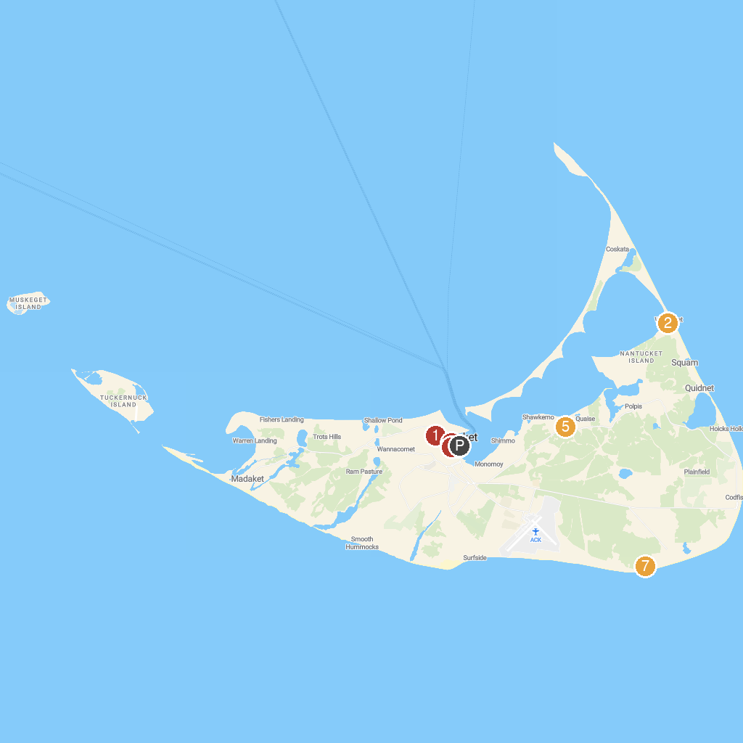
MAP KEY
1. Jethro Coffin House | 5. Nantucket Shipwreck and Life Saving Museum
2. Coskata-Coatue Wildlife Refuge Gatehouse | 6. Nantucket Downtown Historic District
3. Nantucket Whaling Museum | 7. Tom Nevers Field
4. Nantucket By Water
P. Cruise port / terminal
Map © MapTiler © OpenStreetMap contributors · cruiseports.org

