Nantes, Loire-Atlantique, France
Birthplace of Jules Verne and home to a 40-foot walking mechanical elephant, Nantes is France's most eccentric city — a post-industrial port reinvented as a steampunk wonderland of giant machines, medieval castles, and Art Nouveau brasseries.
⚓ Docked (Saint-Nazaire pier) · 🕒 Typical call: 8-10 hrs · 💶 Currency: Euro (€) · 🗣️ Language: French
✍️ MY DAY IN PORT (FILL IN)
Ship / Date
In port | arrive ______ · all aboard ______
Booked excursion
Notes / meeting point
GETTING ASHORE
- Docking: Large ships dock at Saint-Nazaire, 60 km from Nantes city center; river cruise ships dock directly on the Loire quay
- City Transfer: 45-60 min by shuttle or taxi; or taxi to Gare de Saint-Nazaire then 35-min TER train
- Best For: Art lovers, history buffs, foodies, Jules Verne fans
- Don't Miss: The Grand Elephant at Les Machines de l'Île — a 40-ft mechanical beast you can ride
GETTING AROUND
- 🚕 Taxi: €20–€35 — Metered taxis are available at the port and city stands. Daytime rate is approximately €1.78/km with a ~€7 base fare; hi
- 📱 Rideshare: ✅ Uber, Bolt
TOP THINGS TO DO
- Les Machines de l'Île — The former shipyards of the Île de Nantes are now home to a steampunk fantasy world inspired by Jules Verne and da Vinci.
- Château des Ducs de Bretagne — A beautifully preserved 15th-century ducal fortress in the heart of Nantes.
- Follow the Green Line — A literal green stripe painted on Nantes's sidewalks connects every major artistic, historic, and cultural site in the city.
- Passage Pommeraye & Le Bouffay — Nantes's 19th-century covered arcade is one of France's most beautiful — a triple-story glass-roofed gallery with grand…
- Trentemoult Village & Navibus — Hop the Navibus river ferry across the Loire to Trentemoult, a former fishermen's village with narrow lanes of brightly painted…
BEST WALKS
- The Green Line: Castle to Machines: 2-3 km · 45-60 min · Easy — Start at the Château des Ducs de Bretagne, walk through the historic center via Passage Pommeraye…
- Feydeau District & Quays: 1 km · 20-30 min · Easy — Stroll through the historic Feydeau neighborhood — once an island, its 18th-century buildings lean…
WEATHER · DAYLIGHT · MONEY
Month | High °F | Low °F | Rainy days
May | 66 | 51 | 10
Jul | 77 | 61 | 8
Sep | 73 | 57 | 8
Daylight: May 6:30AM–9:35PM · Jul 6:25AM–9:57PM · Sep 7:44AM–8:17PM
cruiseports.org/nantes · Confirm terminal & all-aboard time with your ship

Nantes, Loire-Atlantique, France — Port Map
Red = walkable sights · Amber = excursions farther out · P = cruise terminal
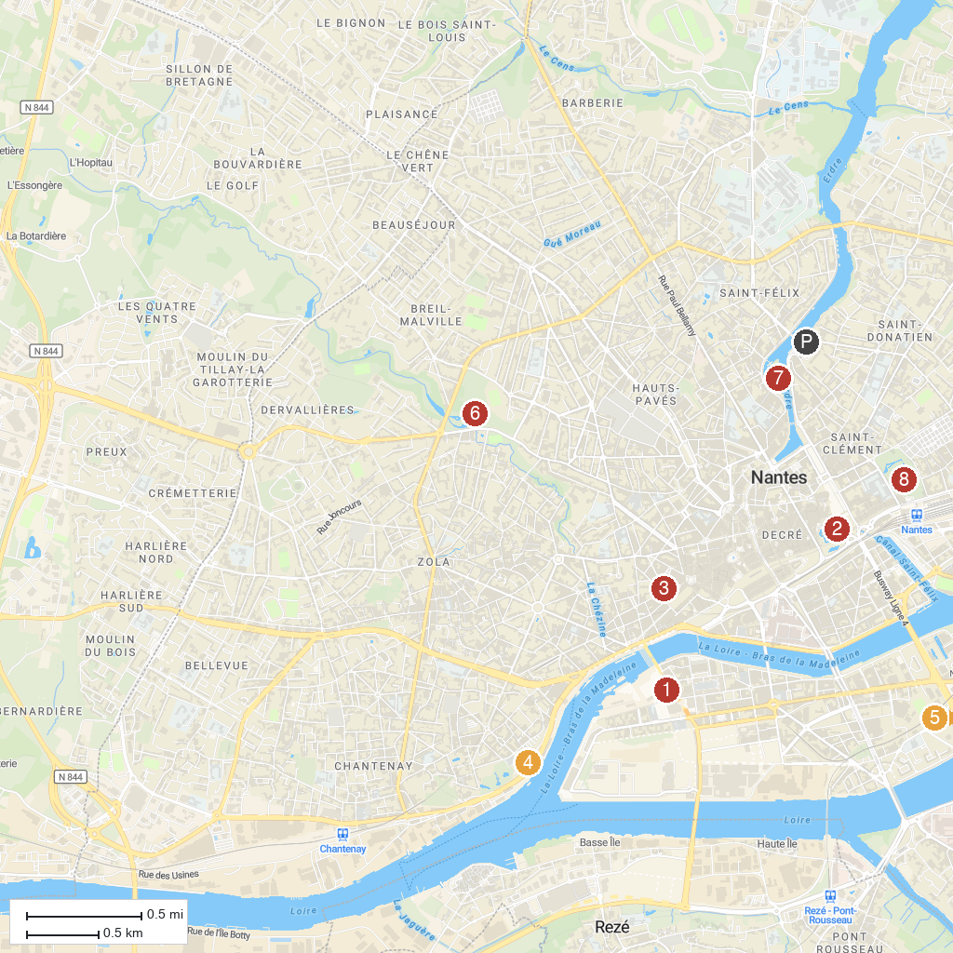
MAP KEY
1. Les Machines de l'Île | 5. Château de Goulaine
2. Château des ducs de Bretagne | 6. Parc de Procé
3. Natural History Museum | 7. Île de Versailles
4. Jules Verne Museum | 8. Botanical Garden
P. Cruise port / terminal
Map © MapTiler © OpenStreetMap contributors · cruiseports.org

