Nancy, Lorraine, France
Home to one of Europe's grandest squares and a thriving Art Nouveau heritage, Nancy rewards river cruise passengers with a walkable baroque city center, gilded ironwork, and unmistakably French cuisine.
⚓ River cruise — docked (Port de Plaisance / canal quay) · 🕒 Typical call: 6–8 hrs · 💶 Currency: Euro (€) · 🗣️ Language: French
✍️ MY DAY IN PORT (FILL IN)
Ship / Date
In port | arrive ______ · all aboard ______
Booked excursion
Notes / meeting point
GETTING ASHORE
- Docking: Docked on Canal de la Marne au Rhin or Meurthe River quay; city center ~10–15 min walk
- Walk to center: Place Stanislas is ~1.2 km from Port de Plaisance — easy flat walk
- Best For: Baroque architecture, Art Nouveau design, French gastronomy, relaxed city walking
- Don't Miss: Place Stanislas at night — free 3D light show (mid-June to mid-September)
GETTING AROUND
- 🚕 Taxi: €8–12 — Taxis available near the port; given the short distance to city center, expect a fare close to the base rate of €8-10.
- 📱 Rideshare: ✅ Uber, Bolt
TOP THINGS TO DO
- Place Stanislas & Baroque Ensemble — The UNESCO-listed Place Stanislas is one of Europe's finest 18th-century squares, framed by gilded wrought-iron gates by Jean…
- École de Nancy Museum (Art Nouveau) — The École de Nancy movement produced some of the most exquisite Art Nouveau furniture, glasswork, and ceramics ever made.
- Musée Lorrain — Housed inside the Ducal Palace, this is one of France's most important regional museums, covering the history and art of the…
- Lorraine Food & Market Walk — Sample the regional specialties that make Nancy famous: Bergamotes de Nancy (bergamot hard candies), original Lorraine macarons…
- Brasserie L'Excelsior — A 1911 Art Nouveau brasserie next to the train station — as much museum as restaurant.
BEST WALKS
- Royal Squares & Old Town Loop: 2–2.5 hrs | 3 km | Easy, flat — Walk from Place Stanislas through the gilded Arc Héré to Place de la Carrière, then explore the old…
- Art Nouveau Trail: 1.5–2 hrs | 2.5 km | Easy — Collect a free map from the Tourist Office and follow the signed Art Nouveau trail through the…
WEATHER · DAYLIGHT · MONEY
Month | High °F | Low °F | Rainy days
May | 65 | 48 | 12
Jul | 77 | 59 | 10
Sep | 70 | 53 | 8
Daylight: May 5:54AM–9:09PM · Jul 5:49AM–9:32PM · Sep 7:12AM–7:47PM
cruiseports.org/nancy · Confirm terminal & all-aboard time with your ship

Nancy, Lorraine, France — Port Map
Red = walkable sights · Amber = excursions farther out · P = cruise terminal
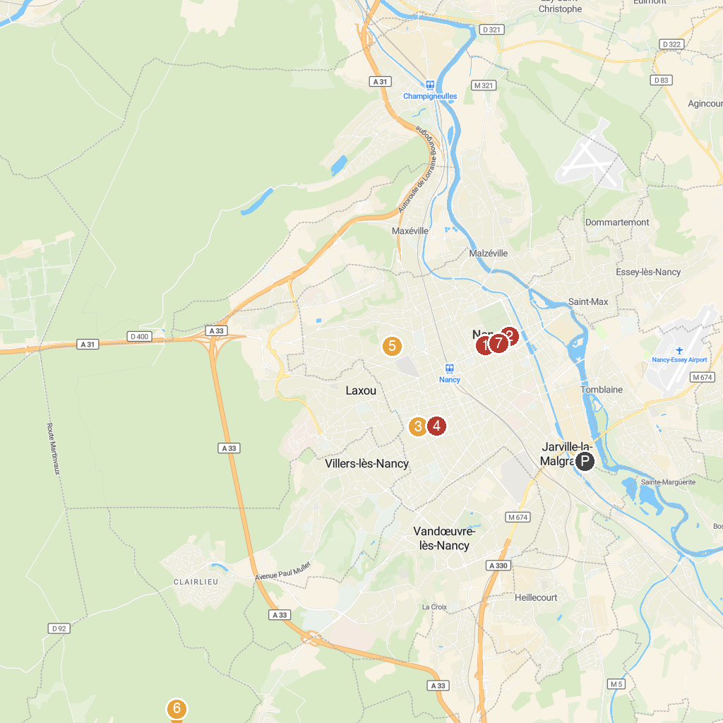
MAP KEY
1. Musée des Beaux-Arts de Nancy | 5. Parc de la Cure d'Air
2. Muséum-Aquarium de Nancy | 6. Mine de Neuves-Maisons (Maron / Val-de-fer)
3. Musée de l'École de Nancy | 7. Alliance Square
4. Saint Mary Park of Nancy
P. Cruise port / terminal
Map © MapTiler © OpenStreetMap contributors · cruiseports.org

