Nanaimo, British Columbia, Canada
Vancouver Island's "Hub City" delivers an authentic Pacific Northwest harbour day — stroll the waterfront to a 170-year-old fort, hunt down the world's best Nanaimo Bar, and ferry over to a car-free island park.
⚓ Pier (dedicated cruise berth) · 🕒 Typical call: 7-9 hrs · 💵 Canadian Dollar (CAD) · 🗣️ English · 🦭 Wildlife: orcas, seals, eagles
✍️ MY DAY IN PORT (FILL IN)
Ship / Date
In port | arrive ______ · all aboard ______
Booked excursion
Notes / meeting point
GETTING ASHORE
- Docking: Dedicated floating pontoon pier — no tendering
- Walk to center: ~15-20 min (1.2 km) along flat waterfront path; free shuttle often available
- Best For: Easy walking, local food & sweets, island day-trip, whale watching
- Don't Miss: The Nanaimo Bar Trail and the noon cannon firing at The Bastion
GETTING AROUND
- 🚕 Taxi: CAD $3.90 flag + ~$2.72/km — Yellow Cab Nanaimo and other local taxis serve the port. Flag fee is CAD $3.90 with CAD $2.72/km thereafter — city cente
- 📱 Rideshare: ✅ Uber
TOP THINGS TO DO
- Nanaimo Bar Trail — Pick up the self-guided map at the pier and hit 30+ stops around town — classic bars, lattes, martinis, cheesecake, and fudge…
- Saysutshun (Newcastle Island) Ferry — A 10-minute foot-passenger ferry from Maffeo Sutton Park drops you on a car-free island provincial park with Snuneymuxw First…
- Whale Watching — Operators depart directly from Nanaimo harbour.
- The Bastion & Nanaimo Museum — Built in 1853 by the Hudson's Bay Company, The Bastion is Nanaimo's most iconic landmark — free to view outside, small fee inside.
- WildPlay Element Park — Ziplining, high-ropes courses, and a 150-foot bungy jump over the Nanaimo River.
BEST WALKS
- Harbourfront Walkway to The Bastion: 2.5 km | ~35 min one-way | Flat, paved — Follow the waterfront path north from the Assembly Wharf past Maffeo Sutton Park, the Sno'uyutth…
- Old City Quarter & Downtown Loop: 3 km | ~45 min | One uphill section — From the Boat Basin, head up the hill into the Old City Quarter's heritage buildings and boutiques…
WEATHER · DAYLIGHT · MONEY
Month | High °F | Low °F | Rainy days
May | 63 | 50 | 9
Jul | 73 | 60 | 5
Sep | 66 | 55 | 12
Daylight: May 5:32AM–8:52PM · Jul 5:27AM–9:15PM · Sep 6:53AM–7:27PM
cruiseports.org/nanaimo-bc · Confirm terminal & all-aboard time with your ship

Nanaimo, British Columbia, Canada — Port Map
Red = walkable sights · Amber = excursions farther out · P = cruise terminal
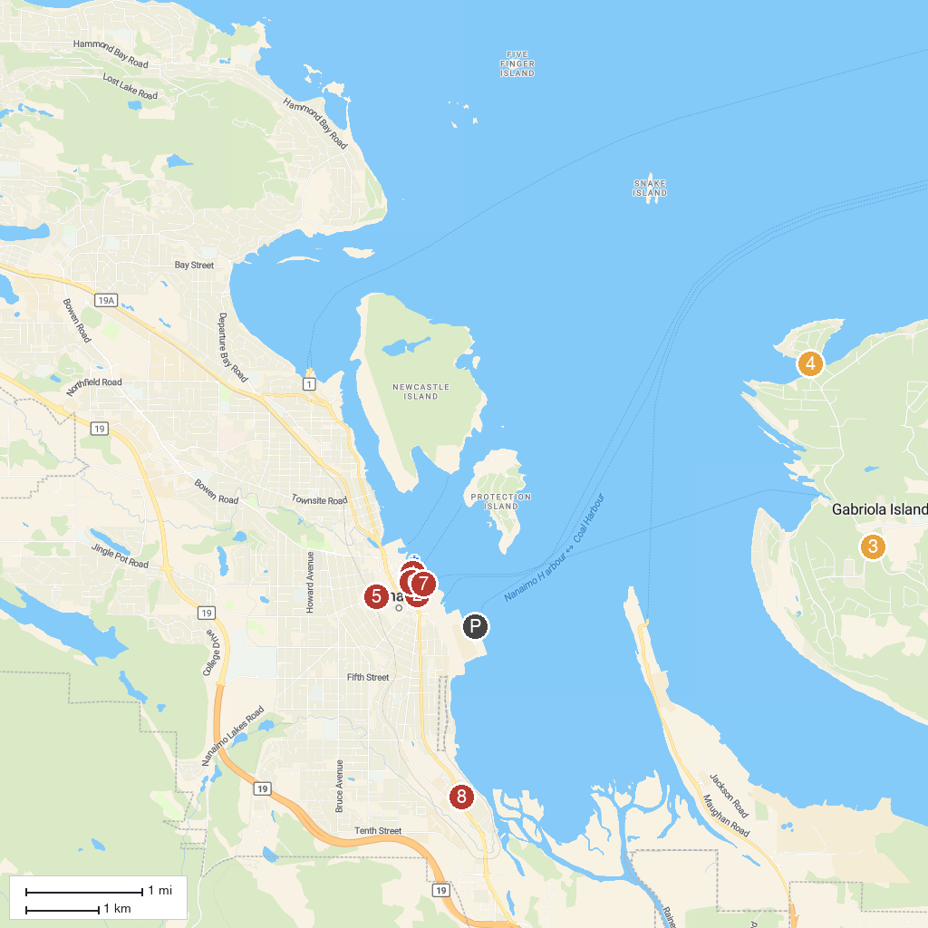
MAP KEY
1. Harbour Air - Nanaimo | 5. Old City Quarter
2. Vancouver Island Military Museum | 6. The Bastion
3. Gabriola Museum | 7. McGregor Park
4. Gabriola Sands Provincial Park | 8. Petroglyph Provincial Park
P. Cruise port / terminal
Map © MapTiler © OpenStreetMap contributors · cruiseports.org

