Namur, Wallonia, Belgium
The snail-paced capital of Wallonia perches at the drama of two rivers meeting beneath a 2,000-year-old citadel — an unhurried gem that rewards the curious shore-day explorer.
⚓ Docked (river quay) · 🕒 Typical call: 6-8 hrs · 💶 Currency: Euro (€) · 🗣️ Language: French
✍️ MY DAY IN PORT (FILL IN)
Ship / Date
In port | arrive ______ · all aboard ______
Booked excursion
Notes / meeting point
GETTING ASHORE
- Docking: Ships tie up along the Quai de Meuse — no tendering
- Walk to center: 5–10 min flat walk to Old Town
- Best For: History, fortress views, Walloon food & beer
- Don't Miss: Citadel underground tunnels & cable car ride up
GETTING AROUND
- 🚕 Taxi: €10–€15 — City-regulated taxis serve the dock area. Short rides within city cost roughly €10–15 during the day; rates increase eve
- 📱 Rideshare: ✅ Uber, Bolt
TOP THINGS TO DO
- Citadel Underground Tour — Descend into 500 m of restored military tunnels for an immersive light-and-sound tour through centuries of sieges and…
- Old Town & Belfry Walk — Wander cobbled lanes past the Baroque Saint-Loup Church, UNESCO-listed Belfry, and neoclassical Saint-Aubain Cathedral.
- Cable Car to the Citadel — Ride the modern Téléphérique from the old town up to the Citadel for sweeping panoramas of the Meuse–Sambre confluence.
- Félicien Rops Museum — A compact museum dedicated to the provocative 19th-century Namur-born artist whose satirical and erotic prints shocked Victorian…
- Day Trip to Dinant — A 30-minute scenic train ride follows the Meuse south to Dinant, where another cliff-top citadel towers over the home town of the…
BEST WALKS
- Old Town to Citadel Loop: 2–3 hrs · Moderate (steep Citadel hill) · Free — Cross the L'Enjambée pedestrian bridge from the dock, stroll through the old town via Place d'Armes…
- Riverside & Old Town Stroll: 1–1.5 hrs · Easy · Free — A flat riverside walk from the dock along the Meuse to the Pont de Jambes, crossing into the old…
WEATHER · DAYLIGHT · MONEY
Month | High °F | Low °F | Rainy days
May | 64 | 47 | 12
Jul | 73 | 58 | 11
Sep | 68 | 53 | 10
Daylight: May 5:52AM–9:21PM · Jul 5:46AM–9:45PM · Sep 7:16AM–7:53PM
cruiseports.org/namur · Confirm terminal & all-aboard time with your ship

Namur, Wallonia, Belgium — Port Map
Red = walkable sights · Amber = excursions farther out · P = cruise terminal
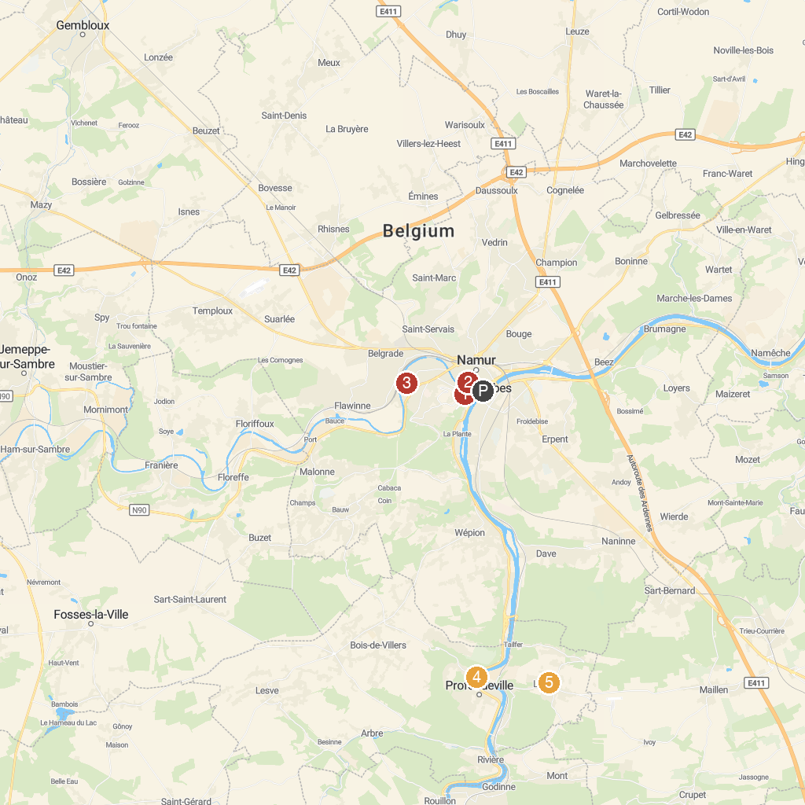
MAP KEY
1. Spy Cave | 5. VTT - Profondeville Autour de l'Eau
2. Citadelle de Namur | 6. La Vieille Boucle Lustinoise
3. Musée Provincial Félicien Rops | 7. Les Jardins d’Annevoie
4. NAM-IP Computer Museum
P. Cruise port / terminal
Map © MapTiler © OpenStreetMap contributors · cruiseports.org

