Namsos, Trøndelag, Norway
Norway's Rock City punches well above its small-town weight — within steps of the pier you'll find a music museum carved from national legend, a mountain with panoramic fjord views, and a fascinating WWII story written into the town's distinctive postwar reconstruction architecture.
⚓ Pier (direct dock) · 🕒 Typical call: 6-8 hrs · 💵 Norwegian Krone (NOK) — cards accepted everywhere · 🗣️ Norwegian / English widely spoken · 🎸 Rock music capital of Norway
✍️ MY DAY IN PORT (FILL IN)
Ship / Date
In port | arrive ______ · all aboard ______
Booked excursion
Notes / meeting point
GETTING ASHORE
- Docking: Pier — kai 68 (turistskipskaia), central waterfront
- Walk to center: 2-5 minutes, flat terrain
- Best For: Music culture, WWII history, fjord scenery, authentic small-town Norway
- Don't Miss: Rock City Namsos museum and the Klompen viewpoint
GETTING AROUND
- 🚕 Taxi: NOK 150–250 — Local taxis (Namsos Taxi SA, TrønderTaxi) serve the area; short in-town rides typically cost NOK 150–250. Book by phone
TOP THINGS TO DO
- Rock City Namsos — Norway's national pop and rock music resource centre.
- Klompen Viewpoint Hike — A 114-metre hill (Klompen, also called Bjørumsklumpen) at the edge of town rewards a 15-20 minute climb with 360-degree views…
- Namdalsmuseet Open-Air Museum — One of Norway's oldest open-air museums, with 20+ historic wooden buildings from the 17th–20th centuries illustrating the…
- Spillum Dampsag — Steam Sawmill — Norway's only major preserved steam-powered sawmill (the Norwegian Sawmill Museum / Norsk Sagbruksmuseum) is a national…
- Oasen Mountain Pool — A spectacular swimming facility carved entirely inside a hollowed-out mountain — 50-metre pool, waterslides, and hot tubs.
BEST WALKS
- Waterfront to Rock City & Town Centre: 45 min | Easy | Flat — From the pier, walk south along the waterfront to Rock City Namsos (5 min).
- Klompen Viewpoint Walk: 1 hr round trip | Moderate | Road or trail — Head from the town centre toward the hill known as Klompen (Bjørumsklumpen).
- Namdalsmuseet Loop: 1 hr walking | Easy | 1 km each way — Walk 1 km from the pier to the Namdal Museum (Namdalsmuseet) open-air site.
WEATHER · DAYLIGHT · MONEY
Month | High °F | Low °F | Rainy days
May | 53 | 39 | 16
Jul | 65 | 52 | 16
Sep | 57 | 46 | 17
Daylight: May 3:55AM–10:27PM · Sep 6:37AM–7:39PM
cruiseports.org/namsos · Confirm terminal & all-aboard time with your ship

Namsos, Trøndelag, Norway — Port Map
Red = walkable sights · Amber = excursions farther out · P = cruise terminal
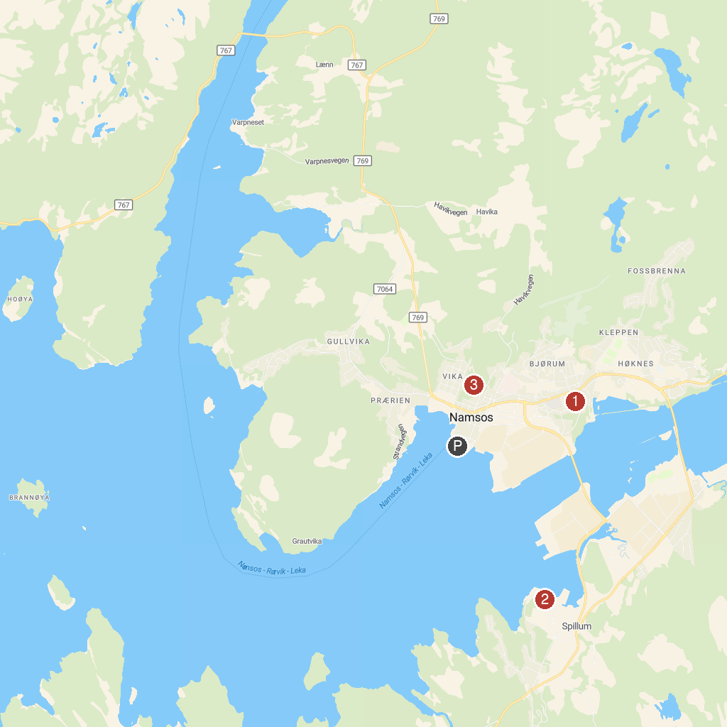
MAP KEY
1. Namdalsmuseet | 3. Bjørumsklompen
2. Norwegian Sawmill Museum
P. Cruise port / terminal
Map © MapTiler © OpenStreetMap contributors · cruiseports.org

