Naha, Okinawa, Japan
Once the heart of the independent Ryukyu Kingdom, Naha blends ancient castle ruins, a buzzing 1.6 km shopping street, and a cuisine shaped by China, the Pacific, and US military presence — all reachable straight from the pier.
⚓ Pier port · 🕒 Typical call: 7-10 hrs · 💴 Currency: Japanese Yen (JPY) · 🗣️ Language: Japanese
✍️ MY DAY IN PORT (FILL IN)
Ship / Date
In port | arrive ______ · all aboard ______
Booked excursion
Notes / meeting point
GETTING ASHORE
- Docking: Pier — Naha Cruise Terminal (Tomari Wharf) or Shinminato Pier; no tendering
- Walk to centre: 20-25 min to Kokusai-dori from Naha Cruise Terminal; Shinminato Pier is not walkable (take ship shuttle or taxi)
- Best For: History, street food, pottery shopping, subtropical beaches
- Don't Miss: Shuri Castle reconstruction, Kokusai-dori, Okinawa soba, Blue Seal beni-imo ice cream
GETTING AROUND
- 🚕 Taxi: ¥1,200–¥2,500 to city center — Taxis reach Kokusai-dori in 10–15 minutes. Fare varies by berth (Wakasa is closer at ~¥1,200; Aja Shinko farther at ~¥2,
TOP THINGS TO DO
- Shuri Castle & Ryukyu Kingdom — The UNESCO-listed palace of the Ryukyu Kingdom was devastated by fire in 2019, but the ongoing reconstruction behind glass…
- Kokusai-dori & Makishi Public Market — Walk Okinawa's 1.6 km 'International Street' — lined with souvenir shops, Orion beer bars, and street food stalls.
- Tsuboya Pottery District (Yachimun-dori) — A quiet cobblestone lane lined with traditional kilns and boutiques producing Okinawa's distinctive Yachimun pottery — bold…
- Naminoue Beach (Walkable City Beach) — The closest beach to the port — about 10 minutes on foot from the Naha Cruise Terminal.
- Toyosaki Chura Sun Beach — Naha's best white-sand beach, south of the city near the airport.
BEST WALKS
- Pier to Kokusai-dori via Naminoue Shrine: 2.5 km · ~35 min · Easy/flat — Head north from the terminal along the waterfront to Naminoue Shrine, perched dramatically on a…
- Fukushuen Chinese Garden Loop: 1.5 km · ~20 min · Easy — A short stroll from the terminal to Fukushuen, a traditional Chinese walled garden built to reflect…
WEATHER · DAYLIGHT · MONEY
Month | High °F | Low °F | Rainy days
May | 78 | 73 | 16
Jul | 86 | 81 | 20
Sep | 85 | 79 | 22
Daylight: May 5:43AM–7:08PM · Jul 5:46AM–7:23PM · Sep 6:15AM–6:33PM
cruiseports.org/naha · Confirm terminal & all-aboard time with your ship

Naha, Okinawa, Japan — Port Map
Red = walkable sights · Amber = excursions farther out · P = cruise terminal
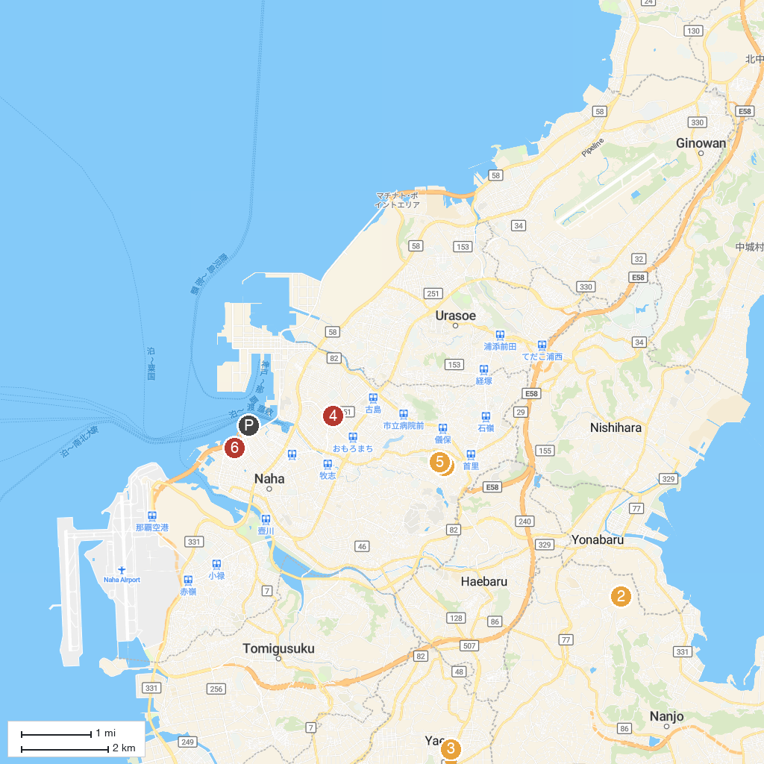
MAP KEY
1. Shuri Castle | 5. Okinawa Prefectural Museum and Art Museum (Okimyu)
2. Cape Kyan | 6. Kyukeimon
3. Ozato Uchibaru Park | 7. Gusuku Road Park
4. Yaese Park | 8. Naminoue Shrine
P. Cruise port / terminal
Map © MapTiler © OpenStreetMap contributors · cruiseports.org

