Nagoya, Aichi, Japan
Birthplace of Japan's three great unifiers and Toyota, Nagoya rewards cruise passengers with golden castle towers, world-class train museums, and a fiercely proud regional food culture — all just a short train ride from the pier.
⚓ Pier (docked) · 🕒 Typical call: 8–10 hrs · 💴 Currency: Japanese Yen (JPY) · 🗣️ Language: Japanese
✍️ MY DAY IN PORT (FILL IN)
Ship / Date
In port | arrive ______ · all aboard ______
Booked excursion
Notes / meeting point
GETTING ASHORE
- Docking: Pier — Kinjo Futo (large ships) or Garden Pier (small/luxury ships)
- Walk to center: Not walkable — 24-min Aonami Line train to Nagoya Station
- Best For: History, technology, Japanese culture, food, families
- Don't Miss: Hommaru Palace inside Nagoya Castle, SCMAGLEV & Railway Park
GETTING AROUND
- 🚕 Taxi: ¥5,500–¥7,000 (~$34–43 USD) — Taxis queue at the pier and are metered. Fare from Kinjo Pier to Nagoya Station runs ¥5,500–¥7,000 depending on traffic.
- 📱 Rideshare: ✅ Uber, GO (JapanTaxi), DiDi
- 🚌 Hop-on hop-off: ✅
TOP THINGS TO DO
- Nagoya Castle & Hommaru Palace — The reconstructed Hommaru Palace inside the castle grounds is a masterpiece of Edo-period craftsmanship — gold-leaf screen…
- Toyota Commemorative Museum of Industry & Technology — Housed in the original red-brick textile factory where Toyota began, this world-class museum traces the company from wooden looms…
- SCMAGLEV and Railway Park — 39 real trains including record-breaking superconducting maglev vehicles, steam locomotives, and Shinkansen.
- Atsuta Jingu Shrine — One of Japan's most sacred Shinto shrines, said to enshrine the Kusanagi legendary sword (one of three Imperial Regalia).
- Nagoya Meshi Food Tour — Osu District — Nagoya has Japan's most distinctive regional food culture.
BEST WALKS
- Sakae & Osu Loop: 2–3 km · Easy · City center — From Sakae Station, admire the futuristic Oasis 21 structure with its elevated water deck, then…
- Nagoya Castle Grounds: 1–2 km · Easy · Historic — Enter through the east gate, explore the Ninomaru Garden, then spend most time inside the Hommaru…
WEATHER · DAYLIGHT · MONEY
Month | High °F | Low °F | Rainy days
May | 75 | 56 | 11
Jul | 86 | 73 | 16
Sep | 82 | 68 | 15
Daylight: May 4:48AM–6:49PM · Jul 4:49AM–7:07PM · Sep 5:35AM–5:59PM
cruiseports.org/nagoya · Confirm terminal & all-aboard time with your ship

Nagoya, Aichi, Japan — Port Map
Red = walkable sights · Amber = excursions farther out · P = cruise terminal
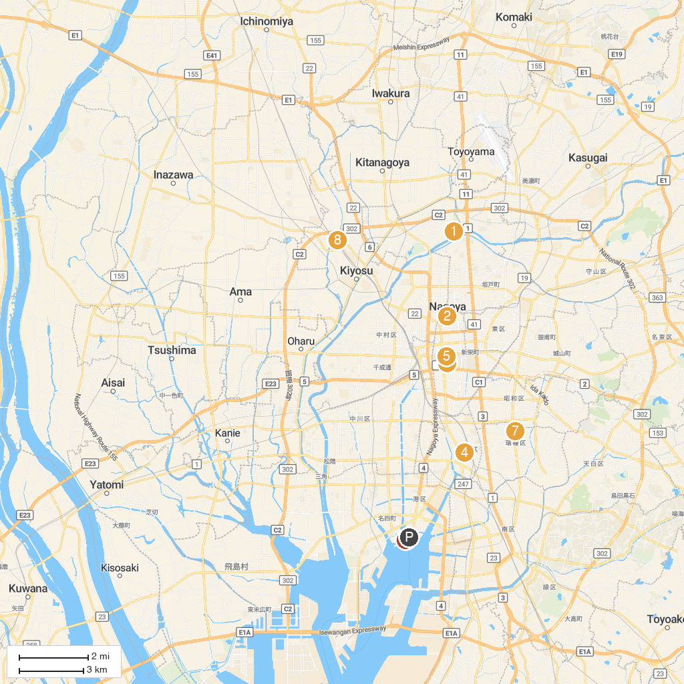
MAP KEY
1. Araizeki Ryokuchi Park | 5. Science Museum of Electricity
2. Nagoya Castle | 6. Port Of Nagoya Public Aquarium
3. FUJI Nagoya Science Museum | 7. Nagoya City Museum
4. Atsuta Jingu | 8. Kiyosu Castle
P. Cruise port / terminal
Map © MapTiler © OpenStreetMap contributors · cruiseports.org

