Naantali, Southwest Finland, Finland
Finland's charming 'Sunshine Town' pairs a medieval cobblestone Old Town with the whimsical world of the Moomins — both within easy walking distance of the pier.
⚓ Pier (docked) · 🕒 Typical call: 6-8 hrs · 💶 Euro (€) · 🗣️ Finnish & Swedish · ☀️ Best Jun–Aug
✍️ MY DAY IN PORT (FILL IN)
Ship / Date
In port | arrive ______ · all aboard ______
Booked excursion
Notes / meeting point
GETTING ASHORE
- Docking: Pier — ships dock directly, no tender
- Walk to Old Town: ~5 min on foot from the harbor
- Best For: Families, history fans, coastal walks
- Don't Miss: Moominworld on Kailo Island (open Jun–Aug)
GETTING AROUND
- 🚕 Taxi: €8–€15 — Taxis and Uber are available for short hops around town or to Turku (~30 km away). Uber partners with licensed local dri
- 📱 Rideshare: ✅ Uber
TOP THINGS TO DO
- Moominworld on Kailo Island — The world's only Moomin theme park sits on a small island connected to the harbor by footbridge.
- Naantali Old Town & Convent Church — One of Finland's best-preserved old towns, with colorful 18th-century wooden houses lining cobblestone lanes.
- Rantaraitti Coastal Walk — A 3.5 km scenic path stretching from Kuparivuori Hill along the Old Town shore to Taimo Beach.
- Kultaranta Presidential Gardens — The President of Finland's summer residence — a granite villa surrounded by 3,500+ rose bushes and ornamental gardens on a nearby…
- Archipelago Sea Kayaking — Paddle through the Turku Archipelago — one of the world's largest — from Naantali's waterfront.
BEST WALKS
- Harbor to Moominworld Loop: 2 km · 30 min · Easy — From the pier, follow the waterfront to the Kailo Island footbridge, explore Moominworld, then loop…
- Rantaraitti Shore Path: 3.5 km one-way · ~50 min · Easy — Walk the signed coastal trail from the Old Town beach south to Taimo Beach, passing viewpoints over…
WEATHER · DAYLIGHT · MONEY
Month | High °F | Low °F | Rainy days
May | 58 | 42 | 9
Jul | 71 | 57 | 13
Sep | 60 | 49 | 10
Daylight: May 4:50AM–10:07PM · Jul 4:31AM–10:42PM · Sep 6:59AM–7:52PM
cruiseports.org/naantali · Confirm terminal & all-aboard time with your ship

Naantali, Southwest Finland, Finland — Port Map
Red = walkable sights · Amber = excursions farther out · P = cruise terminal
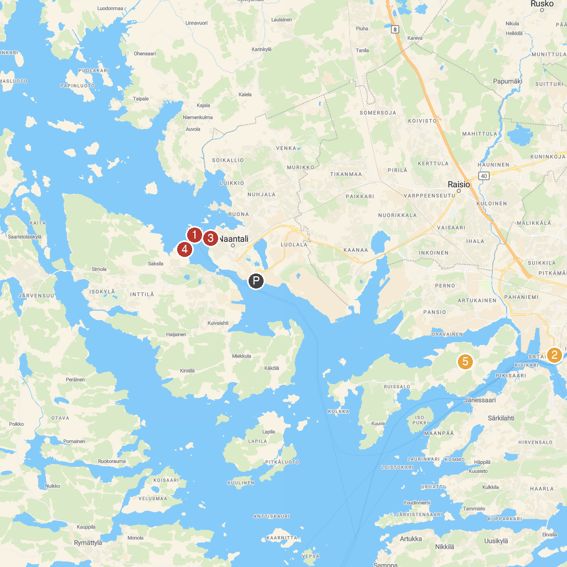
MAP KEY
1. Moomin World | 5. Kultaranta
2. Turku Castle | 6. Turun yliopiston kasvitieteellinen puutarha
3. Turku Market Square | 7. Aboa Vetus Ars Nova
4. Naantali Church | 8. Maununtyttärenpuisto
P. Cruise port / terminal
Map © MapTiler © OpenStreetMap contributors · cruiseports.org

