Mykonos, Greek Islands, Greece
Whitewashed lanes, 16th-century windmills, and Aegean blue — Mykonos is dazzling and expensive, with a tender-or-dock decision that shapes your entire day.
Dock (Tourlos) or tender to Old Port · Typical call: 8-10 hrs · Euro (EUR) · Greek · English widely spoken
✍️ MY DAY IN PORT (FILL IN)
Ship / Date
In port | arrive ______ · all aboard ______
Booked excursion
Notes / meeting point
GETTING ASHORE
- Docking: New Port Tourlos (~2 km from Chora) or tender to Old Port
- Walk to Chora: Immediate from Old Port; do NOT walk from Tourlos (no pavement)
- Best For: Beaches · Windmills · Delos archaeology
- Don't Miss: Kato Mili windmills · Paraportiani Church · Petros the pelican
GETTING AROUND
- 🚕 Taxi: ~€2/person — The fastest and cheapest way from the New Port (Tourlos) to Mykonos Town (Old Port). Runs every 30 minutes during the se
- 📱 Rideshare: ✅ Uber, Bolt
TOP THINGS TO DO
- Delos Island Archaeological Site — A 30-minute ferry from the Old Port, Delos is a UNESCO World Heritage site and the mythological birthplace of Apollo and Artemis.
- Chora: Windmills, Little Venice & Paraportiani Church — The classic Mykonos walk: Old Port waterfront to the Kato Mili windmills, down to Little Venice (18th-century fishing houses…
- Platis Gialos or Ornos Beach — The south-coast beaches are sheltered from the Meltemi wind and have calm turquoise water perfect for swimming.
- Ano Mera Village & Monastery of Panagia Tourliani — A 15-minute bus ride into the island interior brings you to Ano Mera, the only real village beyond Chora.
- Lunch in the Chora Alleyways — The harbor-front restaurants are pricey and mediocre.
BEST WALKS
- Old Port to Windmills to Little Venice Loop: ~1.5 km · 45 min · easy cobblestones — From the tender dock or SeaBus stop at the Old Port, walk the harbor waterfront past the fishing…
- Kastro Quarter & Paraportiani Church: ~0.5 km · 15 min · easy — From the Old Port, head north into the Kastro neighborhood — the oldest part of Chora, built around…
- New Port to Agios Stefanos Beach: ~1 km · 15 min · flat coastal path — If you dock at Tourlos and want to skip town entirely, a flat coastal walk north from the New Port…
WEATHER · DAYLIGHT · MONEY
Month | High °F | Low °F | Rainy days
May | 71 | 63 | 3
Jul | 82 | 75 | 0
Sep | 78 | 72 | 2
Daylight: May 6:09AM–8:20PM · Jul 6:09AM–8:39PM · Sep 7:00AM–7:26PM
cruiseports.org/mykonos · Confirm terminal & all-aboard time with your ship

Mykonos, Greek Islands, Greece — Port Map
Red = walkable sights · Amber = excursions farther out · P = cruise terminal
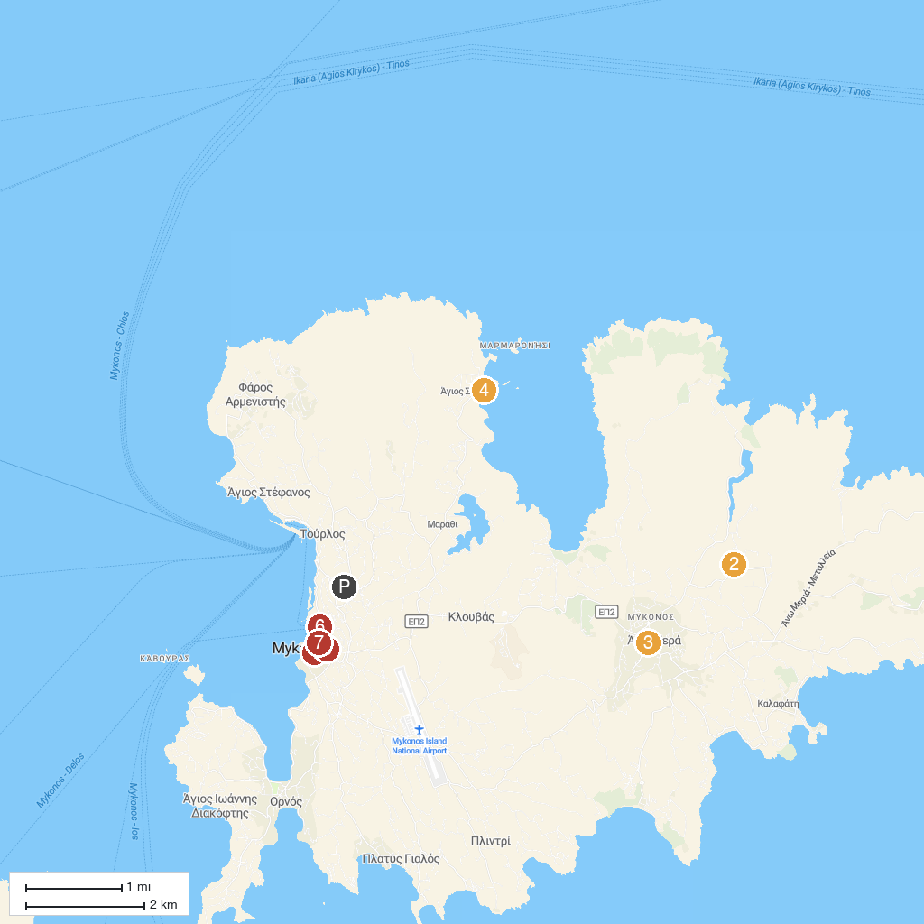
MAP KEY
1. Archaeological Site of Delos | 5. Agios Sostis Beach
2. RARITY GALLERY | 6. Boni's Windmill
3. Mykonos Vioma Organic Farm | 7. Archaeological Museum of Mykonos
4. Monastery of Tourliani | 8. Manto Mavrogenous Statue
P. Cruise port / terminal
Map © MapTiler © OpenStreetMap contributors · cruiseports.org

