My Tho, Tien Giang, Vietnam
Capital of Tien Giang Province and the best river-front launchpad for the Mekong Delta, My Tho puts sampan canals, fruit orchards, coconut monks, and centuries-old pagodas within a short boat ride of the pier.
⚓ River pier (docked) or tender · 🕒 Typical call: 6-8 hrs · 💵 Vietnamese Dong (VND) · 🗣️ Vietnamese · 🚢 River cruises (AmaWaterways, Viking, Pandaw, Heritage Line)
✍️ MY DAY IN PORT (FILL IN)
Ship / Date
In port | arrive ______ · all aboard ______
Booked excursion
Notes / meeting point
GETTING ASHORE
- Docking: River pier (Cảng Mỹ Tho) or anchor + tender; no ocean-ship terminal
- Walk to center: 5–10 min to riverside market and Lac Hong Park
- Best For: Mekong Delta island tours, sampan rides, Southern Vietnamese cuisine
- Don't Miss: Sampan canals of Thoi Son (Unicorn Island) and Vinh Trang Pagoda
GETTING AROUND
- 🚕 Taxi: 50,000–150,000 VND (~$2–$6) — Metered taxis operate in My Tho for short city runs. Negotiate fare upfront or insist on the meter; short port-to-center
- 📱 Rideshare: ✅ Grab
TOP THINGS TO DO
- Four Islands Sampan Tour — Cruise the Tien River to the Dragon, Unicorn, Phoenix, and Tortoise islands.
- Vinh Trang Pagoda — Built in 1849, this is one of Southern Vietnam's most celebrated temples — an eclectic fusion of Vietnamese, Khmer, Chinese, and…
- Phoenix Island & the Coconut Monk — Visit Phung Island to see the quirky ruins of the Coconut Monk's sect — a defunct religion that blended Buddhism and Christianity…
- My Tho Market & Hủ Tiếu Noodles — Walk along the riverfront to My Tho Market (Chợ Mỹ Tho) for exotic tropical fruits, fresh seafood, and local dry goods.
- Ben Tre Coconut Kingdom — Many tours extend into neighboring Ben Tre province — the 'Coconut Kingdom' — where you can watch coconut candy being made by…
BEST WALKS
- Riverside Promenade Walk: 1.5 km · 25 min · Flat · Free — From the pier, stroll west along 30 Thang 4 Street past Lac Hong Park — a breezy riverside green…
- Pagoda Stroll (short taxi + walk): 3 km from pier · Taxi + 15-min walk on grounds · Easy — Take a Grab taxi to Vinh Trang Pagoda (about 10 minutes), then spend an hour walking the peaceful…
WEATHER · DAYLIGHT · MONEY
Month | High °F | Low °F | Rainy days
May | 91 | 78 | 24
Jul | 87 | 76 | 28
Sep | 87 | 76 | 28
Daylight: May 5:33AM–6:08PM · Jul 5:40AM–6:20PM · Sep 5:44AM–5:55PM
cruiseports.org/my-tho · Confirm terminal & all-aboard time with your ship

My Tho, Tien Giang, Vietnam — Port Map
Red = walkable sights · Amber = excursions farther out · P = cruise terminal
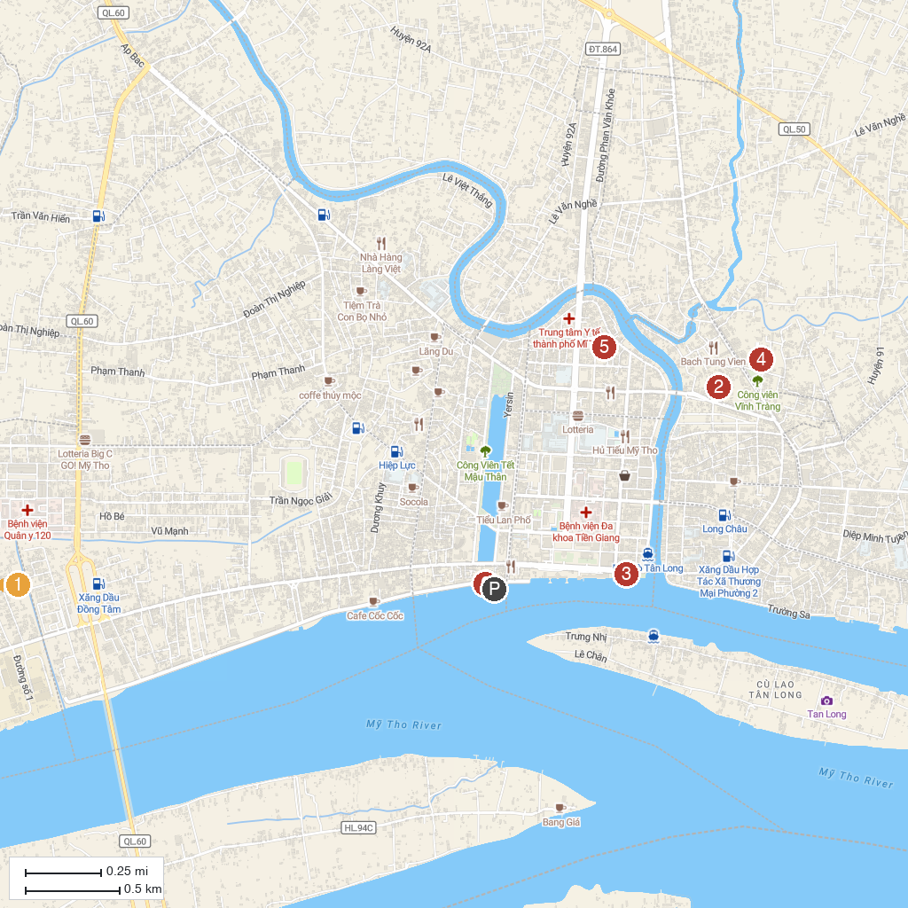
MAP KEY
1. Dong Tam Snake Farm | 4. Vĩnh Tràng Pagoda
2. Buu Lam Pagoda | 5. Đồng Tháp Museum - Branch No.1
3. Lac Hong park. | 6. CẢNG DU THUYỀN MỸ THO
P. Cruise port / terminal
Map © MapTiler © OpenStreetMap contributors · cruiseports.org

