Muskegon, Michigan, USA
Once the Lumber Queen of the World, Muskegon now rolls out the welcome mat for Great Lakes cruisers with WWII submarines, squeaky-clean beaches, and one of Michigan's liveliest craft brewing scenes.
⚓ Pier (docked — Heritage Landing) · 🕒 Typical call: 7–9 hrs · 💵 USD · 🗣️ English · 🌊 Lake Michigan port
✍️ MY DAY IN PORT (FILL IN)
Ship / Date
In port | arrive ______ · all aboard ______
Booked excursion
Notes / meeting point
GETTING ASHORE
- Docking: Pier — ships dock at Heritage Landing on Muskegon Lake, no tendering
- Walk to downtown: 0.5–0.8 mi (10–15 min flat walk) to Western Avenue
- Best For: Military history, Lake Michigan beaches, craft beer, Victorian architecture
- Don't Miss: Board the WWII submarine USS Silversides — one of the most decorated subs of the war
GETTING AROUND
- 🚕 Taxi: $15–$25 — Local taxis (Port City Cab, Blue City Taxi) serve the port. The city center is very close, so fares are typically low.
- 📱 Rideshare: ✅ Uber, Lyft
TOP THINGS TO DO
- USS Silversides Submarine Museum — One of the most decorated US Navy submarines of WWII, credited with sinking 23 enemy ships.
- USS LST-393 Veterans Museum — One of only two surviving WWII Landing Ship Tanks.
- Pere Marquette Park Beach — Muskegon's premier beach on Lake Michigan — miles of certified clean sugar sand that rivals Caribbean shores.
- Hackley & Hume Historic Site — Two ornate Queen Anne Victorian mansions built by Muskegon's lumber barons in the 1880s.
- Muskegon Museum of Art — A genuine Midwest hidden gem with works by Edward Hopper and Winslow Homer, plus a renowned glass art collection.
BEST WALKS
- Heritage Landing to Downtown Muskegon: 0.8 mi · 15 min · flat · easy — Walk from the pier along the Lakeshore Trail to Western Avenue and Hackley Park, passing Hackley &…
- USS Silversides & South Pierhead Lighthouse Walk: 1.5 mi loop · 30 min · easy — From the dock, walk the Lakeshore Trail toward the Muskegon Channel to visit USS Silversides, then…
WEATHER · DAYLIGHT · MONEY
Month | High °F | Low °F | Rainy days
May | 64 | 48 | 12
Jul | 78 | 65 | 10
Sep | 71 | 59 | 10
Daylight: May 6:21AM–9:02PM · Jul 6:19AM–9:22PM · Sep 7:25AM–7:54PM
cruiseports.org/muskegon-mi · Confirm terminal & all-aboard time with your ship

Muskegon, Michigan, USA — Port Map
Red = walkable sights · Amber = excursions farther out · P = cruise terminal
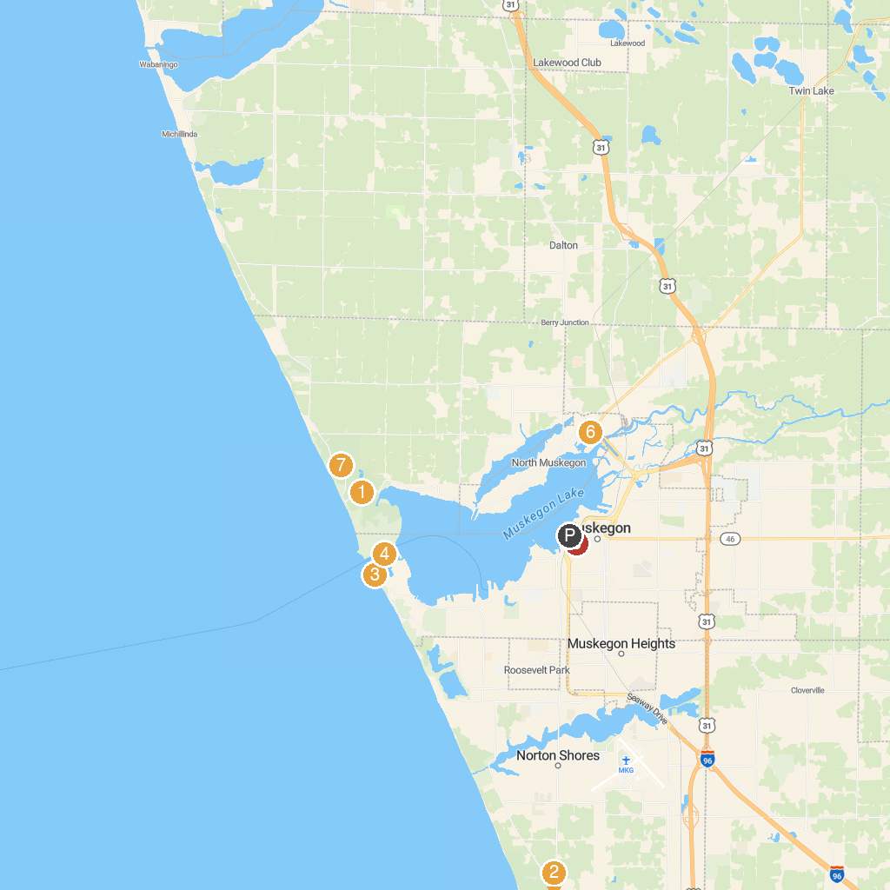
MAP KEY
1. Michigan's Adventure | 5. USS Silversides Submarine Museum
2. Muskegon State Park | 6. Muskegon Heritage Museum of Business & Industry
3. P. J. Hoffmaster State Park | 7. Muskegon Lake Nature Preserve
4. Pere Marquette Park | 8. Muskegon State Park Block House
P. Cruise port / terminal
Map © MapTiler © OpenStreetMap contributors · cruiseports.org

