Muscatine, Iowa, USA
Once the Pearl Button Capital of the World, Muscatine sits on a sweeping bend of the Mississippi where Mark Twain once praised its sunsets. Today river cruisers step ashore to a walkable historic downtown, a world-class art collection, and one of the river's most scenic stretches.
⚓ Docked — Riverside Park · 🕒 Typical call: 6-8 hrs · 💵 US Dollar (USD) · 🗣️ English · 🔘 Pearl Button history
✍️ MY DAY IN PORT (FILL IN)
Ship / Date
In port | arrive ______ · all aboard ______
Booked excursion
Notes / meeting point
GETTING ASHORE
- Docking: Ships dock at Riverside Park on the Muscatine Riverfront — a short walk to downtown.
- Walk to Center: Downtown is 5–10 min on foot from the dock; the riverfront trail connects the two.
- Best For: Mississippi River history, pearl button heritage, small-town Iowa charm.
- Don't Miss: National Pearl Button Museum and the Muscatine Art Center (Musser Mansion).
GETTING AROUND
- 🚕 Taxi: Varies — Local taxi services including Non-Emergency Transport (563-299-3513) and Royal Taxi Cab Service operate in the area. Con
- 📱 Rideshare: ✅ Uber
TOP THINGS TO DO
- National Pearl Button Museum — Muscatine once made 37% of the world's buttons from freshwater mussel shells.
- Muscatine Art Center — Housed in the 1908 Musser Mansion, this small-city museum holds a surprisingly strong collection — Chagall, Picasso, Renoir…
- Wildcat Den State Park & Pine Creek Grist Mill — About 12 miles from the riverfront, Wildcat Den shelters hiking trails through sandstone bluffs and the Pine Creek Grist Mill…
- Historic Downtown Walk & Mark Twain Connection — Mark Twain lived in Muscatine in 1854-55 and later wrote in Life on the Mississippi that he had never seen sunsets anywhere that…
- Lock & Dam No. 16 Tour — The U.S.
BEST WALKS
- Riverfront to Downtown Loop: 1.5 miles · Flat · 30-45 min — From the Riverside Park dock, walk north along the riverfront trail past the Mississippi Mist…
- West Hill Historic District Stroll: 1 mile · Gentle hills · 20-30 min — A short climb from downtown into the West Hill neighborhood reveals a dense collection of Victorian…
WEATHER · DAYLIGHT · MONEY
Month | High °F | Low °F | Rainy days
May | 72 | 54 | 14
Jul | 84 | 67 | 9
Sep | 77 | 61 | 8
Daylight: May 5:45AM–8:16PM · Jul 5:44AM–8:35PM · Sep 6:45AM–7:12PM
cruiseports.org/muscatine-ia · Confirm terminal & all-aboard time with your ship

Muscatine, Iowa, USA — Port Map
Red = walkable sights · Amber = excursions farther out · P = cruise terminal
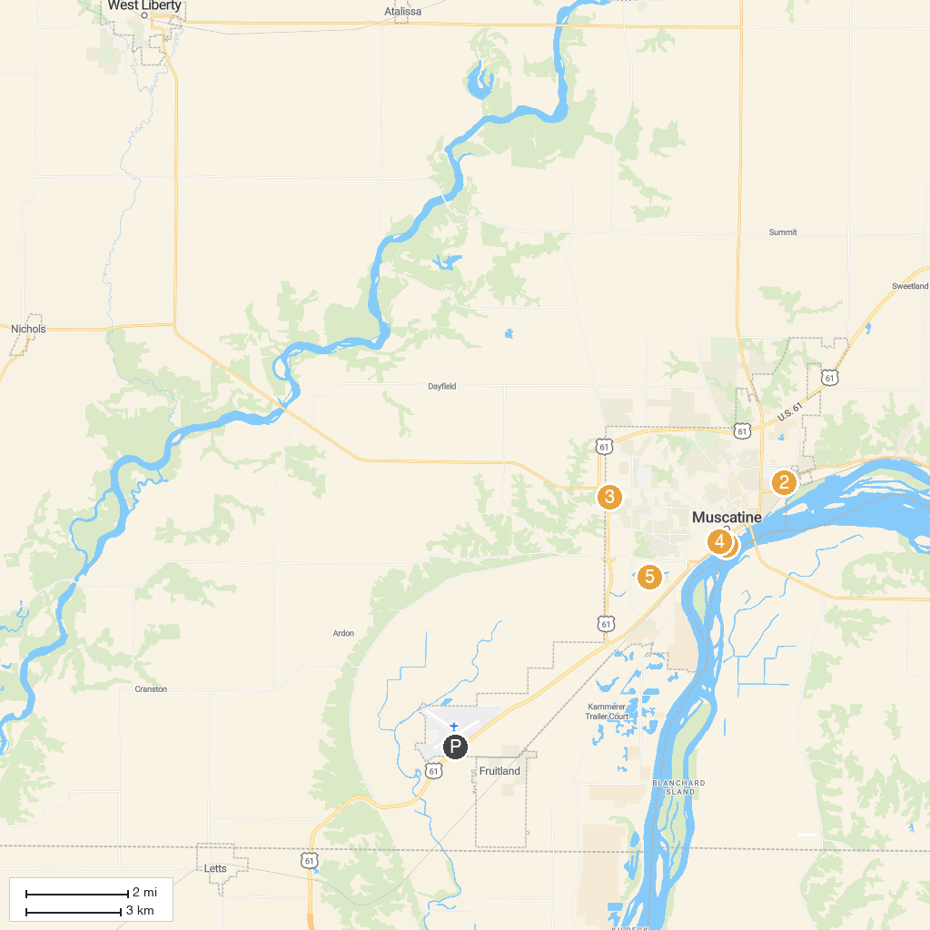
MAP KEY
1. Riverside Park | 4. The National Pearl Button Museum @ The History and Industry Center
2. Weed Park Maintenance Shop | 5. Muscatine Kent-Stein Park
3. Discovery Park | 6. Deep Lakes Park
P. Cruise port / terminal
Map © MapTiler © OpenStreetMap contributors · cruiseports.org

