Muroran, Hokkaido, Japan
Hokkaido's industrial port hides dramatic Pacific cliffs, singing-sand beaches, and the gateway to Noboribetsu's steaming Hell Valley — one of Japan's most off-the-beaten-path cruise stops.
⚓ Pier (always docked) · 🕒 Typical call: 8-10 hrs · 💴 Currency: Japanese Yen (JPY) · 🗣️ Language: Japanese · 🏭 Industrial port — shuttle to town
✍️ MY DAY IN PORT (FILL IN)
Ship / Date
In port | arrive ______ · all aboard ______
Booked excursion
Notes / meeting point
GETTING ASHORE
- Docking: Pier — Shukutsu, Sakimori, or Chuo Wharf depending on ship size; no tendering
- Walk to center: Not practical — 4.5 km industrial roads; free shuttle usually runs to JR Muroran Station
- Best For: Day trips to Noboribetsu Hell Valley or Lake Toya, Cape Chikyu cliffs, unique local food
- Don't Miss: Muroran curry ramen (the original) and the pork yakitori — totally unlike the rest of Japan
GETTING AROUND
- 🚕 Taxi: ¥1,500–¥3,000 — Metered taxis are available at the port area. A ride to Cape Chikyu is approximately ¥2,500; city center fares are simil
- 📱 Rideshare: ✅ Uber Taxi
TOP THINGS TO DO
- Noboribetsu Hell Valley (Jigokudani) — Hokkaido's most famous hot spring resort.
- Lake Toya & Mount Usu — A stunning volcanic caldera lake with an active stratovolcano looming above.
- Cape Chikyu Scenic Cliffs — Muroran's signature sight — a white lighthouse on a 120-metre cliff above the Pacific, where the horizon visibly curves ('Earth…
- Muroran Yakitori & Curry Ramen Crawl — Muroran has two utterly unique dishes: curry ramen (the city's invention, with thick spiced broth) and 'yakitori' made with pork…
- Itanki Singing Sand Beach — A wild, cliff-framed beach where dry, clean quartz sand 'squeaks' underfoot — one of Japan's rare singing sands.
BEST WALKS
- Cape Chikyu & Tokkarisho Loop: 2.5 km loop · Easy · 45-60 min · Taxi to start — Take a taxi to Cape Chikyu Lighthouse, walk the cliff-edge path to Tokkarisho Lookout for…
- Hakucho Bridge Viewpoint Stroll: 1 km · Flat · 20 min · Near Chuo Wharf — If docked at Chuo Wharf, walk to Miyakoshi Park for the best free view of the Hakucho (Swan) Bridge…
WEATHER · DAYLIGHT · MONEY
Month | High °F | Low °F | Rainy days
May | 54 | 47 | 11
Jul | 69 | 64 | 12
Sep | 69 | 64 | 12
Daylight: May 4:15AM–6:50PM · Jul 4:12AM–7:10PM · Sep 5:15AM–5:45PM
cruiseports.org/muroran · Confirm terminal & all-aboard time with your ship

Muroran, Hokkaido, Japan — Port Map
Red = walkable sights · Amber = excursions farther out · P = cruise terminal
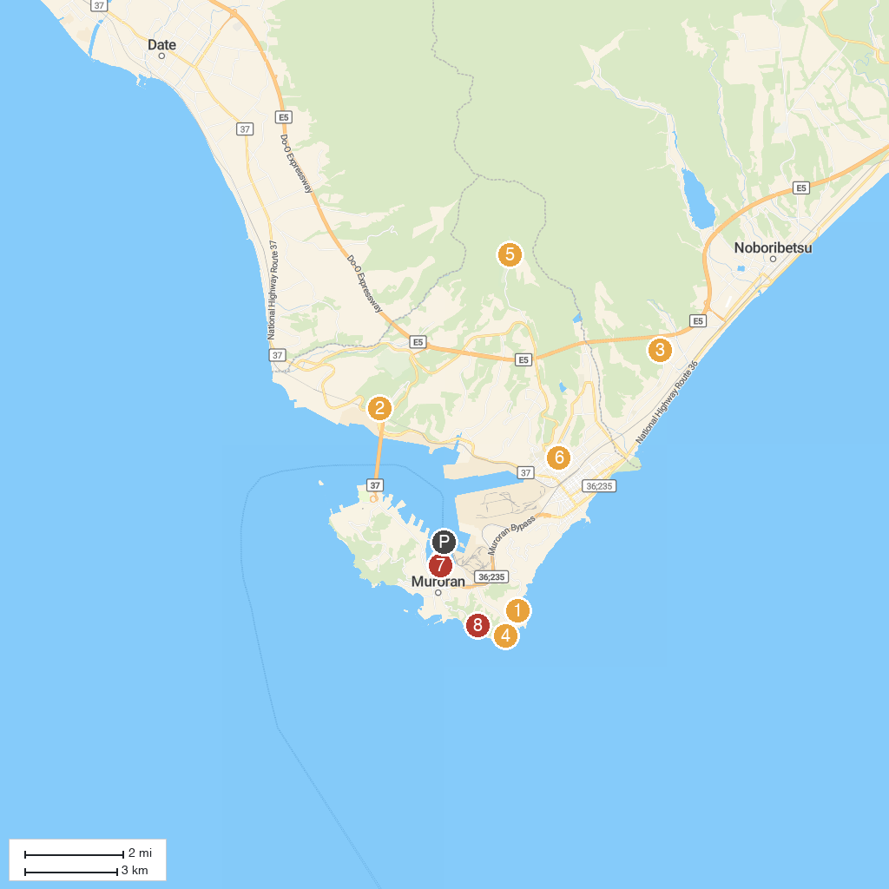
MAP KEY
1. Tokkarisho Observatory | 5. Muroranshi Danpara Snow Bowl
2. Muroran History Museum Tonten-kan | 6. Nakajima Shrine Sai Gibu
3. Kameda Memorial Park | 7. Irierinkai Park
4. Cape Chikyu | 8. Charatsunai Observatory
P. Cruise port / terminal
Map © MapTiler © OpenStreetMap contributors · cruiseports.org

