Mumbai, Maharashtra, India
Mumbai's new international cruise terminal drops you at the edge of one of Asia's great cities — colonial-era monuments, ancient cave temples, and one of the world's most chaotic and captivating street scenes all within reach in a single day.
⚓ Docked — Ballard Pier, South Mumbai · 🕒 Typical call: 8–12 hrs · 💵 Indian Rupee (INR) · 🗣️ Hindi & English widely spoken · 🛂 India e-Visa required in advance
✍️ MY DAY IN PORT (FILL IN)
Ship / Date
In port | arrive ______ · all aboard ______
Booked excursion
Notes / meeting point
GETTING ASHORE
- Docking: Mumbai International Cruise Terminal, Ballard Pier Extension — alongside berth, no tender
- Walk to Center: Not walkable from terminal — 10–15 min taxi/Uber to Gateway of India (₹200–400)
- Best For: UNESCO cave temples, colonial architecture, street food, bazaars
- Don't Miss: Ferry to Elephanta Caves from Gateway of India (1 hr each way)
GETTING AROUND
- 🚕 Taxi: ₹270–400 (~$3–5) — Yellow/black metered cabs wait outside the terminal. Gateway of India and Colaba are only 1–2 km away, so fares are low.
- 📱 Rideshare: ✅ Uber, Ola
- 🚌 Hop-on hop-off: ✅
TOP THINGS TO DO
- Gateway of India & Elephanta Caves — Take a short taxi to the Gateway of India (1924 basalt arch on the waterfront), then board the hour-long public ferry to…
- Colonial Fort District Heritage Walk — South Mumbai's Victorian Gothic precinct — Chhatrapati Shivaji Maharaj Terminus (UNESCO), the High Court, Oval Maidan, and the…
- Colaba Causeway & Taj Mahal Palace — Stroll the famous street market for spices, textiles, and silver jewellery (bargain hard), then step inside or onto the terrace…
- Mumbai Street Food Tour — Vada pav (Mumbai's beloved spiced-potato slider), pav bhaji, bhel puri on Chowpatty Beach, and fresh sugarcane juice.
- Dharavi & Dhobi Ghat Community Tours — Responsible guided tours of Dharavi (one of Asia's largest urban communities) and Dhobi Ghat (the vast open-air laundry) offer an…
BEST WALKS
- Colaba Waterfront to Fort Heritage Loop: 3–4 km · 1.5–2 hrs · Easy — Start at the Gateway of India, walk north along the harbour promenade past the Taj Mahal Palace…
- Oval Maidan Precinct Walk: 1.5 km · 45 min · Easy — A compact loop around the Oval Maidan taking in the Rajabai Clock Tower, Bombay High Court, and the…
WEATHER · DAYLIGHT · MONEY
Month | High °F | Low °F | Rainy days
May | 91 | 81 | 3
Jul | 82 | 78 | 31
Sep | 83 | 77 | 26
Daylight: May 6:04AM–7:05PM · Jul 6:09AM–7:19PM · Sep 6:26AM–6:40PM
cruiseports.org/mumbai · Confirm terminal & all-aboard time with your ship

Mumbai, Maharashtra, India — Port Map
Red = walkable sights · Amber = excursions farther out · P = cruise terminal
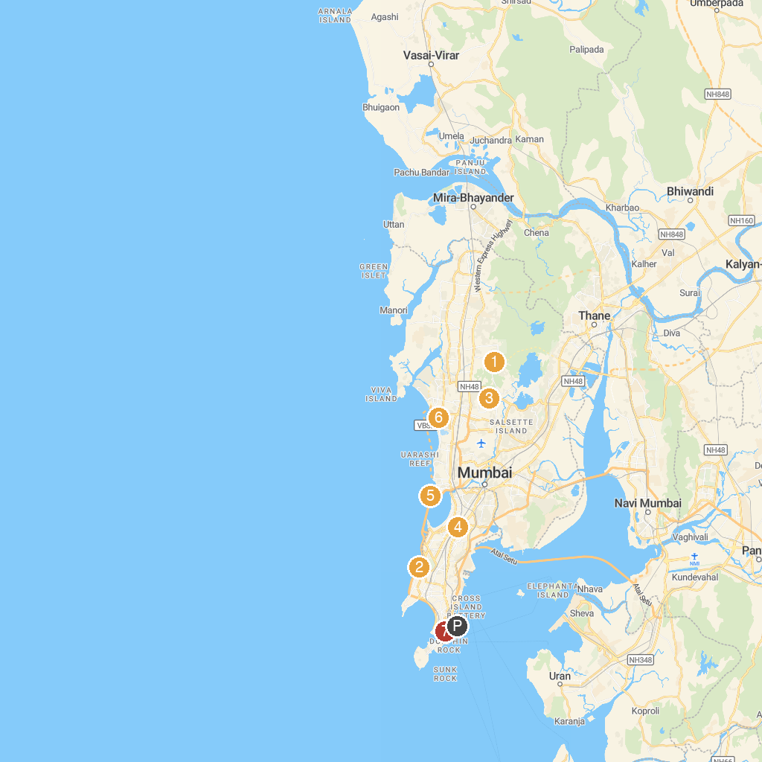
MAP KEY
1. Dadasaheb Phalke Chitranagari | 5. BAPS Shri Swaminarayan Mandir, Mumbai
2. Haji Ali Dargah | 6. Band Stand
3. Elephanta Caves | 7. ISKCON Temple, Juhu
4. Mahakali Caves | 8. Chhatrapati Shivaji Maharaj Vastu Sangrahalaya
P. Cruise port / terminal
Map © MapTiler © OpenStreetMap contributors · cruiseports.org

