Mühlhausen, Thuringia, Germany
A fortress of medieval stone that time largely forgot, Mühlhausen bristles with Gothic spires, Bach's early organ, and the ghost of a peasant revolution that shook the Holy Roman Empire.
⚓ River pier (Unstrut River) · 🕒 Typical call: 4–6 hrs · 💶 Currency: Euro (€) · 🗣️ Language: German
✍️ MY DAY IN PORT (FILL IN)
Ship / Date
In port | arrive ______ · all aboard ______
Booked excursion
Notes / meeting point
GETTING ASHORE
- Docking: River pier on the Unstrut; short transfer to the old town
- Walk to centre: ~10–15 min from riverbank to Untermarkt
- Best For: Medieval history, Bach, Reformation sites, Gothic churches
- Don't Miss: St. Mary's Church tower climb & the walkable city wall section
GETTING AROUND
- 🚕 Taxi: €5–€15 — Local taxis operate with a €5.00 base fare plus €3.50/km daytime rate. Short rides within the compact city center are in
- 📱 Rideshare: ✅ Uber
TOP THINGS TO DO
- St. Mary's Church & Müntzer Memorial — The tallest spire in Thuringia marks St.
- Divi Blasii Church — Bach's Early Organ — Johann Sebastian Bach served as organist here in 1707–08, composing some of his earliest cantatas including BWV 71.
- Medieval City Wall Walk — Walk a 370-metre section of the almost entirely intact 2.2 km city wall — one of Germany's best-preserved.
- Peasants' War Museum (Kornmarktkirche) — Housed in the former Corn Market Church, this museum dives deep into the German Peasants' War of 1525 — the largest popular…
- Old Town Self-Guided Walk — Stroll Linsenstraße, the Untermarkt, and around the Town Hall to admire half-timbered houses, Gothic facades, and the Imperial…
BEST WALKS
- Old Town Loop: 2 km · ~45 min · flat cobblestones — From the Frauentor gate, walk through the Altstadt to Untermarkt, past the Town Hall, along…
- City Wall Walk: 370 m walkable section · ~30 min · some stairs — Follow the signposted path along the medieval fortifications between the Frauentor and the…
WEATHER · DAYLIGHT · MONEY
Month | High °F | Low °F | Rainy days
May | 63 | 46 | 10
Jul | 75 | 58 | 11
Sep | 67 | 51 | 8
Daylight: May 5:27AM–9:02PM · Jul 5:20AM–9:27PM · Sep 6:53AM–7:31PM
cruiseports.org/muhlhausen · Confirm terminal & all-aboard time with your ship

Mühlhausen, Thuringia, Germany — Port Map
Red = walkable sights · Amber = excursions farther out · P = cruise terminal
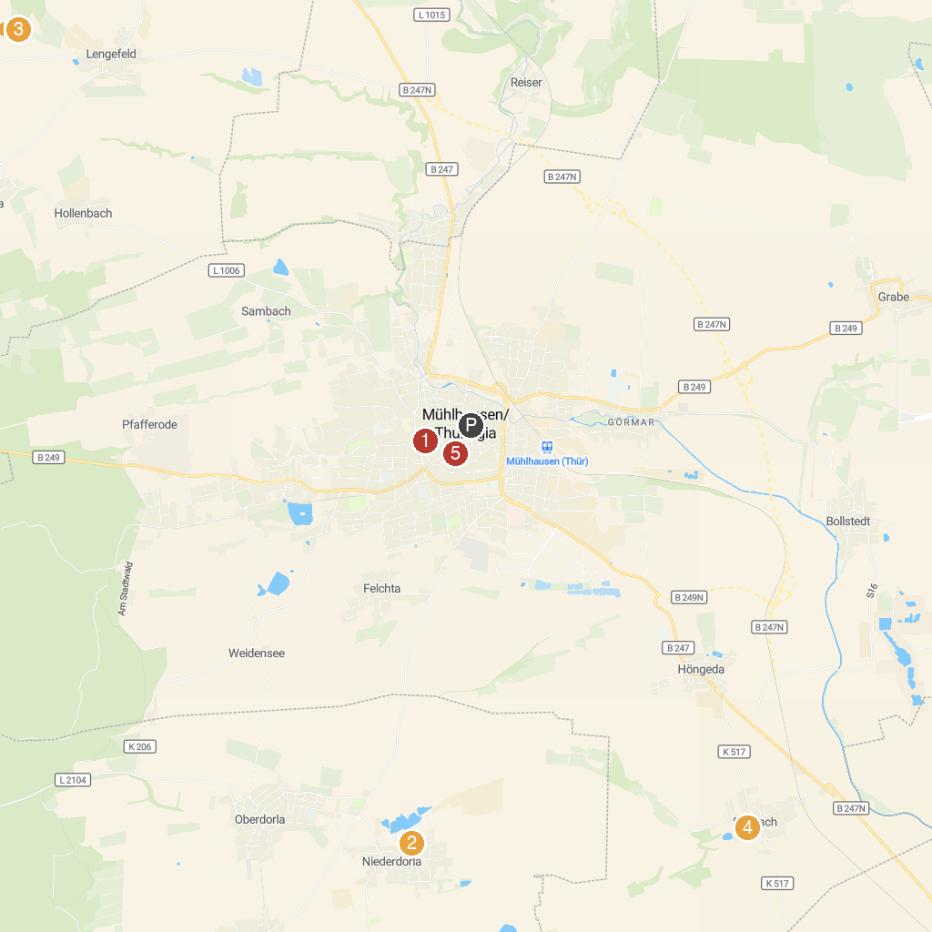
MAP KEY
1. Nationalpark Hainich | 5. Climbing Forest Hainich on Reckenbühl
2. Historische Wehranlage | 6. Haineck Castle
3. Gemeinde Vogtei "Ausstellung Opfermoor Vogtei" | 7. Staatliche Vogelschutzwarte
4. Kloster Anrode | 8. Kornmarktkirche
P. Cruise port / terminal
Map © MapTiler © OpenStreetMap contributors · cruiseports.org

