Mozambique Island, Nampula, Mozambique
A 3 km sliver of coral and history off Mozambique's northern coast, Ilha de Moçambique packs five centuries of Portuguese, Arab, and African heritage into a single walkable island — including the oldest European building in the Southern Hemisphere.
⚓ Tender (anchor offshore) · 🕒 Typical call: 6-8 hrs · 💵 Mozambican Metical (USD/EUR accepted) · 🗣️ Portuguese · 🏛️ UNESCO World Heritage Site
✍️ MY DAY IN PORT (FILL IN)
Ship / Date
In port | arrive ______ · all aboard ______
Booked excursion
Notes / meeting point
GETTING ASHORE
- Docking: Tender — ships anchor in the bay; boats bring you to the Stone Town pier
- Walk to center: 2 min from tender pier to Stone Town; full island end-to-end ~40 min
- Best For: History buffs, architecture lovers, off-the-beaten-path culture
- Don't Miss: Fort of São Sebastião & the 1522 Chapel of Nossa Senhora de Baluarte
GETTING AROUND
- 🚕 Taxi: $3–$8 — If your ship docks at Lumbo on the mainland, informal taxis are available for the short run to the bridge and across to
TOP THINGS TO DO
- Fort of São Sebastião & Chapel — The oldest complete fort in sub-Saharan Africa (begun 1558) anchors the island's northern tip.
- Palace of St. Paul & Museum of Sacred Art — The Palácio de São Paulo — once a Jesuit college, later the Governor's Palace — holds one of the finest collections of 17th- and…
- Dhow Sail to Goa Island — Traditional wooden dhows ferry you to uninhabited Ilha de Goa, about 5 km east — pristine white sand, turquoise water, and an…
- Stone Town Architecture Walk — Wander the grid of Stone Town streets: pastel colonial facades, ornate wooden doors, the Green Mosque, and the Hindu temple all…
- Macuti Town & Local Market — The southern half of the island is a dense, vibrant neighborhood of traditional macuti (reed and thatch) houses and local markets.
BEST WALKS
- Stone Town Heritage Loop: 1 km · 20–30 min · Easy — From the tender pier, walk north through Stone Town to the Fort of São Sebastião at the island's…
- End-to-End Island Walk: 3 km one-way · 40-45 min · Easy — Walk the full length of the island from the northern fort through Stone Town, past the 3.4 km…
WEATHER · DAYLIGHT · MONEY
Month | High °F | Low °F | Rainy days
May | 81 | 64 | 3
Jul | 78 | 61 | 4
Sep | 86 | 64 | 2
Daylight: May 5:37AM–5:01PM · Jul 5:49AM–5:08PM · Sep 5:18AM–5:18PM
cruiseports.org/mozambique-island · Confirm terminal & all-aboard time with your ship

Mozambique Island, Nampula, Mozambique — Port Map
Red = walkable sights · Amber = excursions farther out · P = cruise terminal
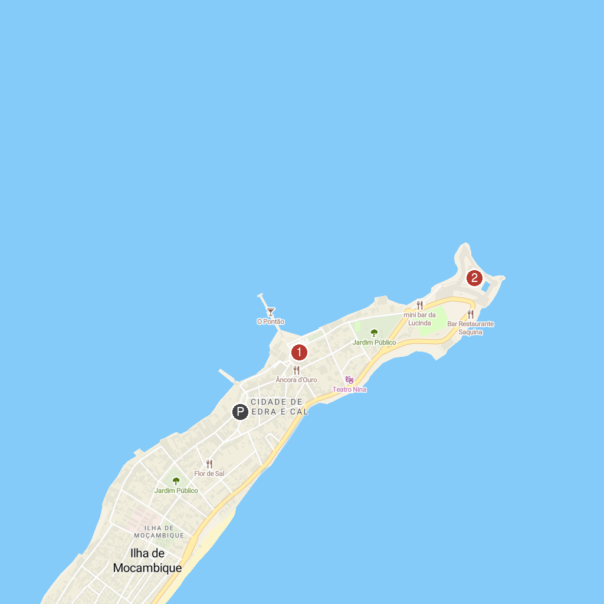
MAP KEY
1. Ilha De Mocambique museum | 2. Saint Sebastian Fort
P. Cruise port / terminal
Map © MapTiler © OpenStreetMap contributors · cruiseports.org

