Motobu, Okinawa, Japan
Okinawa's northern peninsula delivers world-class marine life at Churaumi Aquarium, sweeping coral coastlines, and a laid-back Ryukyuan vibe that big-city Japan rarely offers.
⚓ Pier (docked) · 🕒 Typical call: 8-10 hrs · 💴 Japanese Yen (JPY) · 🗣️ Japanese (minimal English outside aquarium)
✍️ MY DAY IN PORT (FILL IN)
Ship / Date
In port | arrive ______ · all aboard ______
Booked excursion
Notes / meeting point
GETTING ASHORE
- Docking: Pier — 420m quay, handles ships up to 220,000 GT
- Walk to Aquarium: ~8 km (17–25 min by bus or 14 min taxi)
- Best For: Aquarium, ocean park, coastal walks, Okinawan food
- Don't Miss: Whale sharks in the Kuroshio Tank, Emerald Beach
GETTING AROUND
- 🚕 Taxi: ¥2,400–¥4,700 — Taxis available at the port. Short ride to Churaumi Aquarium (~¥2,400–¥3,000, ~14 min); Nago City ~¥3,900–¥4,700 (~19 mi
- 📱 Rideshare: ✅ Uber, Grab
TOP THINGS TO DO
- Okinawa Churaumi Aquarium — One of Japan's finest aquariums, headlined by the enormous Kuroshio Tank where whale sharks and manta rays glide past an acrylic…
- Ocean Expo Park & Emerald Beach — The free park surrounding the aquarium spans 3km of coastline.
- Bise Fukugi Tree Road — A 1km lane in Bise village, just north of Ocean Expo Park, shaded by ancient fukugi trees.
- Kouri Island Day Trip — Connected to the mainland by a striking 2km bridge (the 1,960m Kouri Bridge), Kouri Island has a beautiful beach, the Kouri Ocean…
- Okinawan Food & Orion Beer — Nago city, about 20 minutes southeast of Motobu, has excellent local restaurants serving champuru stir-fries, Okinawa soba…
BEST WALKS
- Bise Fukugi Tree Road to the Sea: 1 km · Flat · 20-30 min — Starting at the entrance to Bise village, walk the shaded lane of ancient fukugi trees to the…
- Ocean Expo Park Loop: 2-3 km · Flat · 1 hr — Wander the free park from the Oceanic Culture Museum along the shoreline to Emerald Beach, passing…
WEATHER · DAYLIGHT · MONEY
Month | High °F | Low °F | Rainy days
May | 78 | 71 | 16
Jul | 86 | 80 | 19
Sep | 85 | 79 | 21
Daylight: May 5:41AM–7:08PM · Jul 5:44AM–7:23PM · Sep 6:14AM–6:32PM
cruiseports.org/motobu · Confirm terminal & all-aboard time with your ship

Motobu, Okinawa, Japan — Port Map
Red = walkable sights · Amber = excursions farther out · P = cruise terminal
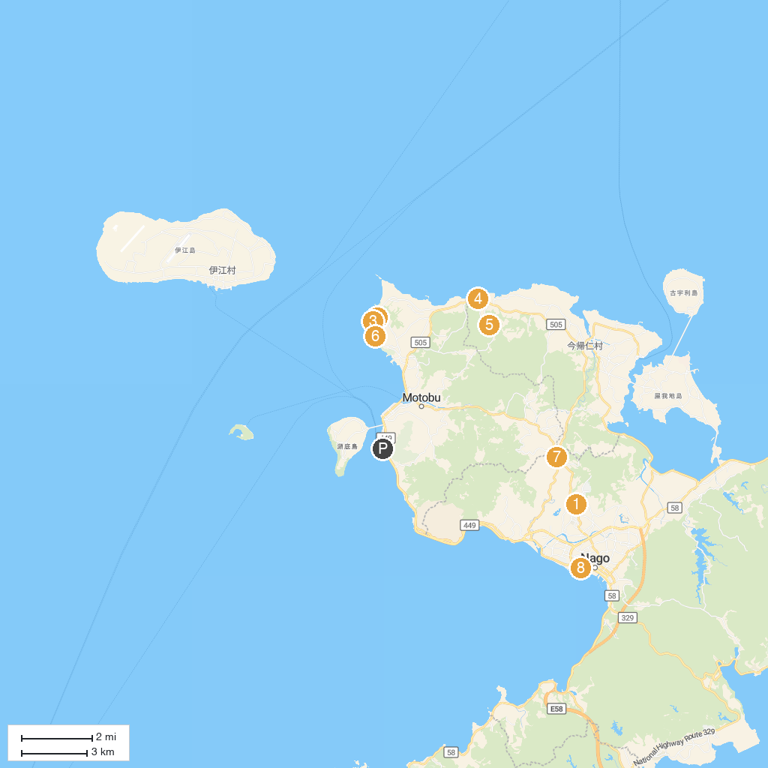
MAP KEY
1. Okinawa Fruits Land | 5. Nakijin Castle Ruins
2. Okinawa Churaumi Aquarium | 6. Maimai Shisa
3. Okichan Theatre | 7. Okinawa History and Folklore Museum
4. Shisa Pottery Experience workshop Ryukyu kiln | 8. 21 Seikinomori Park
P. Cruise port / terminal
Map © MapTiler © OpenStreetMap contributors · cruiseports.org

