Mossel Bay, Western Cape, South Africa
One of the most walkable ports in South Africa, Mossel Bay packs a Dias museum with a replica caravel, a famous Post Office Tree, shark-cage diving, and the world's longest over-ocean zipline into a compact harbor town blessed with near-perfect weather.
⚓ Tender port (anchor in bay) · 🕒 Typical call: 8–10 hrs · 💵 South African Rand (ZAR) — cards widely accepted · 🗣️ English, Afrikaans, isiXhosa · 🌤️ Mild year-round; breezy coast
✍️ MY DAY IN PORT (FILL IN)
Ship / Date
In port | arrive ______ · all aboard ______
Booked excursion
Notes / meeting point
GETTING ASHORE
- Docking: Tender — ships anchor in the bay; tender boats bring you to the working harbor waterfront
- Walk to center: Dias Museum: 2 min • Santos Beach: 10 min • Cape St. Blaize Lighthouse: 25 min
- Best For: History buffs, beach lovers, adventure seekers (zipline, shark diving), easy walkers
- Don't Miss: Bartolomeu Dias Museum caravel replica and mailing a postcard from the Post Office Tree
GETTING AROUND
- 🚕 Taxi: R 60–120 (~$4–7 USD) — Metered taxis are available near the harbor. A short trip within town is approximately R 60–90; fares to attractions fur
- 📱 Rideshare: ✅ Uber, Bolt
TOP THINGS TO DO
- Bartolomeu Dias Museum Complex — The cultural heart of Mossel Bay centers on a full-size replica of the caravel that sailed here in 1988 to mark 500 years since…
- Mossel Bay Zipline — Billed as the world's longest over-ocean zipline at 1.1 km, you launch from the cliffs at The Point and glide as high as ~90 m…
- Shark Cage Diving — Mossel Bay is one of South Africa's top great white shark sites.
- St. Blaize Trail & Lighthouse — Walk the dramatic cliff-top St.
- Botlierskop Private Game Reserve Safari — About 30 minutes from the harbor, this private reserve offers guided game drives to see four of the Big Five (lion, elephant…
BEST WALKS
- Harbor to The Point Coastal Walk: 2.5 km one-way • ~25 min • Flat • Scenic — Exit the harbor gates and follow the waterfront right past Santos Beach and along the coastal path…
- Harbor to Dias Museum & Town Center: 1.5 km loop • ~30 min walking • Easy — Step off the tender and visit the Dias Museum Complex immediately (2 minutes from the gates).
WEATHER · DAYLIGHT · MONEY
Month | High °F | Low °F | Rainy days
May | 69 | 54 | 5
Jul | 65 | 49 | 6
Sep | 67 | 53 | 6
Daylight: May 7:17AM–5:37PM · Jul 7:35AM–5:39PM · Sep 6:30AM–6:22PM
cruiseports.org/mossel-bay · Confirm terminal & all-aboard time with your ship

Mossel Bay, Western Cape, South Africa — Port Map
Red = walkable sights · Amber = excursions farther out · P = cruise terminal
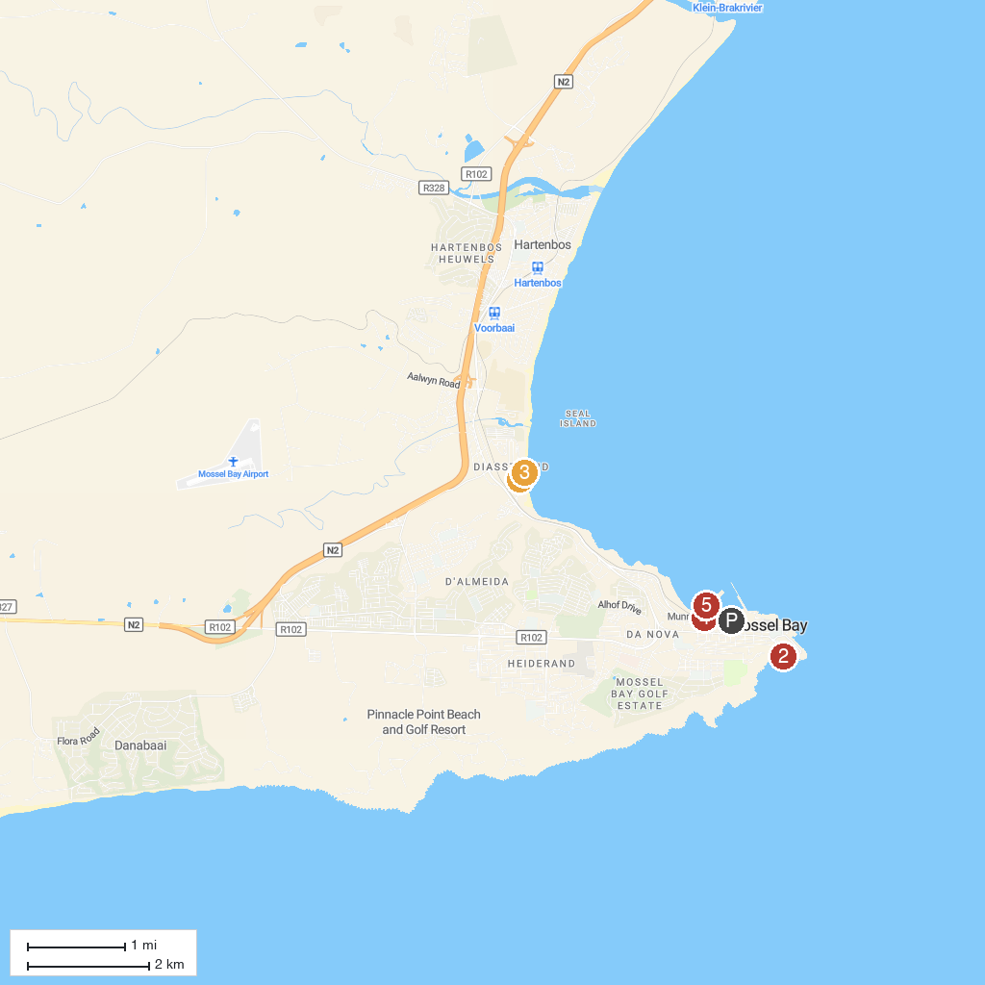
MAP KEY
1. Diaz Water Park | 4. Bartolomeu Dias Museum Complex
2. Cape St Blaize Lighthouse Complex | 5. Mossel Bay Boat Adventures
3. Surf's Up Mossel Bay
P. Cruise port / terminal
Map © MapTiler © OpenStreetMap contributors · cruiseports.org

