Mormugao, Goa, India
India's smallest state packs 450 years of Portuguese heritage, golden beaches, and aromatic spice farms into one sun-soaked shore day. Goa's laid-back 'Susegad' spirit is infectious — even on a tight turnaround.
⚓ Pier (dedicated cruise berth) · 🕒 Typical call: 8-10 hrs · 💵 Currency: Indian Rupee (INR) · 🗣️ Language: Konkani, Hindi, English · 📋 Visa required in advance (e-Visa)
✍️ MY DAY IN PORT (FILL IN)
Ship / Date
In port | arrive ______ · all aboard ______
Booked excursion
Notes / meeting point
GETTING ASHORE
- Docking: Pier — Mormugao Harbour, Vasco da Gama
- Walk to center: Vasco da Gama ~1 km; taxi needed for sights
- Best For: History, food, beaches, culture
- Don't Miss: Basilica of Bom Jesus, Old Goa churches
GETTING AROUND
- 🚕 Taxi: ₹200–₹250 (~$2–3) — Vasco da Gama is the nearest city, just ~3.5 km from the port. Pre-paid taxis are available at the terminal; agree on a
- 📱 Rideshare: ✅ Uber, GoaMiles, Goa Taxi App
- 🚌 Hop-on hop-off: ✅
TOP THINGS TO DO
- Old Goa — Rome of the East — The Basilica of Bom Jesus (housing St.
- Fontainhas Latin Quarter, Panaji — Wander Goa's capital through narrow streets of brightly painted 18th-century Portuguese villas.
- Spice Plantation Tour & Goan Buffet — Sahakari Spice Farm or Tropical Spice Plantation offer guided walks through vanilla, cardamom, and nutmeg groves, followed by a…
- Bogmalo Beach — The closest decent beach to the port — a crescent cove 15 minutes away with beach shacks, fresh seafood, and cold Kingfisher beer.
- Fort Aguada — 17th-century Portuguese fort and lighthouse on a headland above the sea — one of the best-preserved colonial fortifications in…
BEST WALKS
- Fontainhas Heritage Walk, Panaji: 1.5 km · Easy · ~1 hr — Loop through the Latin Quarter's painted houses, St.
- Old Goa Church Complex: 0.5 km · Easy · 30 min walk between sites — Walk between the Basilica of Bom Jesus and the Sé Cathedral — they face each other across a broad…
WEATHER · DAYLIGHT · MONEY
Month | High °F | Low °F | Rainy days
May | 87 | 82 | 8
Jul | 81 | 78 | 31
Sep | 81 | 77 | 26
Daylight: May 6:06AM–6:56PM · Jul 6:12AM–7:09PM · Sep 6:23AM–6:36PM
cruiseports.org/mormugao · Confirm terminal & all-aboard time with your ship

Mormugao, Goa, India — Port Map
Red = walkable sights · Amber = excursions farther out · P = cruise terminal
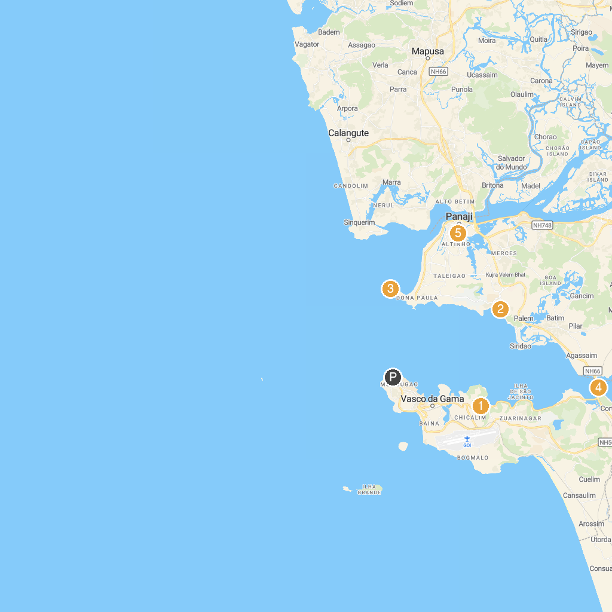
MAP KEY
1. Immaculate Conception Church | 5. Crocodile Station Kamat Kingfisher
2. Saint Francis Xavier Church, Chicalim | 6. Sunaparanta Goa Centre for the Arts
3. Strike Casino By Big Daddy | 7. Abyss
4. Raj Bhavan | 8. Public Astronomical Observatory Goa - Association of Friends of Astronomy(AFA)
P. Cruise port / terminal
Map © MapTiler © OpenStreetMap contributors · cruiseports.org

