Moreton Island, Queensland, Australia
The world's third-largest sand island floats just 40 km off Brisbane — 98% national park, zero paved roads, and a legendary fleet of deliberately sunk ships teeming with marine life.
⚓ Tender (no pier) · 🕒 Typical call: 7-9 hrs · 💵 AUD — largely cashless at resort · 🗣️ English · 🏝️ National Park island
✍️ MY DAY IN PORT (FILL IN)
Ship / Date
In port | arrive ______ · all aboard ______
Booked excursion
Notes / meeting point
GETTING ASHORE
- Docking: Tender to Tangalooma Resort Jetty
- Walk to resort: 2 min from jetty to beach & restaurants
- Best For: Wreck snorkelling, sand tobogganing, beach days
- Don't Miss: The 15 deliberately sunken Tangalooma Wrecks
GETTING AROUND
- 📱 Rideshare: ❌ not available
TOP THINGS TO DO
- Sand Tobogganing & Desert Safari — A 4WD bus takes you into the island's interior to towering white sand dunes where you slide down on Masonite boards at up to 40…
- Tangalooma Wrecks Snorkel Tour — A guided boat takes you to 15 deliberately sunk ships now colonised by 100+ fish species, sea turtles, and rays.
- Marine Discovery Cruise — Catamaran cruise through Moreton Bay searching for dugongs, sea turtles, dolphins, and manta rays in their natural habitat.
- ATV Quad Biking — Guided quad bike tours wind through coastal bushland and over sand dunes behind the resort.
- Beach Day at Tangalooma — Free use of the calm, white-sand beach right at the resort.
BEST WALKS
- Resort to Tangalooma Wrecks: 4 km return | 1-1.5 hrs | Easy-moderate (soft sand) — Walk north along the beach from Tangalooma Jetty to the cluster of 15 sunken ships.
- Resort Beach Stroll: 1-2 km | 20-30 min | Easy — A leisurely walk along the western beach from the jetty toward the resort's southern end.
WEATHER · DAYLIGHT · MONEY
Month | High °F | Low °F | Rainy days
May | 70 | 65 | 13
Jul | 66 | 60 | 8
Sep | 69 | 63 | 6
Daylight: May 6:19AM–5:05PM · Jul 6:35AM–5:09PM · Sep 5:44AM–5:39PM
cruiseports.org/moreton-island · Confirm terminal & all-aboard time with your ship

Moreton Island, Queensland, Australia — Port Map
Red = walkable sights · Amber = excursions farther out · P = cruise terminal
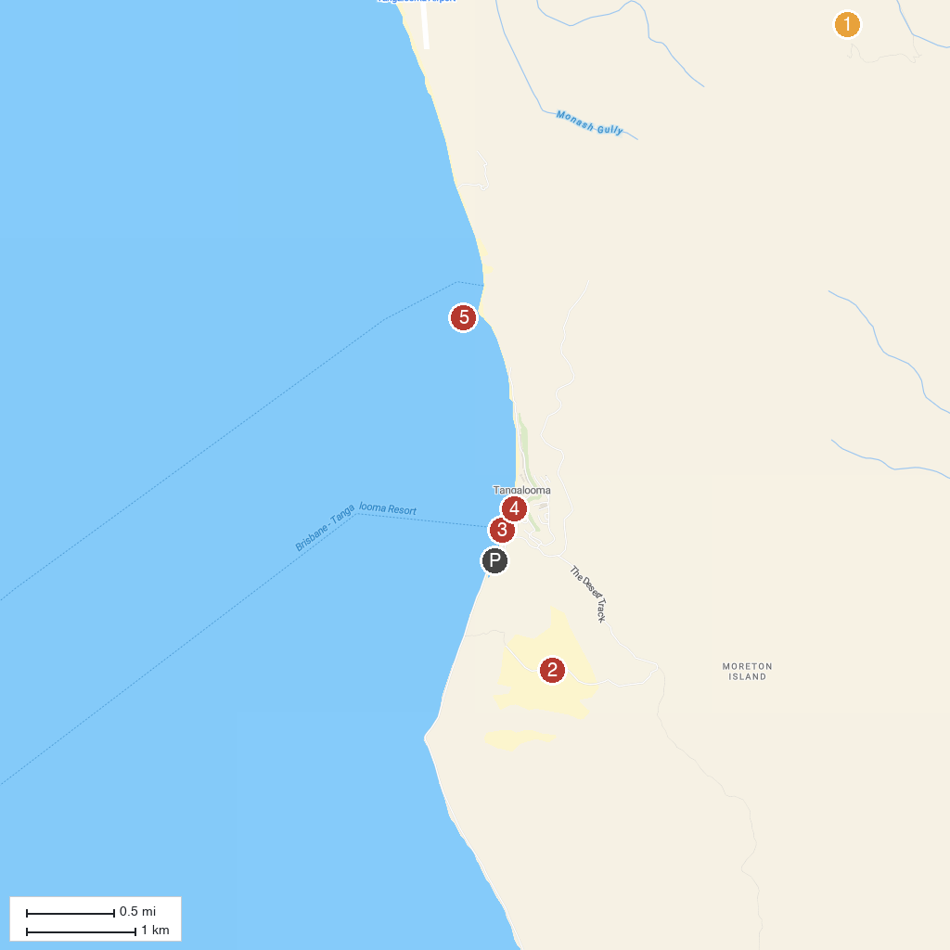
MAP KEY
1. Moreton Island National Park | 4. Tangatours
2. Moreton Island Desert | 5. Tangalooma Wrecks
3. Tangalooma Wild Dolphin Feeding
P. Cruise port / terminal
Map © MapTiler © OpenStreetMap contributors · cruiseports.org

