Mooloolaba, Queensland, Australia
A sun-drenched Sunshine Coast gem where world-class prawns, a north-facing beach, and a walk-everywhere waterfront make for one of Australia's easiest shore days.
⚓ Tender (no pier) · 🕒 Typical call: 7-9 hrs · 💵 AUD — cards accepted everywhere · 🗣️ English · 🦐 Famous for Mooloolaba prawns
✍️ MY DAY IN PORT (FILL IN)
Ship / Date
In port | arrive ______ · all aboard ______
Booked excursion
Notes / meeting point
GETTING ASHORE
- Docking: Tender to The Wharf Mooloolaba (~15 min ride)
- Walk to beach: 5 min from tender dock to Mooloolaba Main Beach
- Best For: Beach days, seafood, SEA LIFE aquarium, Australia Zoo day trips
- Don't Miss: Fresh Mooloolaba prawns at the Mooloolaba Fish Market on the Spit
GETTING AROUND
- 🚕 Taxi: A$10–15 (short town trips) — Taxis are available near the wharf. Queensland regulated fares apply: A$3.70 flagfall (weekdays) plus A$2.69/km. For mos
- 📱 Rideshare: ✅ Uber
TOP THINGS TO DO
- Australia Zoo — Steve Irwin's legendary zoo is just 30 minutes inland — one of Australia's best wildlife parks, with koalas, crocs, wombats, and…
- SEA LIFE Sunshine Coast — Right at the tender dock, this aquarium features an 80-metre ocean tunnel, Queensland's largest jellyfish display, seal…
- Mooloolaba Beach Day — Walk five minutes to one of Australia's safest swimming beaches — north-facing, surf lifesaver-patrolled year-round, and…
- HMAS Brisbane Dive — The ex-Navy guided-missile destroyer was scuttled in 2005 about 5km offshore as an artificial reef and is one of Australia's top…
- Eumundi Markets — The famous Original Eumundi Markets operate Wednesday and Saturday mornings — 600+ stalls of handmade goods, art, and food in a…
BEST WALKS
- Wharf to Mooloolaba Beach & Esplanade: 1.5 km • 20 min • Flat — From the tender dock at The Wharf, stroll along the Mooloolah River boardwalk to Mooloolaba Beach…
- Esplanade to Alexandra Headland: 3 km one-way • 35 min • Flat coastal path — Extend north from Mooloolaba Beach along the coastal boardwalk to Alexandra Headland for sweeping…
- Boardwalk to the Mooloolaba Fish Market (the Spit): 1.2 km • 15 min • Flat — Walk south from The Wharf along the flat river boardwalk to the Spit, where trawlers unload daily.
WEATHER · DAYLIGHT · MONEY
Month | High °F | Low °F | Rainy days
May | 72 | 60 | 12
Jul | 68 | 54 | 7
Sep | 73 | 59 | 8
Daylight: May 6:19AM–5:07PM · Jul 6:35AM–5:11PM · Sep 5:45AM–5:40PM
cruiseports.org/mooloolaba · Confirm terminal & all-aboard time with your ship

Mooloolaba, Queensland, Australia — Port Map
Red = walkable sights · Amber = excursions farther out · P = cruise terminal
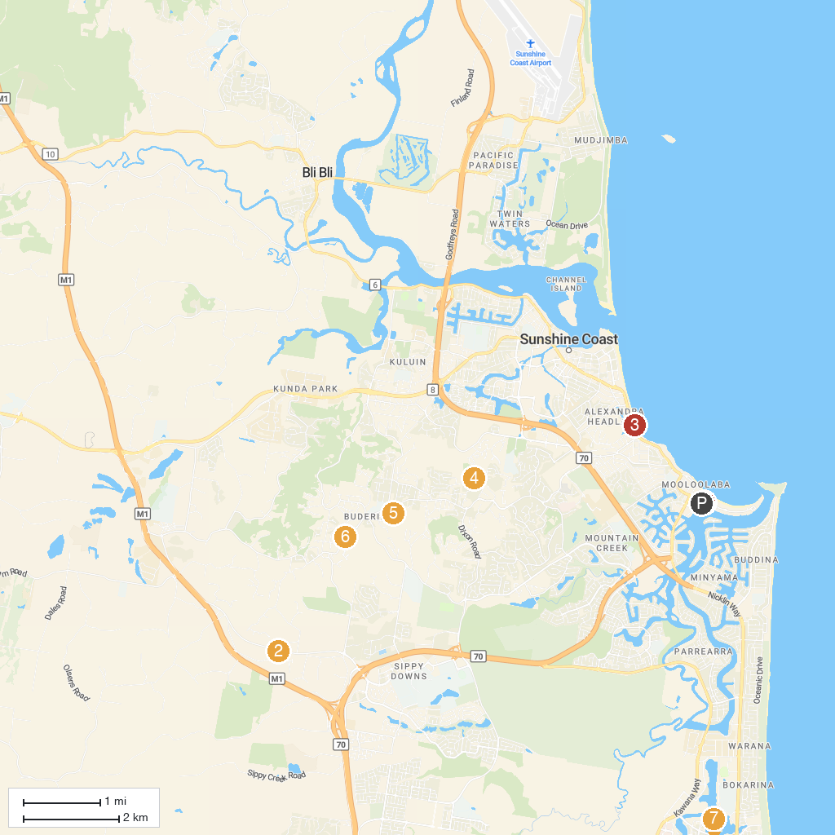
MAP KEY
1. The Big Pineapple | 5. Eric Joseph Foote War Memorial Sanctuary
2. SEA LIFE Sunshine Coast Aquarium | 6. Buderim Village Park
3. Amaze World | 7. Lions Park
4. Buhk Family Park | 8. Crummunda Park
P. Cruise port / terminal
Map © MapTiler © OpenStreetMap contributors · cruiseports.org

