Monterey, California, USA
A marine sanctuary city where sea otters float in kelp beds and Steinbeck's ghost haunts Cannery Row — though cruise calls here are now a rarity after the city ended passenger landing services in 2023.
⚓ Former tender port (city ended cruise services 2023) · 🕒 Historical call: 8-10 hrs · 💵 USD · 🗣️ English · 🐦 Marine Sanctuary — strict wildlife rules
✍️ MY DAY IN PORT (FILL IN)
Ship / Date
In port | arrive ______ · all aboard ______
Booked excursion
Notes / meeting point
GETTING ASHORE
- Docking: Tender (anchor in bay) — city ended cruise landing services Feb 2023; verify with your cruise line before sailing
- Walk to center: Old Fisherman's Wharf: 2 min from tender dock; Cannery Row: 25 min (1.2 mi)
- Best For: Marine life, Monterey Bay Aquarium, Steinbeck history, coastal cycling
- Don't Miss: Sea otters at Breakwater Cove; clam chowder on Fisherman's Wharf; Aquarium kelp forest
GETTING AROUND
- 🚕 Taxi: $6–$10 — Yellow Cab and other local taxis are available near the wharf. The short distance to Cannery Row keeps fares low, though
- 📱 Rideshare: ✅ Uber, Lyft
TOP THINGS TO DO
- Whale Watching from Fisherman's Wharf — Monterey Bay sits above a deep submarine canyon, making it one of the world's premier whale-watching spots year-round.
- Monterey Bay Aquarium — One of the top aquariums on the planet, anchored at the end of Cannery Row.
- Coastal Trail Bike Ride — Rent a bike or e-bike near the wharf and cruise the flat, paved Monterey Bay Coastal Recreation Trail from Fisherman's Wharf past…
- Path of History Walking Tour — Follow yellow tiles in the downtown sidewalks linking California's oldest public building (Custom House, 1827) through Spanish…
- 17-Mile Drive & Pebble Beach — The legendary scenic toll road through the Del Monte Forest showcases the Lone Cypress, Bird Rock, Fanshell Beach, and the…
BEST WALKS
- Fisherman's Wharf to Cannery Row Coastal Stroll: 1.2 miles one-way | 25 min | Flat & paved — Walk west from Municipal Wharf along the Monterey Bay Coastal Recreation Trail through Breakwater…
- Path of History — Downtown Monterey: 0.6-mile loop | 60-90 min | Flat — From Custom House Plaza (right at the tender landing), follow yellow sidewalk tiles through Old…
WEATHER · DAYLIGHT · MONEY
Month | High °F | Low °F | Rainy days
May | 64 | 50 | 3
Jul | 68 | 55 | 1
Sep | 71 | 55 | 2
Daylight: May 6:01AM–8:06PM · Jul 6:00AM–8:27PM · Sep 6:49AM–7:17PM
cruiseports.org/monterey-ca · Confirm terminal & all-aboard time with your ship

Monterey, California, USA — Port Map
Red = walkable sights · Amber = excursions farther out · P = cruise terminal
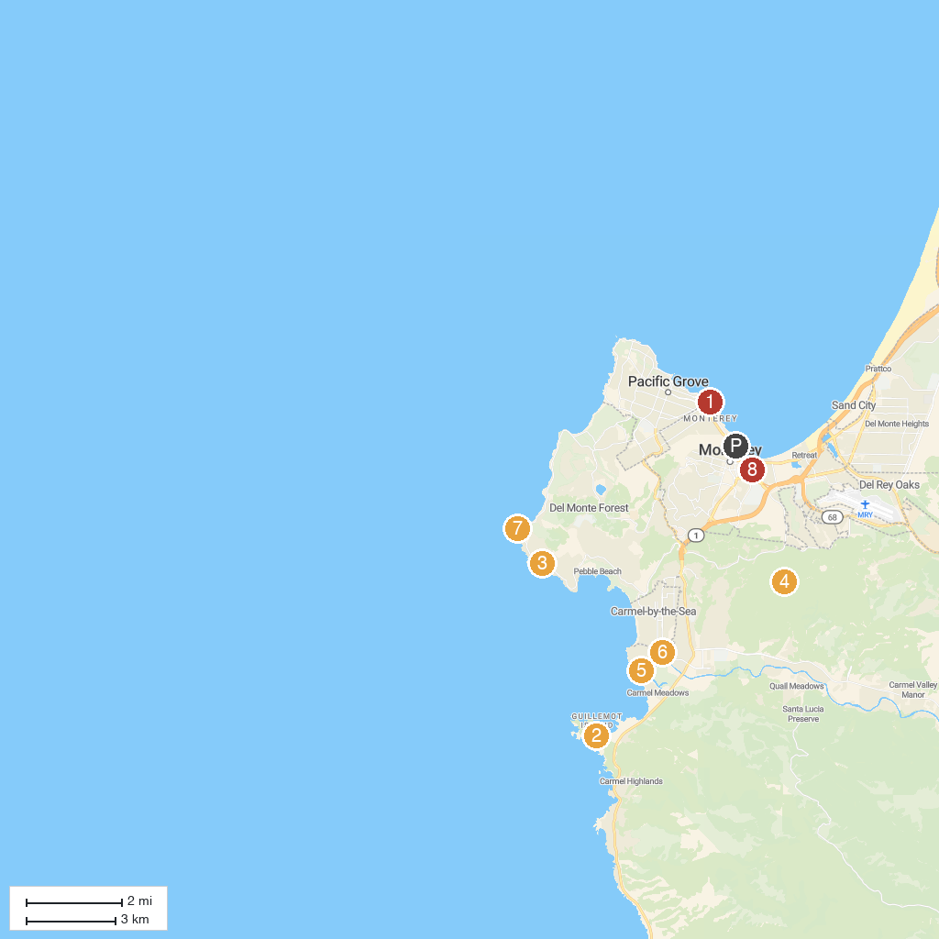
MAP KEY
1. Monterey Bay Aquarium | 5. Carmel River State Beach
2. Point Lobos State Natural Reserve | 6. Carmel Mission Basilica
3. Lone Cypress | 7. Cypress Point Club
4. Jacks Peak Park | 8. Dennis The Menace Playground
P. Cruise port / terminal
Map © MapTiler © OpenStreetMap contributors · cruiseports.org

