Montego Bay, Jamaica
Jamaica's second city delivers turquoise bays, reggae rhythms, and colonial plantation history — all from a modern pier that can berth four ships simultaneously, now expanding to become the Caribbean's next major homeport hub.
⚓ Docked (Freeport Pier) · 🕒 Typical call: 7-10 hrs · 💵 USD widely accepted / JMD · 🗣️ English (Patois locally) · ☀️ Tropical year-round
✍️ MY DAY IN PORT (FILL IN)
Ship / Date
In port | arrive ______ · all aboard ______
Booked excursion
Notes / meeting point
GETTING ASHORE
- Docking: Ships dock at Montego Bay Cruise Port (Freeport) — no tendering. Up to 4 vessels simultaneously; major $1.5B expansion underway through 2027.
- Walk to center: 5–8 km (3–5 miles) to the Hip Strip. Taxi ~$15–20 USD one-way; the port area itself has duty-free shops and a craft market.
- Best For: Beaches, plantation history, river rafting, adventure excursions, reggae culture, and authentic Jamaican jerk.
- Don't Miss: Jerk chicken at Scotchies, Doctor's Cave Beach, and Rose Hall Great House — all within 25 minutes of the port.
GETTING AROUND
- 🚕 Taxi: USD 5–10 — Official taxis have red license plates and wait at the cruise terminal. The ride to downtown or the Hip Strip takes 5–10
- 📱 Rideshare: ✅ Uber
TOP THINGS TO DO
- Doctor's Cave Beach — MoBay's most famous beach — powder-white sand, calm turquoise water, and a full beach club with chairs, food, snorkeling, and…
- Rose Hall Great House — A beautifully restored 18th-century Georgian plantation home, famous for guided tours through period rooms and the spine-tingling…
- Martha Brae River Rafting — Glide through lush rainforest on a 30-foot bamboo raft, poled by a local guide who shares folklore and points out wildlife.
- Jerk Lunch at Scotchies — The authentic local pilgrimage for MoBay jerk — smoky chicken and pork cooked low-and-slow over pimento wood at this legendary…
- Chukka Adventures — Horseback, ATV & Zip — Jamaica's leading adventure operator offers horseback-ride-n-swim, ATV backcountry rides, ziplining, river tubing, and catamaran…
BEST WALKS
- The Hip Strip (Gloucester Avenue): 1–2 hrs | Flat | Shopping, food & beach — Montego Bay's main tourist boulevard runs parallel to the coast from the Gloucester Avenue strip…
- Cruise Terminal Craft Market: 30–60 min | Flat | Shopping — The terminal's own craft market has Jamaican wood carvings, spices, Blue Mountain coffee, and rum…
- Sam Sharpe Square (Downtown): 30–45 min | Flat | History & local life — The heart of downtown MoBay, named after national hero Samuel Sharpe.
WEATHER · DAYLIGHT · MONEY
Month | High °F | Low °F | Rainy days
May | 87 | 74 | 25
Jul | 88 | 77 | 18
Sep | 88 | 77 | 24
Daylight: May 5:38AM–6:38PM · Jul 5:43AM–6:51PM · Sep 5:59AM–6:13PM
cruiseports.org/montego-bay · Confirm terminal & all-aboard time with your ship

Montego Bay, Jamaica — Port Map
Red = walkable sights · Amber = excursions farther out · P = cruise terminal
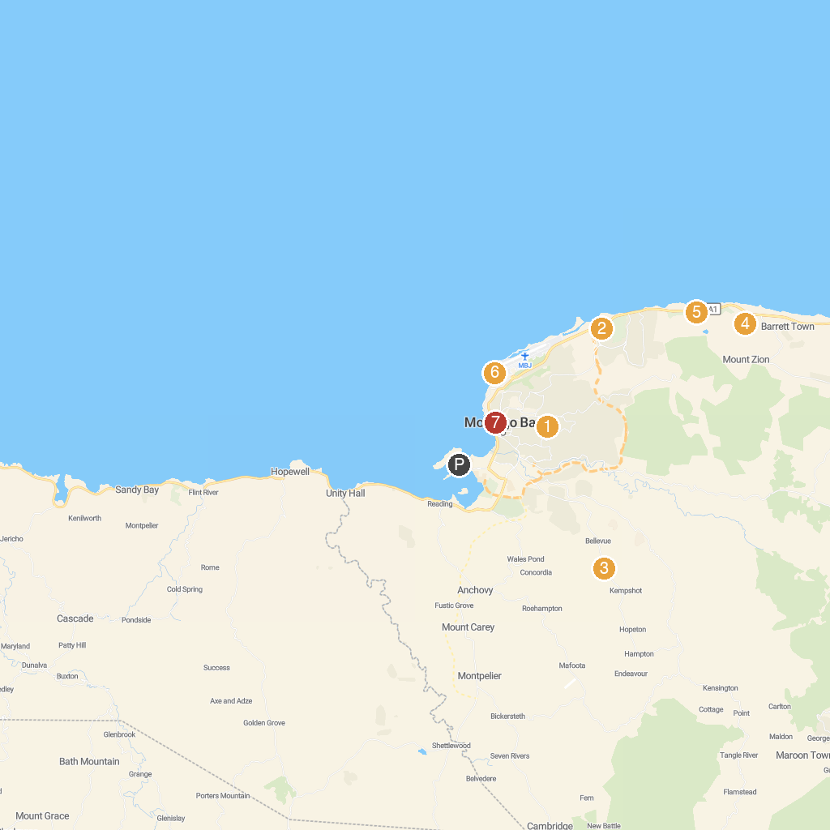
MAP KEY
1. Jamaica Exquisite Transfer and Tours | 5. Rose Hall Great House
2. Treasure Hunt Gaming | 6. Half Moon Golf Course
3. Ahhh...Ras Natango Gallery and Garden | 7. Dead End Beach
4. Cinnamon Hill Golf Course | 8. Harmony Beach
P. Cruise port / terminal
Map © MapTiler © OpenStreetMap contributors · cruiseports.org

