Mons, Wallonia, Belgium
The only Baroque belfry in Belgium crowns this compact Wallonian city where WWI's first and last British shots were fired — and where a little iron monkey on the town hall is said to grant good luck.
⚓ River cruise — dockside quay · 🕒 Typical call: 6-8 hrs · 💶 Currency: Euro (€) · 🗣️ Language: French
✍️ MY DAY IN PORT (FILL IN)
Ship / Date
In port | arrive ______ · all aboard ______
Booked excursion
Notes / meeting point
GETTING ASHORE
- Docking: Grand Large marina quay — no tender required
- Walk to center: ~25 min (2.5 km) from Grand Large marina; shuttle often provided
- Best For: History, UNESCO sites, Belgian food & beer, folklore
- Don't Miss: Rub the Monkey of the Grand-Garde for good luck
GETTING AROUND
- 🚕 Taxi: €8–€20 — Local taxis charge a ~€3 base fare plus €2.50–€3.00/km; the short 2 km ride to the center typically runs €8–€10. Longer
- 📱 Rideshare: ✅ Uber, Bolt
TOP THINGS TO DO
- Belfry of Mons Climb — Belgium's only Baroque belfry and a UNESCO World Heritage site.
- Mons Memorial Museum (WWI) — Mons was where the British fired their first and last shots of WWI.
- Mundaneum — The Paper Internet — Paul Otlet's visionary early-20th-century project to catalogue all the world's knowledge — a remarkable proto-internet housed in…
- Collegiate Church of Sainte-Waudru — A grand Brabantine Gothic church housing the golden Car d'Or processional carriage — the centerpiece of the annual Doudou festival.
- Belgian Flavours Food Walk — CroisiEurope and local guides run culinary walks through Mons sampling Belgian beer, artisanal chocolate, waffles, and regional…
BEST WALKS
- Grand-Place to Belfry Loop: 1.5 km · 45-60 min · Easy (one gentle hill to the Belfry) — The essential Mons stroll, starting from the Grand-Place: find the iron Monkey on the town hall…
- Mundaneum & Museum Quarter: 2 km · 30 min walk + museum time · Easy — Head north from Grand-Place along Rue de Nimy to the Mundaneum, then continue to the Mons Memorial…
WEATHER · DAYLIGHT · MONEY
Month | High °F | Low °F | Rainy days
May | 64 | 48 | 12
Jul | 74 | 58 | 10
Sep | 68 | 54 | 10
Daylight: May 5:56AM–9:25PM · Jul 5:50AM–9:49PM · Sep 7:20AM–7:57PM
cruiseports.org/mons · Confirm terminal & all-aboard time with your ship

Mons, Wallonia, Belgium — Port Map
Red = walkable sights · Amber = excursions farther out · P = cruise terminal
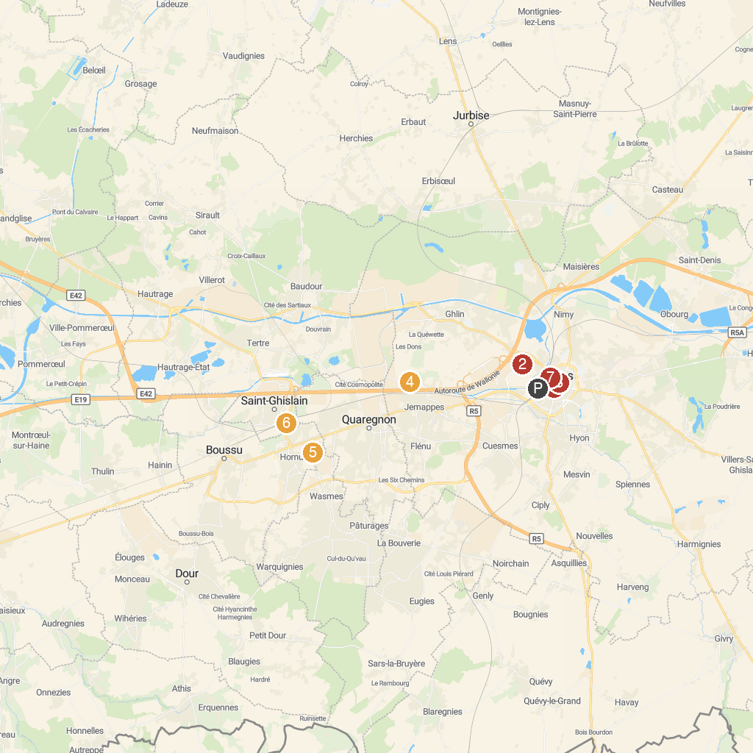
MAP KEY
1. Belfry of Mons | 5. The Grand Hornu
2. Laser Game Evolution Mons Imagix / Labyrinthes Multi-Niveaux | 6. Retrotrain (musée du PFT-TSP asbl)🚂
3. Beaux-Arts Mons | 7. Ascenseur N°2 - Ancien canal du Centre
4. Park Jemappes | 8. Regional Museum of Natural Sciences
P. Cruise port / terminal
Map © MapTiler © OpenStreetMap contributors · cruiseports.org

