Monfalcone, Friuli Venezia Giulia, Italy
Home to Fincantieri's legendary shipyard, where cruise ships are born, Monfalcone punches above its size as the gateway to magnificent Trieste, Roman Aquileia, and even Venice.
⚓ Pier (direct docking) · 🕒 Typical call: 8-10 hrs · 💶 Euro (€) · 🗣️ Italian · 🚢 MSC homeport
✍️ MY DAY IN PORT (FILL IN)
Ship / Date
In port | arrive ______ · all aboard ______
Booked excursion
Notes / meeting point
GETTING ASHORE
- Docking: Direct pier at Marina Hannibal — no tender
- Walk to Center: Shuttle required (~10-15 min); train station 20 min walk from drop-off
- Best For: Day-tripping to Trieste (25 min) or Aquileia UNESCO ruins
- Don't Miss: Fincantieri shipyard views — you may see a cruise ship under construction dockside
GETTING AROUND
- 🚕 Taxi: €5–€10 — Taxis (Radiotaxi Monfalcone) are available at the port. Given the very short distance to the city center, fares are low.
- 📱 Rideshare: ✅ Uber
TOP THINGS TO DO
- Trieste — The Adriatic's Viennese Gem — Just 25 minutes by train, Trieste feels more Central European than Italian.
- Aquileia — Roman UNESCO Ruins — One of the ancient Roman Empire's great cities, Aquileia's Basilica holds Europe's largest paleo-Christian floor mosaic.
- Duino Castle — Cliffside Medieval Drama — A 14th-century private castle perched dramatically on limestone cliffs above the sea, about 15 minutes from Monfalcone.
- WWI Trenches — Parco della Grande Guerra — Preserved WWI trenches, tunnels, and fortifications on the hills behind town.
- Grado — Golden Island Beach Day — Known as the 'Golden Island,' Grado is a historic spa town with shallow, sandy Adriatic beaches and a well-preserved Roman old…
BEST WALKS
- Town Center to Rocca di Monfalcone: 2.5 km round trip | Moderate (uphill) | 45-60 min — From Piazza della Repubblica, walk uphill through the residential streets to the medieval Rocca…
- Town Center Café Stroll: 1 km | Easy | 30 min — Explore the pedestrian streets around Piazza della Repubblica, grab a Friulano aperitivo, pick up…
WEATHER · DAYLIGHT · MONEY
Month | High °F | Low °F | Rainy days
May | 70 | 55 | 15
Jul | 84 | 67 | 10
Sep | 75 | 60 | 12
Daylight: May 5:34AM–8:30PM · Jul 5:30AM–8:52PM · Sep 6:44AM–7:16PM
cruiseports.org/monfalcone · Confirm terminal & all-aboard time with your ship

Monfalcone, Friuli Venezia Giulia, Italy — Port Map
Red = walkable sights · Amber = excursions farther out · P = cruise terminal
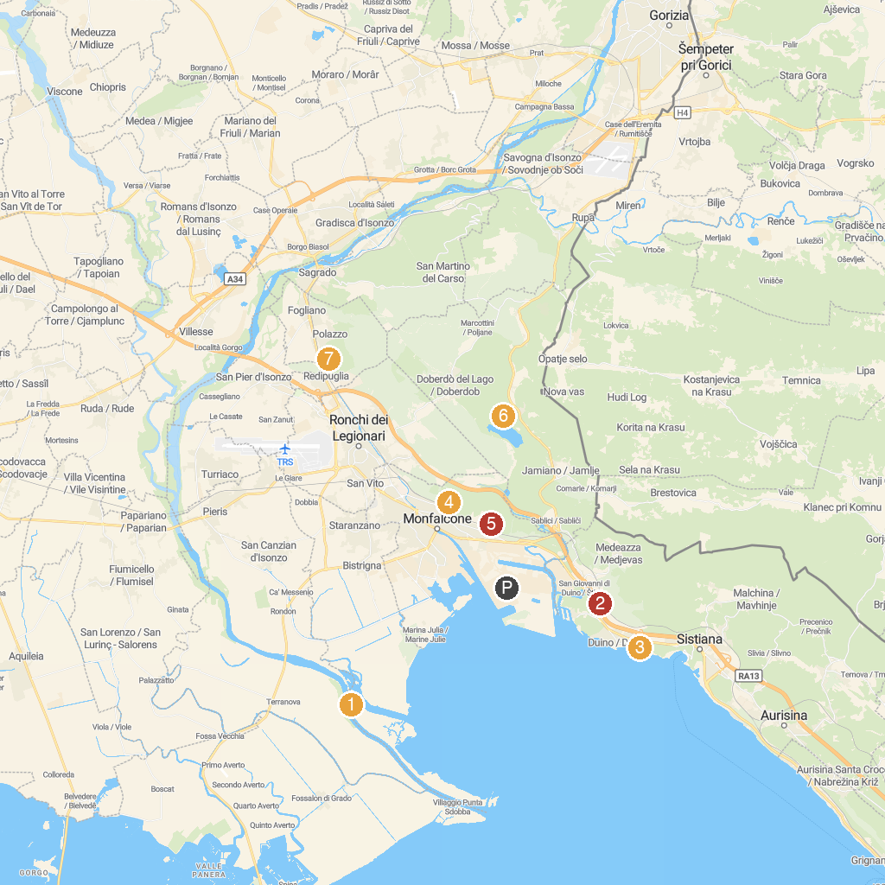
MAP KEY
1. Riserva Naturale Regionale della Foce dell'Isonzo Isola della Cona | 5. Rocca di Monfalcone
2. Duino Mithraeum | 6. Theme Park of the Great War of Monfalcone
3. Archaeological area of ​​Aquileia - Roman necropolis | 7. Rifugio Casa Cadorna
4. Regional Nature Reserve Duino Cliffs | 8. Military Memorial Redipuglia
P. Cruise port / terminal
Map © MapTiler © OpenStreetMap contributors · cruiseports.org

