Mombasa, Coast Province, Kenya
Kenya's gateway port blends a 16th-century Portuguese fort, labyrinthine Swahili lanes, and one of East Africa's most ambitious wildlife coastlines — all within a day's reach.
⚓ Docked — Kilindini Harbour · 🕒 Typical call: 8–10 hrs · 💵 Kenyan Shilling (USD widely accepted) · 🗣️ Swahili & English
✍️ MY DAY IN PORT (FILL IN)
Ship / Date
In port | arrive ______ · all aboard ______
Booked excursion
Notes / meeting point
GETTING ASHORE
- Docking: Mombasa Cruise Terminal, Kilindini Harbour — all cruise lines dock; no tender
- Walk to center: 3–4 km to Old Town; taxi or tuk-tuk required
- Best For: History buffs, safari seekers, beach lovers, Swahili cuisine
- Don't Miss: Fort Jesus (UNESCO), Mombasa Tusks, Haller Park giraffes
GETTING AROUND
- 🚕 Taxi: KSh 850–1,100 (~$7–9 USD) — Unmetered taxis are plentiful at the port gate. Always negotiate the fare before you get in; the city center (Fort Jesus
- 📱 Rideshare: ✅ Uber, Bolt
TOP THINGS TO DO
- Fort Jesus & Old Town Walk — Explore the 1593 Portuguese fortress — a UNESCO World Heritage Site — then wander Mombasa Old Town's carved-door alleyways…
- Tsavo East National Park Safari — Full-day drive to Tsavo East for Kenya's iconic red elephants, lions, cheetahs, and Aruba Dam waterhole.
- Haller Park Nature Walk — A reclaimed limestone quarry in Bamburi turned wildlife sanctuary about 10 km north of the port.
- Wasini Island Dolphin & Snorkel Trip — Boat south to Kisite Mpunguti Marine Park for dolphin watching and snorkeling over coral reefs, then a Swahili seafood lunch on…
- Mombasa Old Town Spice & Food Tour — Join a local guide through Marikiti Market, sample Swahili street food like mahamri and samaki wa kupaka, and browse fragrant…
BEST WALKS
- Fort Jesus to Old Town: 1–2 km | 1–2 hrs | Easy | History & culture — Start at Fort Jesus on Ndia Kuu Road, explore the fort and its museum, then head north into Old…
- Moi Avenue & the Tusks: 1 km | 30 min | Easy | City landmark — A short stroll along Moi Avenue past the iconic aluminum Mombasa Tusks — built in 1956 to mark…
WEATHER · DAYLIGHT · MONEY
Month | High °F | Low °F | Rainy days
May | 82 | 76 | 24
Jul | 79 | 73 | 21
Sep | 81 | 74 | 20
Daylight: May 6:19AM–6:15PM · Jul 6:30AM–6:24PM · Sep 6:14AM–6:18PM
cruiseports.org/mombasa · Confirm terminal & all-aboard time with your ship

Mombasa, Coast Province, Kenya — Port Map
Red = walkable sights · Amber = excursions farther out · P = cruise terminal
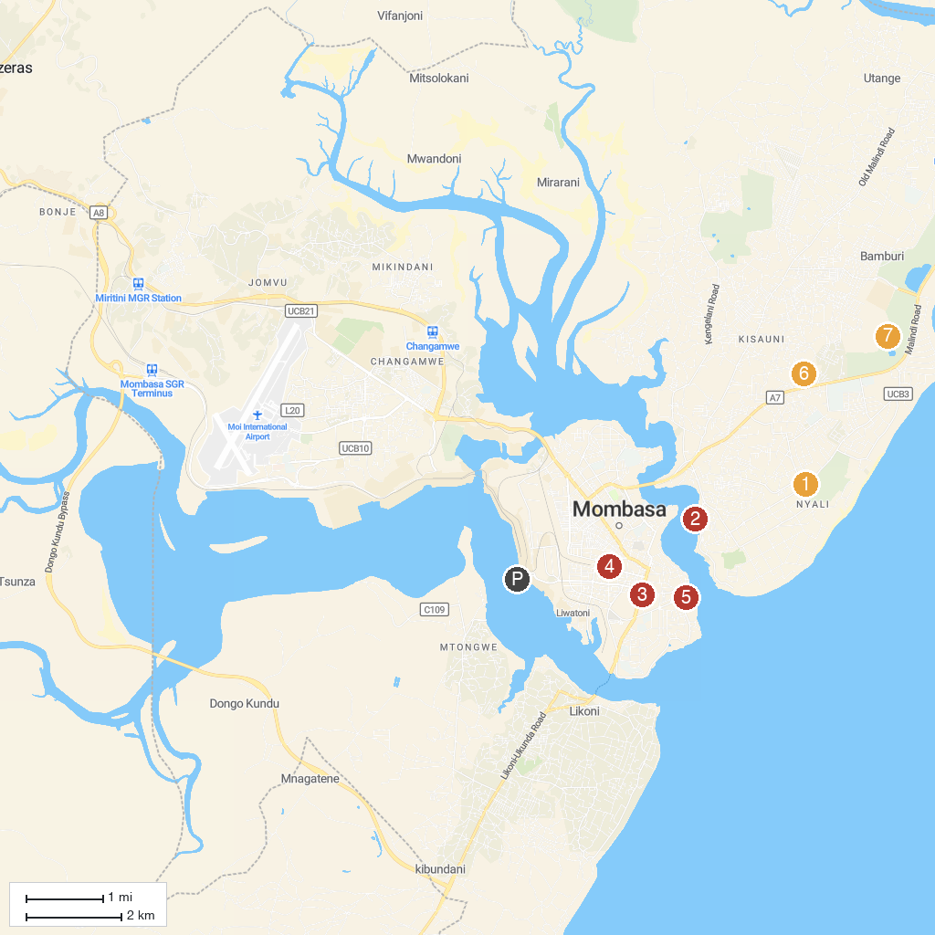
MAP KEY
1. Mamba Village Mombasa | 5. Swahili Cultural Centre
2. Golden Key Casino | 6. Bombolulu Coast Workshop and Cultural Centre
3. Holy Ghost Cathedral | 7. Haller Park
4. Shree Cutch Satsang Swaminarayan Temple
P. Cruise port / terminal
Map © MapTiler © OpenStreetMap contributors · cruiseports.org

