Molde, Møre og Romsdal, Norway
Norway's 'Town of Roses' sits on the Romsdalsfjord beneath 222 snow-capped peaks. Ships dock right in town, putting cafés, museums, and a legendary mountain panorama within easy walking distance.
⚓ Pier (central dock) · 🕒 Typical call: 7–10 hrs · 💵 Norwegian Krone (NOK) — card accepted everywhere · 🗣️ Norwegian (English widely spoken)
✍️ MY DAY IN PORT (FILL IN)
Ship / Date
In port | arrive ______ · all aboard ______
Booked excursion
Notes / meeting point
GETTING ASHORE
- Docking: Pier — Storkaia or Tindekaia, both in city centre
- Walk to centre: 2–5 min from gangway to town square
- Best For: Scenery, hiking, fjord drives, roses
- Don't Miss: Varden viewpoint for the 222-peak panorama
GETTING AROUND
- 🚕 Taxi: 100–200 NOK (~$9–$18 USD) — Taxis (Molde Taxi) are available at the pier. Norway taxis are expensive; base fare ~99 NOK plus ~10 NOK/km. Useful for
- 📱 Rideshare: ❌ not available
TOP THINGS TO DO
- Varden Viewpoint — The Molde Panorama — Hike or ride to 407 m above sea level for Norway's most famous fjord panorama: 222 partially snow-capped peaks above the…
- Atlantic Ocean Road Drive — One of the world's most dramatic roads — 8.3 km hopping between islands via eight bridges, including the iconic curved…
- Romsdal Folk Museum (Romsdalsmuseet) — One of Norway's largest open-air folk museums, with 40+ historic turf-roofed buildings from the 16th–20th centuries and a…
- WWII Royal Birch Monument — In 1940, King Haakon VII and Crown Prince Olav sheltered under a birch tree as German bombers attacked Molde.
- Retiro Beach & Fjordside Walk — Molde's sandy beach sits in a sheltered cove 2.5 km east of the pier, with picnic areas and fjord views.
BEST WALKS
- Town Centre & Rose Garden Loop: 1–1.5 hrs · Easy · Free — Walk from the pier to the town square (Torget), then to Molde Cathedral and its rose gardens, and…
- Varden Panorama Hike: 2–2.5 hrs return · Moderate · Free — Follow the 'Green Corridor' (Grønn Løype) trail uphill from near the Romsdal Museum to the Varden…
WEATHER · DAYLIGHT · MONEY
Month | High °F | Low °F | Rainy days
May | 53 | 42 | 16
Jul | 63 | 53 | 18
Sep | 59 | 50 | 18
Daylight: May 4:31AM–10:26PM · Sep 6:56AM–7:54PM
cruiseports.org/molde · Confirm terminal & all-aboard time with your ship

Molde, Møre og Romsdal, Norway — Port Map
Red = walkable sights · Amber = excursions farther out · P = cruise terminal
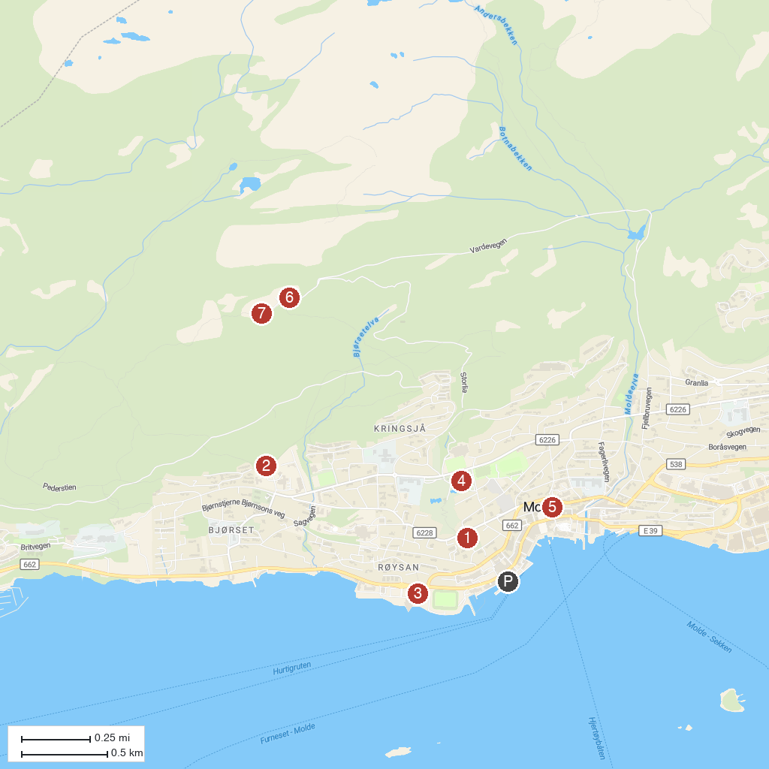
MAP KEY
1. The Château | 5. Molde Cathedral
2. The Royal Birch | 6. Molde Panorama
3. Moldebadet | 7. Molde Utsiktspunkt
4. Romsdal Museum
P. Cruise port / terminal
Map © MapTiler © OpenStreetMap contributors · cruiseports.org

